
FOOD GUIDE PYRAMID

To accompany the Culinary Arts, 
Family and Consumer Sciences
CTAE Resource Network, Instructional Resources Office, 2010
Georgia Performance Standards:
CA-ICA-9. Students will examine an introduction to nutrition including the six
major classes of nutrients, proteins, and carbohydrates: simple, complex, fats,
vitamins, minerals and water.

FCS-FNW-4. Students will utilize the My Pyramid to demonstrate serving sizes and recommended daily intake of different food groups.

See the end of this document for complete GPS listing

Student Information Guide
Directions:
Use the information in this student information sheet to complete the accompanying student study sheet. Complete all items on the study sheet and turn in to the teacher.
 Food Guide Pyramid
The food guide pyramid, historically known as the food pyramid, and formally titled the Improved American Food Guide Pyramid, was published by the USDA (United States Department of Agriculture) in 1992 to replace the earlier food groups classification system. The food guide pyramid suggested optimal nutrition guidelines for each food category, per day, using a mnemonic graphic of a pyramid with horizontal dividing lines to represent suggested percentages of the daily diet for each food group. Currently published every five years, an update to the 2005 system is expected in 2010.
Groups based on the Food Guide Pyramid

Carbohydrates
Carbohydrates an ideal source of energy for the body. This is because they can be converted more readily into glucose, the form of sugar that's transported and used by the body, that can contain proteins or fats. Even so, a diet too high in carbohydrates can upset the delicate balance of your body's blood sugar level, resulting in fluctuations in energy and mood that leave you feeling irritated and tired. It is better to balance your intake of carbohydrates with protein, a little fat and fiber.

Vegetable group
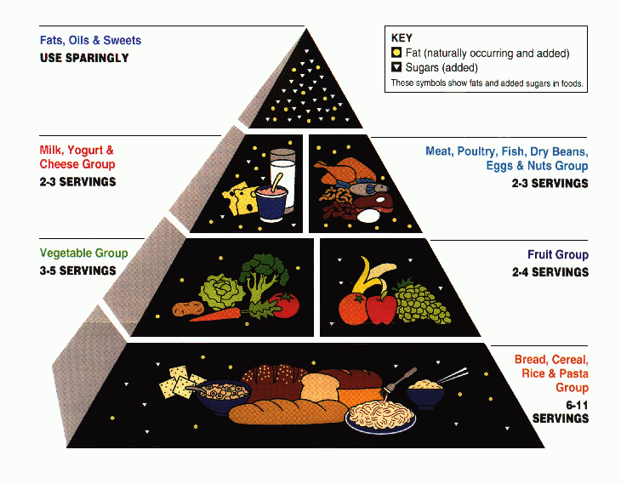
A vegetable is a part of a plant consumed by humans that is generally savory (not sweet) and not considered a grain, fruit, nut, spice, or herb. For example, the stem, root, flower, etc., may be eaten as vegetables. Vegetables contain many vitamins and minerals; however, different vegetables contain different spreads, so it is important to eat a wide variety of types. For example, green vegetables typically contain vitamin A, dark orange and dark green vegetables contain vitamin C,and vegetables like broccoli and related plants contain iron and calcium. Vegetables are very low in fats and calories, but cooking can often add these.
3-5 servings of vegetables in a day. They may be fresh, frozen, canned, or juiced.

Fruit group
In terms of food (rather than botany), fruits are the sweet-tasting seed-bearing parts of plants, or occasionally sweet parts of plants which do not bear seeds. These include apples, oranges, plums, bananas, etc. Fruits are low in calories and fat and are a source of natural sugars, fiber and vitamins. Processing fruits when canning or making into juices unfortunately may add sugars and remove nutrients. The fruit food group is sometimes combined with the vegetable food group. Note that many foods considered fruits in botany because they bear seeds are not considered fruits in cuisine because they lack the characteristic sweet taste, e.g., tomatoes or avocados. It is best to consume 2-4 servings of fruit in a day. They may be fresh, frozen, canned, dried, pureed or juiced.
The original food pyramid from the USDA.

Oil group
The oil group is represented by a large yellow strip between the dairy and fruits groups. It is most needed in the body and it is needed to stay healthy. You need to have these in small amounts and not much per day

Dairy group
The dairy group is represented by a medium-thick blue strip between the oil and meat groups. Dairy products are produced from the milk of mammals, most usually but not exclusively cattle. They include milk, yogurt and cheese. Milk and its derivative products are a rich source of the mineral calcium, but also provide protein, phosphorus, vitamin A, and vitamin D. However, many dairy products are high in saturated fat and cholesterol compared to vegetables, fruits and whole grains, which is why skimmed products are available as an alternative. For adults, 3 cups of dairy products are recommended per day.

Meat, Poultry, Fish, Dry Beans, Eggs, and Nuts group
Meat is the tissue - usually muscle - of an animal consumed by humans. Since most parts of many animals are edible, there are a vast variety of meats. Meat is a major source of protein, as well as iron, zinc, and vitamin B12. Meats, poultry, and fish include beef, chicken, pork, salmon, tuna, and shrimp, eggs, spices and herbs are also in this group. However, since many of the same nutrients found in meat can also be found in foods like eggs, dry beans, and nuts, such foods are typically placed in the same category as meats, as meat alternatives. These include tofu, products that resemble meat or fish but are made with soy, eggs, and cheeses. The meat group is one of the major compacted food groups in the food guide pyramid. Although meats provide energy and nutrients, they are often high in fat and cholesterol, and can be high in sodium. Simply trimming off fatty tissue can go a long way towards reducing this negative effect. However, this tactic may prove to be ineffective, so large portions of meats are not recommended; 2-3 ounces per day of meat or alternatives are recommended. This is 3-5 servings. For those who don't consume meat or animal products (see Vegetarianism and Taboo food and drink), meat analogs, tofu, beans, lentils, chick peas, nuts and other high-protein vegetables make up this group.
Food Pyramid and serving sizes
The serving size of a food product is a confusing term, as it is found both on the Food Pyramid and on Nutrition Labels and has two related but differing meanings. The USDA Center for Nutrition Policy and Promotion sets the standards for these meanings in the United States.
The purpose of The Food Pyramid is to assist people in meeting daily nutrient recommendations while providing relatively few serving sizes for each food group.
According to the USDA, serving sizes in the Pyramid are determined through four factors:
- Consideration of typical portion sizes from food consumption surveys.
- Convenience in relation to common measuring sizes.
- Nutrient content.
- Sizes from previous guides.
Some food groups receive different emphasis than others. See Food Pyramid for recommended daily servings.
Nutrition Facts Label
Nutrition Facts Label Serving Sizes are specific in their nutritional information to allow for easy comparison with other similar foods. Consumers may visualize important nutritional variations without excessive calculation. While designed for easy comparison with other similar products, such as Coke vs. Diet Coke or Fruit Loops vs. Frosted Flakes, the label is not meant for direct comparison with the Food Pyramid's recommended servings.
Serving sizes on Nutrition Facts Labels are loosely based on the amount of a product normally eaten in one sitting or reference amounts, determined from nationwide food consumption surveys. The variation in caloric content per serving from product to product is normally because of the reference amount, not because of any set value or common unit.
Reference amounts affect serving sizes in one of three ways:
- Bulk products, such as sugar, have sizes in common units of measurement, such as the cup or tablespoon, to show the quantity closest to the reference amount.
- Commonly divided products, such as pie or cake, have a serving size given in a fraction of the whole product (e.g., 1/8 pizza).
- Products which are sliced beforehand or are bought in distinct, grouped units (such as olives), are listed in the approximate number of units corresponding to the reference amount. For example, if the reference amount for olives were 30 g, and one olive weighed 10 g, the serving size would probably be listed as three olives.
One serving of grain: one cup of whole grain cereal, one fourth of a bagel, one cup of pasta.
One serving of vegetables: five cherry tomatoes, five sticks of celery, one whole carrot.
One serving of fruit: a medium apple, fifteen large grapes, half a banana.
One serving of dairy: one cup of milk, three cheese cubes, half cup of low fat cottage cheese.
One serving of meat: 1/4 chicken breast, daily guide line: one fist full per meal.
Fats and Sugars: as little as possible, dairy and meat contain plenty of necessary fat, while fruits contain enough natural sugars.
First-time dieters can find the process of calculating serving sizes and calorie counting confusing, and due to the nature of the sheer volume of variety of supermarket products, serving sizes are commonly inaccurate.

Controversy
Before the dietary pyramid that most of people have become familiar with was invented, the USDA (United States Department of Agriculture) published the first list of dietary recommendations. In 1916, the first food guide was published and named "food for young children". In 1943 the "basic seven" guidelines that President Franklin Roosevelt introduced was deemed obsolete because of its complexity and was replaced by the much more simple "basic four". This consists of milk, meats, fruits, and vegetables. In the 1970s, there was a fifth group added, fats, sugars, and alcohol. People were advised to only have this on a restricted basis though. Then in 1994, after careful consideration of all of the different dietary factors, the USDA released the commonly known food pyramid that consists of four levels with different types of food on each level. However, a recent change has been made to dietary suggestions yet again by editing the food pyramid released in 1994. Many nutritional experts, like Harvard nutritionist Dr. Walter Willett, believe the 1992 pyramid does not reflect the latest research on dietetics. Certain dietary choices that have been linked to heart disease, such as three cups of whole milk and an 8 oz. serving of hamburger daily, were technically permitted under the pyramid. The pyramid also lacked differentiation within the protein-rich group ("Meat, Poultry, Fish, Dry Beans, Eggs, and Nuts").
Some of the recommended quantities for the different types of food in the old pyramid have also come under criticism for lack of clarity. For instance, the pyramid recommends two to three servings from the protein-rich group, but this is intended to be a maximum. The pyramid recommends two to four fruit servings, but this is intended to be the minimum.
The fats group as a whole have been put at the tip of the pyramid, under the direction to eat as little as possible, which is largely problematic. Under the guide, one would assume to avoid fats and fatty foods, which can lead to health problems. For one, fat is essential in a person's general sustainability. Unsaturated fats from a natural source can actually aid in weight loss, reduce heart disease risk, lower blood sugar, and even lower cholesterol. These fats can be found in olive oil, nuts, pesto, seafood (including fish, shrimp, squid, and krill among many more) and avocados. Also, they are very long sustaining, and help keep blood sugar at a steady level. On top of that, these fats help brain function as well.
Another problem of the old pyramid is the grains group, in which many simple refined grain carbohydrates are listed. Refined carbohydrates are often referred to as "empty calories", which means the food source is adequate in caloric amount and mass but lacks attributes to curb hunger.
There are claims that the USDA was (and continues to be) unduly influenced by political pressure exerted by food production associations. Food industries, such as milk companies, have been accused of influencing the United States Department of Agriculture into making the colored spots on the newly created food pyramid larger for their particular product. The milk section is clearly the easiest to see out of the six sections of the pyramid. This makes individuals believe that more milk should be consumed on a daily basis compared to the others. Furthermore, the inclusion of milk as a group unto itself implies that is an essential part of a healthy diet, which is easily disproved by the number of healthy vegans, the many people who are lactose intolerant and choose to abstain from dairy, and a number of cultures that have historically consumed little if any dairy products with the exception of breast-feeding.
Alternatives
The Harvard School of Public Health proposes the Healthy eating pyramid, which includes calcium and multi-vitamin supplements as well as moderate amounts of alcohol, as an alternative to the Food Guide Pyramid.
Many observers believe that the Harvard pyramid follows the results of nutrition studies published in peer reviewed scientific journals more closely.
In their book "Fanatastic Voyage - Live Long Enough To Live Forever" published in 2004, Ray Kurzweil and Terry Grossman M.D., point out that the guidelines provided in the Harvard Pyramid, fail to distinguish between healthy and unhealthy oils. In addition, whole-grain foods are given more priority than vegetables, which should not be the case as vegetables have a lower glycemic load. Other observations are that fish should be given a higher priority due to its high omega-3 content, and that high fat dairy products should be excluded. As an alternative, the authors postulate a new food
pyramid, emphasising low glycemic load vegetables, healthy fats, such as avocados, nuts and seeds, lean animal protein, fish, and extra virgin olive oil.
Vegan version of the nutritional food pyramid.
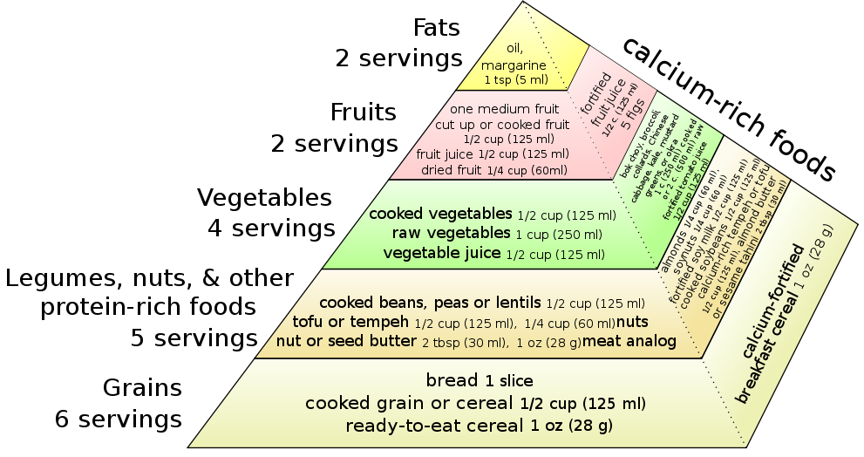
The University of Michigan Integrative Medicine’s Healing Foods Pyramid emphasizes plant-based choices, variety and balance. It includes sections for seasonings and water as well as healthy fats.
MyPyramid

MyPyramid, released by the United States Department of Agriculture (USDA) on April 19, 2005, is an update on the American food guide pyramid. The new icon stresses activity and moderation along with a proper mix of food groups in one's diet. As part of the MyPyramid food guidance system, consumers are asked to visit the MyPyramid website for personalized nutrition information. Significant changes from the previous food pyramid include:
- Inclusion of a new symbol—a person on the stairs—representing physical activity.
- Measuring quantities in cups and ounces instead of servings.
MyPyramid was designed to educate consumers about a lifestyle consistent with the January 2005 Dietary Guidelines for Americans, an 80-page document. The guidelines, produced jointly by the USDA and Department of Health and Human Services (HHS), represented the official position of the U.S. government and served as the foundation of Federal nutrition policy. Currently published every five years, an update is expected in 2010.

Overview
MyPyramid contains eight divisions. From left to right on the pyramid are a person and six food groups:
- Physical activity, represented by a person climbing steps on the pyramid, to illustrate moderate physical activity every day, in addition to usual activity. The key recommendations for 2005 (other specific recommendations are provided for children and adolescents, pregnant and breastfeeding women, for older adults and for weight maintenance) are:
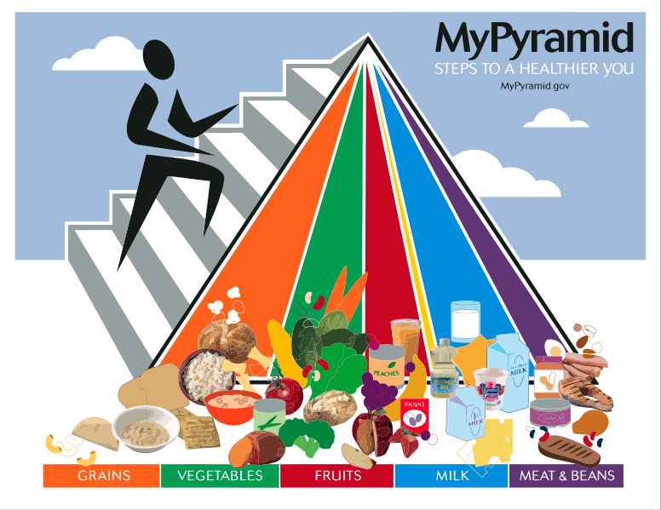
- Engage in regular physical activity and reduce sedentary activities to promote health, psychological well-being, and a healthy body weight. (At least 30 minutes on most, and if possible, every day for adults and at least 60 minutes each day for children and teenagers, and for most people increasing to more vigorous-intensity or a longer duration will bring greater benefits.)
- Achieve physical fitness by including cardiovascular conditioning, stretching exercises for flexibility, and resistance exercises or calisthenics for muscle strength and endurance.
The six divisions of the pyramid
- Grains, recommending that at least half of grains consumed be as whole grains
- Vegetables, emphasizing dark green vegetables, orange vegetables, and dry beans and peas
- Fruits, emphasizing variety and deemphasizing fruit juices
- Oils, recommending fish, nut, and vegetables sources
- Milk, a category that includes fluid milk and many other milk-based products
- Meat and beans, emphasizing low-fat and lean meats such as fish as well as more beans, peas, nuts, and seeds
There is one other category:
- Discretionary calories, represented by the narrow tip of each colored band, including items such as candy, alcohol, or additional food from any other group.

Themes
The USDA encoded several themes into the design of the MyPyramid icon. According to the USDA, MyPyramid incorporated:
- Personalization, demonstrated by the MyPyramid website. To find a personalized recommendation of the kinds and amounts of food to eat each day, individuals must visit MyPyramid.gov.
- Gradual improvement, represented by the slogan Steps to a Healthier You. It suggests that individuals can benefit from taking small steps to improve their diet and lifestyle each day.
- Physical activity, represented by the steps and the person climbing them, as a reminder of the importance of daily physical activity.
- Variety, symbolized by the six color bands representing the five food groups of MyPyramid and oils. Suggests that foods from all groups are needed each day for good health.
- Moderation, represented by the narrowing of each food group from bottom to top. The wider base stands for foods with little or no solid fats, added sugars, or caloric sweeteners. Suggests these should be selected more often to get the most nutrition from calories consumed.
- Proportionality, shown by the different widths of the food group bands. The widths suggest how much food a person should choose from each group. The widths are just a general guide.

Differences from the food guide pyramid
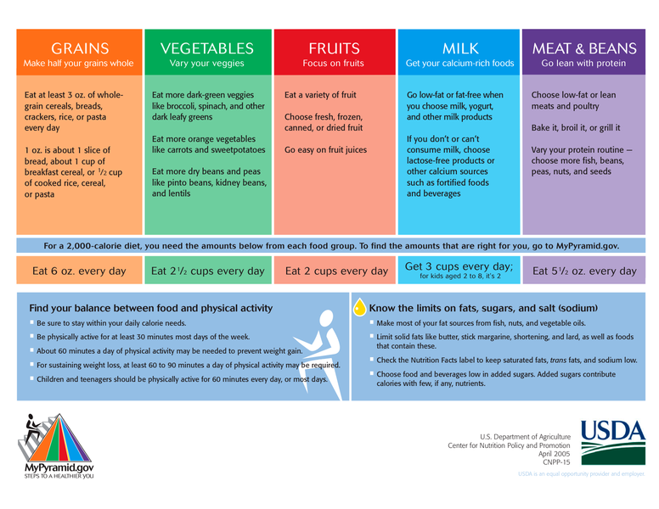
In a departure from the food guide pyramid, which was launched in 1992, no foods are pictured on the MyPyramid logo itself. Instead, colored vertical bands represent different food groups. Additionally, the logo emphasizes physical activity by showing a person climbing steps on the side of the pyramid. MyPyramid was intentionally made simpler than the food guide pyramid after several USDA studies indicated that consumers widely misunderstood the original design. Consumers are asked to visit the MyPyramid.gov website for personalized nutrition information.
The food guide pyramid gave recommendations measured in serving sizes, which some people found confusing. MyPyramid gives its recommendations in common household measures, such as cups, ounces, and other measures that may be easier to understand.
MyPyramid miniposter with sample food group recommendations
The food guide pyramid gave a single set of specific recommendations for all people. In contrast, MyPyramid has 12 sets of possible recommendations, with the appropriate guide for an individual selected based on sex, age group, and activity level.
Georgia Performance Standards
CA-ICA-9. Students will examine an introduction to nutrition including the six major classes of nutrients, proteins, and carbohydrates: simple, complex, fats,vitamins, minerals and water.
a. Discuss and develop knowledge of the importance of My Pyramid and examine how My Pyramid can be misleading and complex due to cultural constraints, eating disorders, and food allergies.
b. Examine the six major food groups, nutrient contributions of vitamins, minerals, and nutrient variability within a group and daily recommended intake.
c. Define a serving size, portion control, recommended serving size and balanced diet while maintaining a correct nutritional intake.
d. Examine current trends and issues in food and nutrition, fad diets, proper weight loss techniques and how these fit into healthy menu options.
CA-CAI-8. Students will examine in detail the nutritional concepts that relate to a balanced and healthy diet, covering the six major classes of nutrients in developing a personalized healthy diet plan.
a. Identify and develop a personalized healthy diet based upon My Pyramid and examine the impacts on cultural constraints, eating disorders and food allergies.

FCS-FNW-4. Students will utilize the My Pyramid to demonstrate serving sizes and recommended daily intake of different food groups.
a. Apply My Pyramid to the planning and selection of a nutritionally adequate and balanced diet.
b. Explain why an active lifestyle plays an important role in My Pyramid.
c. Visit the My Pyramid website and calculate the recommended servings for age and activity level.

FCS- FNW-5. Students will apply the Dietary Guidelines throughout the lifespan as they relate to modern life.
b. Explain how to build a healthy base following the My Pyramid, choosing whole grains and a variety of fruits and vegetables daily, and keeping foods safe to eat.

License & Verification
Text is available under the Creative Commons Attribution-ShareAlike License; additional terms may apply. See Terms of Use for details. - http://creativecommons.org/licenses/by-sa/3.0/
Wikipedia® is a registered trademark of the Wikimedia Foundation, Inc., a non-profit organization.
Website Sources: http://en.wikipedia.org/wiki/Food_guide_pyramid
http://en.wikipedia.org/wiki/MyPyramid
http://en.wikipedia.org/wiki/Serving_size

This document, originally from Wikipedia, has been modified
and the information has been independently verified.

