
HACCP
Hazard Analysis & Critical Control Points

Culinary Arts
To accompany the Culinary Arts Curriculum.
CTAE Resource Network, Instructional Resources Office, 2010
Georgia Performance Standards:
CA-ICA-2. Students will demonstrate and practice correct sanitation as it relates to healthy living and the modern commercial kitchen
CA-CAI-2. Students will demonstrate and practice food sanitation and safety with food preparation and service.
CA-CAII-6. Students will identify and apply practices required for menu planning and development, purchasing and receiving, cost control and analysis, and marketing functions in quality food service operations.
AG-BAS-21: The student outlines important areas of agricultural processing and processing technology.
See the end of this document for complete GPS listing

Student Information Guide
Directions:
Use the information in this student information sheet to complete the accompanying student study sheet. Complete all items on the study sheet and turn in to the teacher.
 Hazard Analysis & Critical Control Points


Hazard Analysis and Critical Control Point (HACCP) is a systematic preventive approach to food safety and pharmaceutical safety that addresses physical, chemical, and biological hazards as a means of prevention rather than finished product inspection. HACCP is used in the food industry to identify potential food safety hazards, so that key actions, known as Critical Control Points (CCPs) can be taken to reduce or eliminate the risk of the hazards such as foodborne illness. Some of the most common foodborne illnesses HACCP tries to prevent include Botulism (a paralytic illness caused by a bacteria that can enter the body by ingesting contaminated food), E. Coli (a bacteria found in the lower intestine. Most E. coli strains are harmless, but some, such as serotype O157:H7, can cause serious food poisoning in humans), and Salmonella (a bacteria that causes illnesses in humans, such as typhoid fever, paratyphoid fever, and the foodborne illness salmonellosis). By monitoring each step of production and ensuring proper handling of foods, these illnesses are more likely to be avoided. The system is used at all stages of food production and preparation processes including packaging, distribution, etc. The Food and Drug Administration (FDA) and the United States Department of Agriculture (USDA) say that their mandatory HACCP programs for juice and meat are an effective approach to food safety and protecting public health. Meat HACCP systems are regulated by the USDA, while seafood and juice are regulated by the FDA. The use of HACCP is currently voluntary in other food industries.
History

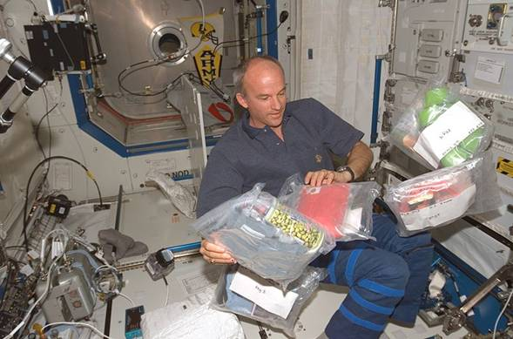
HACCP was conceived in the 1960s when the US National Aeronautics and Space Administration (NASA) asked Pillsbury to design and manufacture the first foods for space flights. The main goal was to produce food that would not crumble under zero gravity, but also be safe to eat. Since then, HACCP has been recognized internationally as a logical tool for adapting traditional inspection methods to a modern, science-based, food safety system. In 1994, the organization of International HACCP Alliance was established initially for the US meat and poultry industries to assist them with implementing HACCP and now its membership has been spread over other professional/industrial areas. This method, which in effect seeks to plan out unsafe practices, differs from traditional "produce and test" quality control methods which are less successful and inappropriate for highly perishable foods. HACCP expanded in all realms of the food industry, going into meat, poultry, seafood, dairy, and has spread now from the farm to the fork.
The HACCP Seven Principles

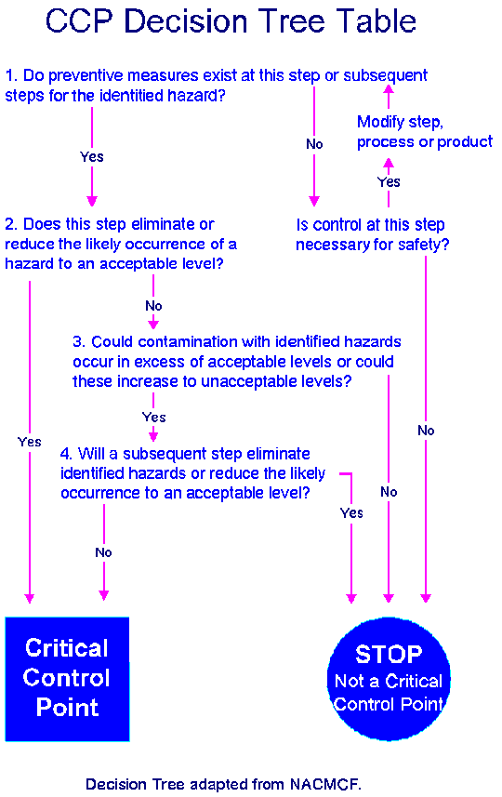
HACCP is a systematic approach to the identification, evaluation, and control of food safety hazards based on the following seven principles:
- Conduct a hazard analysis
- Identify Critical Control Points
- Establish critical limits for each critical control point
- Establish critical control point monitoring requirements
- Establish corrective actions
- Establish verification procedures
- Establish record-keeping and documentation procedures
Principle 1: Conduct a hazard analysis.
Plans determine the food safety hazards and identify the preventive measures the plan can apply to control these hazards. A food safety hazard is any biological, chemical, or physical property that may cause a food to be unsafe for human consumption. It is important to consider in the hazard analysis the ingredients and raw materials, each step in the process, product storage and distribution, and final preparation and use by the consumer.
Principle 2: Identify critical control points.
A Critical Control Point (CCP) is a point, step, or procedure in a food manufacturing process at which control can be applied and, as a result, a food safety hazard can be prevented, eliminated, or reduced to an acceptable level. Examples of CCPs may include: thermal processing, chilling, testing ingredients for chemical residues, product formulation control, and testing product for metal contaminants. Complete and accurate identification of CCPs is fundamental to controlling food safety hazards. One strategy to facilitate the identification of each CCP is the use of a CCP decision tree.
Principle 3: Establish critical limits for each critical control point.
A critical limit is the maximum or minimum value to which a physical, biological, or chemical hazard must be controlled at a critical control point to prevent, eliminate, or reduce to an acceptable level. A critical limit is used to distinguish between safe and unsafe operating conditions at a CCP. Critical limits may be based upon factors such as: temperature (microorganisms tend to grow best at temperatures between 41°F and 135°F), time, physical dimensions, humidity, moisture level, water activity (a_{w}), pH, titratable acidity, salt concentration, available chlorine, viscosity, preservatives, or sensory information such as aroma and visual appearance. FAT TOM, the six required conditions for foodborne pathogens to grow, can also be used as critical control points. These include food, acidity, time, oxygen, and moisture. (See section on FAT TOM for more details)
FAT TOM
Food | Temperature
Acidity | Oxygen
Time | Moisture

Principle 4: Establish critical control point monitoring requirements.
Monitoring is a planned sequence of observations or measurements to assess whether a CCP is under control and to produce an accurate record for future use in verification. Monitoring activities are necessary to ensure that the process is under control at each critical control point. In the United States, the FSIS (Food Safety and Inspection Service) is requiring that each monitoring procedure and its frequency be listed in the HACCP plan. All records and documents associated with CCP monitoring should be dated and signed or initialed by the person doing the monitoring.
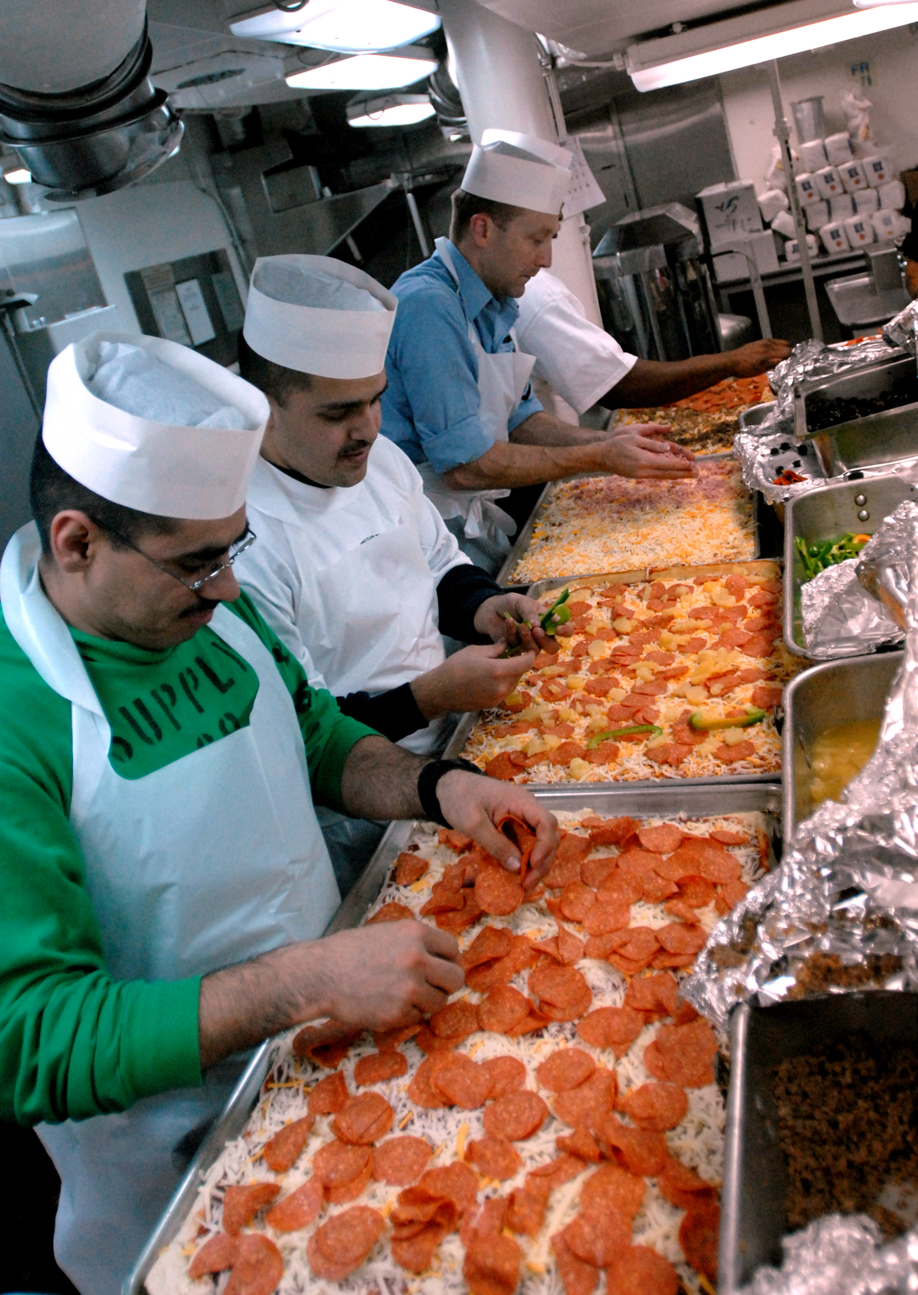
Principle 5: Establish corrective actions.
These are actions to be taken when monitoring indicates a deviation from an established critical limit. The final rule requires a plant's HACCP plan to identify the corrective actions to be taken if a critical limit is not met. Corrective actions are intended to ensure that no product hazardous or injurious to health reaches consumers.
Principle 6: Establish verification procedures.
Verification is defined as those activities, other than monitoring, that determine the validity of the HACCP plan and that the system is operating according to the plan. The HACCP regulation requires that all plants maintain certain documents, including its hazard analysis and written HACCP plan, and records documenting the monitoring of critical control points, critical limits, verification activities, and the handling of processing deviations. One aspect of verification is evaluating whether the facility's HACCP system is functioning according to the HACCP plan. Another important aspect of verification is the initial validation of the HACCP plan to determine that the plan is scientifically and technically sound, that all hazards have been identified and that if the HACCP plan is properly implemented these hazards will be effectively controlled. Validation ensures that the plants do what they were designed to do; that is, they are successful in ensuring the production of safe product.
Principle 7: Establish record-keeping and documentation procedures.
Generally, the records maintained for the HACCP System should include the following:
1. A summary of the hazard analysis, including the rationale for determining hazards and control measures.
2. The HACCP Plan
-Listing of the HACCP team and assigned responsibilities.
-Description of the food, its distribution, intended use, and consumer.
-Verified flow diagram.
-HACCP Plan Summary Table that includes information for:
-Steps in the process that are CCPs
-The hazard(s) of concern.
-Critical limits
-Monitoring*
-Corrective actions*
-Verification procedures and schedule*
-Record-keeping procedures*
* A brief summary of position responsible for performing the activity and the procedures and frequency should be provided
The following is an example of a HACCP plan summary table:
CCP | Hazards | Critical limit(s) | Monitoring | Corrective Actions | Verification | Records
3. Support documentation such as validation records.
4. Records that are generated during the operation of the plan.
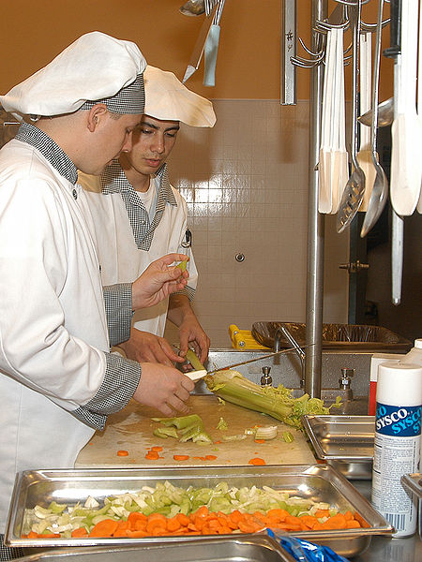
HACCP Implementation
The successful implementation of a HACCP plan is facilitated by commitment from top management. The next step is to establish a plan that describes the individuals responsible for developing, implementing and maintaining the HACCP system. Initially, the HACCP coordinator and team are selected and trained as necessary. The team is then responsible for developing the initial plan and coordinating its implementation. Product teams can be appointed to develop HACCP plans for specific products. An important aspect in developing these teams is to assure that they have appropriate training. The workers who will be responsible for monitoring need to be adequately trained. Upon completion of the HACCP plan, operator procedures, forms and procedures for monitoring and corrective action are developed. Implementation of the HACCP system involves the continual application of the monitoring, record-keeping, corrective action procedures and other activities as described in the HACCP plan.
Maintaining an effective HACCP system depends largely on regularly scheduled verification activities. The HACCP plan should be updated and revised as needed. An important aspect of maintaining the HACCP system is to assure that all individuals involved are properly trained so they understand their role and can effectively fulfill their responsibilities.
FAT TOM
FAT TOM is a mnemonic device that is used in the food service industry to describe the six favorable conditions required for the growth of foodborne pathogens. It is an acronym for food, acidity, time, temperature, oxygen and moisture. Foodborne pathogens will thrive if certain conditions are met within each of these.
- Food: there are several nutrients that promote the growth of microorganisms; however, protein rich foods (such as milk, eggs, fish, and meat) are some of the most susceptible.
- Acidity: foodborne pathogens require a slightly acidic pH level of 4.6-7.5, while they thrive in conditions with a pH of 6.6-7.5. FDA regulations for acid/acidified foods require that the food be brought to pH 4.5 or below.
- Time: food should be removed from the “danger zone” within two hours (some guidelines allow for four hours). This should be done by either heating or cooling the food.
- Temperature: pathogens thrive in temperatures that are between 70°F and 120°F. This is known as the temperature danger zone (TDZ).
- Oxygen: most pathogens require oxygen to grow. Some exceptions include clostridium botulinum, the source of botulism.
- Moisture: Water is essential for the growth foodborne pathogens, water activity (w_{a}) is a measure of the water available for use and is measured on a scale of 0 to 1.0. Foodborne pathogens grow best in foods that have a w_{a} between 1.0 and 0.86. FDA regulations for canned foods require w_{a} of 0.85 or below.
Definitions
- Botulism: a severe, sometimes fatal, food poisoning caused by a bacterium that enters the body through contaminated food.
- CCP Decision Tree: A sequence of questions to assist in determining whether a control point is a CCP.
- Control Measure: Any action or activity that can be used to prevent, eliminate or reduce a significant hazard.
- Control Point: Any step at which a hazard can be controlled.
- Corrective Action: Procedures followed when a deviation occurs.
- Critical Control Point: A step at which control can be applied and is essential to prevent or eliminate a food safety hazard or reduce it to an acceptable level.
- Critical Limit: A maximum and/or minimum value to which a biological, chemical or physical parameter must be controlled at a CCP to prevent, eliminate or reduce to an acceptable level the occurrence of a food safety hazard.
- E. coli: bacteria found in the lower intestine. Most E. coli strains are harmless, but some, such as serotype O157:H7, can cause serious food poisoning in humans
- FAT TOM: describes the six favorable conditions required for the growth of foodborne pathogens. It is an acronym for food, acidity, time, temperature, oxygen and moisture.
- Foodborne illness: any illness resulting from the consumption of contaminated food.
- HACCP: A systematic approach to the identification, evaluation, and control of food safety hazards.
- HACCP Plan: The written document which is based upon the principles of HACCP and which delineates the procedures to be followed.
- HACCP System: The result of the implementation of the HACCP Plan.
- HACCP Team: The group of people who are responsible for developing, implementing and maintaining the HACCP system.
- Hazard: A biological, chemical, or physical agent that is reasonably likely to cause illness or injury in the absence of its control.
- Hazard Analysis: The process of collecting and evaluating information on hazards associated with the food under consideration to decide which are significant and must be addressed in the HACCP plan.
- Monitoring: a planned sequence of observations or measurements to assess whether a CCP is under control and to produce an accurate record for future use in verification
- Pathogen: an infectious agent or germ
- Prerequisite Programs: Procedures, including Good Manufacturing Practices, that address operational conditions providing the foundation for the HACCP system.
- Salmonella: bacteria that causes illnesses in humans, such as typhoid fever, paratyphoid fever, and the foodborne illness salmonellosis.
- Step: A point, procedure, operation or stage in the food system from primary production to final consumption.
- Validation: That element of verification focused on collecting and evaluating scientific and technical information to determine if the HACCP plan, when properly implemented, will effectively control the hazards.
- Verification: Those activities, other than monitoring, that determine the validity of the HACCP plan and that the system is operating according to the plan.

Georgia Performance Standards
CA-ICA-2. Students will demonstrate and practice correct sanitation as it relates to healthy living and the modern commercial kitchen
k. Discuss the concept of HACCP and the flow of food in a variety of foodservice
establishments.
CA-CAI-2. Students will demonstrate and practice food sanitation and safety with food preparation and service.
e. Identify common allergens and major foodborne illnesses, their associated symptoms,
and methods of prevention.
h. Identify the factors that affect the growth of foodborne pathogens, FAT TOM, and
explain how time and temperature guidelines can reduce growth of microorganisms.
n. Identify the principles of HACCP and define the flow of food.
CA-CAII-6. Students will identify and apply practices required for menu planning and development, purchasing and receiving, cost control and analysis, and marketing functions in quality food service operations.
e. Describe HACCP critical control points managed by the purchasing and receiving functions.
AG-BAS-21: The student outlines important areas of agricultural processing and processing technology.
d. Describes safety and regulations that apply to processing.
License & Verification
Text is available under the Creative Commons Attribution-ShareAlike License; additional terms may apply. See Terms of Use for details. - http://creativecommons.org/licenses/by-sa/3.0/

Wikipedia® is a registered trademark of the Wikimedia Foundation, Inc., a non-profit organization.
This document, originally from Wikipedia, has been modified
and the information has been independently verified.

