Introduction to International Trade

Name: ________________ Date: _________
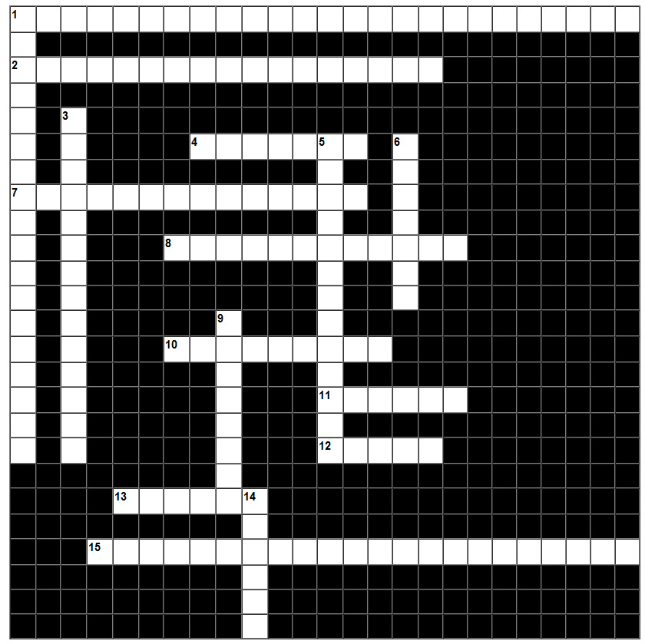

Across:
1. The international organization that oversees the global financial system by following the policies of its member countries.
2. Looks at how procedures and controls governing the movement of goods across national borders can be improved to reduce associated cost burdens and maximize efficiency while safeguarding regulatory objectives.
4. The partial or complete prohibition of commerce and trade with a particular country, in order to isolate it.
7. An economic term related to international economics in which trade is diverted from a more efficient exporter towards a less efficient one by the formation of a free trade agreement.
8. Any government policy or regulation that restricts international trade.
10. An international financial institution that provides leveraged loans to developing countries for capital programs.
11. Any good or service brought in from one country to another country for sale.
12. An agreement signed by the governments of the U.S., Canada, and Mexico creating a trilateral trade bloc in North America.
13. Any good or commodity transported from one country to another country, typically for use in trade.
15. An international organization designed by its founders to supervise and liberalize international trade.

Down:
1. The exchange of capital, goods, and services across international borders or territories.
3. The difference between the monetary value of exports and imports of output in an economy over a certain period.
5. An ongoing process by which regional economies, societies, and cultures have become integrated through a globe-spanning network of communication and trade.
6. A form of financial assistance paid to a business or economic sector.
9. When two or more nations raise or create tariffs or other trade barriers in retaliation for other trade barriers.
14. A tax levied on imported or exported goods.

