
TYPHOID MARY


Healthcare
To accompany the Georgia Healthcare Science Curriculum.
CTAE Resource Network, Instructional Resources Office, 2010
Georgia Performance Standards:
HS-IHS-10: The student will practice preventive health behaviors personally and professional with clients.
HS-IHS-11: The student will utilize the principles of infection control.
HS-GM-6. Students will understand and apply infection control guidelines including techniques for maintaining isolation.
HS-NE-3: The student will demonstrate behavior which maintains residents’/patients’ rights. Practice resident/patient/client privacy according to OBRA and HIPAA guidelines.
HS-NE-9: The student will describe and demonstrate infection control practices.
See the end of this document for complete GPS listing
Student Information Guide
Directions:
Use the information in this student information sheet to complete the accompanying student study sheet. Complete all items on the study sheet and turn in to the teacher.
 Mary Mallon
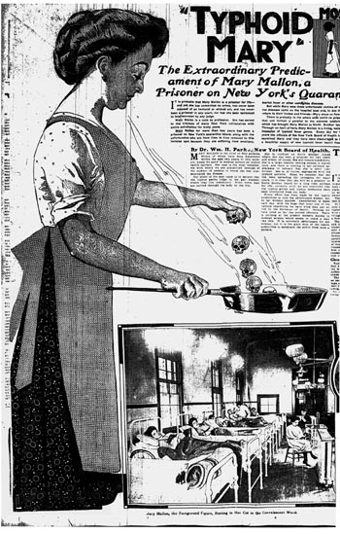
Mary Mallon (September 23, 1869 – November 11, 1938), also known as Typhoid Mary, was the first person in the United States to be identified as a healthy carrier of typhoid fever. Over the course of her career as a cook, she is known to have infected 53 people, three of whom died from the disease. Her notoriety is in part due to her vehement denial of her own role in spreading the disease, together with her refusal to cease working as a cook. She was forcibly quarantined twice by public health authorities and died in quarantine. It is possible that she was born with the disease, as her mother had typhoid fever during her pregnancy.

COOK
Mallon was born in 1869 in County Tyrone, Ireland (now Northern Ireland), and immigrated to the United States in 1884. She worked as a cook in the New York City area from 1900 to 1907. She had been working in a house in Mamaroneck, New York, for less than two weeks when the residents came down with typhoid. She moved to Manhattan in 1901, and members of the family for whom she worked developed fevers and diarrhea and the laundress died. She then went to work for a lawyer until seven of the eight household members developed typhoid; Mary spent months helping to care for the people she made sick, but her care further spread the disease through the household. In 1906, she took a position in Long Island; within two weeks, six out of eleven family members were hospitalized with typhoid. She changed employment again and three more households were infected.
People can catch typhoid fever after ingesting food or water that has been contaminated during handling by a human carrier. The human carrier is usually a healthy person who has survived a previous episode of typhoid fever but in whom the typhoid bacteria have been able to survive without causing further symptoms. Carriers continue to excrete the bacteria in their feces and urine. It takes vigorous scrubbing and thorough disinfection with soap and hot water to remove the bacteria from the hands.
When typhoid researcher George Soper approached Mallon with the news she was possibly spreading typhoid, she adamantly rejected his request for urine and stool samples to ascertain whether she was a typhoid carrier. Soper left and later published his findings in the June 15, 1907, issue of the Journal of the American Medical Association. On his next contact with her, he brought a doctor with him, but was turned away again. Mallon's denials that she was a carrier were based in part on the diagnosis of a reputable chemist who had found she was not harboring the bacteria. It is possible she was in temporary remission when tested. Moreover, when Soper first told her she was a carrier, the concept that a person could spread disease and remain healthy was not well known. What is more, Soper may have been somewhat tactless with her; class prejudice and prejudice towards the Irish were very strong, as was a lingering belief that dirty, slum-dwelling immigrants were a major cause of epidemics. During a later encounter in the hospital, he told Mary that he would write a book about her and give her all the royalties; she angrily rejected his proposal and locked herself in the lavatory until he left.

QUARANTINE
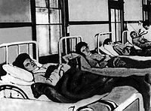
Mary Mallon (foreground) in a hospital bed during her first quarantine
The New York City Health Department sent Dr. Sara Josephine Baker to talk to Mary, but "by that time she was convinced that the law was wantonly persecuting her when she had done nothing wrong." A few days later, Baker arrived at Mary's place of work with several police officers and took her into custody. The New York City health inspector investigated and found her to be a carrier. Under powers granted by sections 1169 and 1170 of the Greater New York Charter, Mallon was held in isolation for three years at a hospital located on North Brother Island. Eventually, a new health commissioner decided that Mallon could be freed from quarantine if she agreed to no longer work as a cook and to take reasonable steps to prevent transmitting typhoid to others. Eager to regain her freedom, Mallon accepted these terms. On February 19, 1910, Mallon agreed that she "[was] prepared to change her occupation (that of cook), and would give assurance by affidavit that she would upon her release take such hygienic precautions as would protect those with whom she came in contact, from infection". She therefore was released from quarantine and returned to the mainland.
However, she had been given a job as a laundress, which paid lower wages than her previous occupation as a cook. Mallon concealed her true identity by adopting the pseudonym Mary Brown, returned to her previous occupation of cook, and in 1915 infected 25 people while working as one at New York's Sloane Hospital for Women; one of those infected died. Public-health authorities again tracked down and arrested Mary Mallon, returning her to quarantine on the island. Mallon was confined there for the rest of her life. She became something of a minor celebrity, and was interviewed by journalists, who were forbidden to accept as much as a glass of water from her. Later in life, she was allowed to work as a technician in the island's laboratory.

DEATH
Mallon spent the rest of her life in quarantine. Six years before her death, she was paralyzed by a stroke. On November 11, 1938, aged 69, she died of pneumonia. She was still infectious on the day of her death: an autopsy found evidence of live typhoid bacteria in her gallbladder. Her body was cremated; the ashes were buried at Saint Raymond's Cemetery in the Bronx.

LEGACY
Mallon's status as the first healthy typhoid carrier to be identified by medical science meant there was no pre-existing policy providing guidelines for handling the situation. Many of the problems surrounding her case stemmed from Mallon's own vehement denial that she was infected with typhoid. She refused to acknowledge any connection between her working as a cook and others' falling seriously ill, despite this scenario's repeated occurrence. Though presented with medical evidence of her infection, Mallon maintained that she was perfectly healthy, had never had typhoid fever, and therefore could not possibly be the culprit. Given Mallon's refusal to heed doctors' warnings that she was a typhoid carrier, her continual pursuit of employment in kitchens, the misery inflicted on her many victims, and her failure to comply with the conditions of her initial release from quarantine, public-health authorities determined that permanent quarantine was the only way to prevent Mallon from causing significant future typhoid outbreaks.
Other healthy typhoid carriers identified around the first quarter of the 20th century include Tony Labella, an Italian immigrant who caused more than 100 infections and five deaths; an Adirondack guide dubbed Typhoid John, who infected 36 people, causing two deaths; and Alphonse Cotils, a restaurant- and bakery-owner.
Today, Typhoid Mary is a generic term for a healthy carrier of a dangerous disease.
Typhoid Fever

Diagnosis
Diagnosis is made by any blood, bone marrow or stool cultures. Typhoid fever is rare in the U.S. today. Most cases reported are of people who have traveled recently to developing countries.

Treatment
Typhoid fever in most cases is not fatal. Antibiotics, such as ampicillin and Amoxicillin , have been commonly used to treat typhoid fever in developed countries. Prompt treatment of the disease with antibiotics reduces the case-fatality rate to approximately 1%.
When untreated, typhoid fever persists for three weeks to a month. Death occurs in between 10% and 30% of untreated case. In some communities, however, case-fatality rates may reach as high as 47%.

Prevention
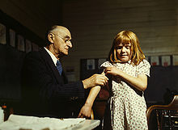
Doctor administering a typhoid vaccination at a school in San Augustine County, Texas
Sanitation and hygiene are the critical measures that can be taken to prevent typhoid. Typhoid does not affect animals and therefore transmission is only from human to human. Typhoid can only spread in environments where human feces or urine are able to come into contact with food or drinking water. Careful food preparation and washing of hands are crucial to preventing typhoid.
There are two vaccines currently recommended by the World Health Organization for the prevention of typhoid: these are the live, oral Ty21a vaccine (sold as Vivotif Berna) and the injectable Typhoid polysaccharide vaccine . Both are between 50% to 80% protective and are recommended for travelers to areas where typhoid is endemic.
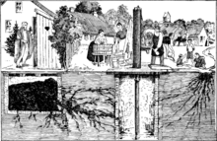
1939 conceptual illustration showing various ways that typhoid bacteria can contaminate a water well (center)

Transmission
Flying insects feeding on feces may occasionally transfer the bacteria through poor hygiene habits and public sanitation conditions. Public education campaigns encouraging people to wash their hands after defecating and before handling food are an important component in controlling spread of the disease. According to statistics from the United States Center for Disease Control, the chlorination of drinking water has led to dramatic decreases in the transmission of typhoid fever in the U.S.
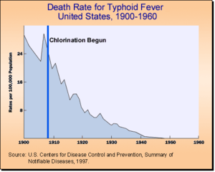
Death rates for typhoid fever in the U.S. 1906–1960
Many carriers of typhoid were locked into an isolation ward never to be released in order to prevent further typhoid cases. These people often deteriorated mentally, driven mad by the conditions they lived in.
Georgia Performance Standards
HS-IHS-10: The student will practice preventive health behaviors personally and professional with clients.
a. Distinguish between health and wellness and behaviors that promote each.
b. Explain the fundamentals of wellness and the prevention of disease processes.
c. Define OSHA, CDC, Clinical Laboratory Improvements Amendments (CLIA) and explain each agency’s role in healthcare practice.
d. Compare and contrast the different types of immunity.
HS-IHS-11: The student will utilize the principles of infection control.
a. Evaluate the need for asepsis in the health environment.
b. Differentiate between cleaning, disinfecting, and sterilizing.
c. Analyze ways microorganisms are spread using the chain of infection model and analyze methods to destroy or control the spread of pathogenic microorganisms.
d. Identify risk factors associated with nosocominal infections and evaluate their impact on client and employee health.
e. Define, demonstrate, and use standard precautions as described in the rules and regulations set forth by the Occupational Safety and Health Administration (OSHA).
f. Demonstrate medical aseptic technique included but not limited to: medical aseptic handwash, cleaning, disinfecting, (non-sterile) gloving and de-gloving.
HS-GM-6. Students will understand and apply infection control guidelines including techniques for maintaining isolation.
a. Demonstrate understanding of and practice standard precautions.
b. Demonstrate understanding of isolation techniques.
c. Describe risk and prevention of cross contamination.
d. Demonstrate sanitizing, disinfecting, and sterilizing techniques.
HS-NE-3: The student will demonstrate behavior which maintains residents’/patients’ rights. Practice resident/patient/client privacy according to OBRA and HIPAA guidelines.
b. Promote the resident’s/patients/client’s right to make personal choices to accommodate their needs.
HS-NE-9: The student will describe and demonstrate infection control practices.
a. Use correct medical aseptic hand washing techniques.
b. Use standard precautions when providing care.

c. Use isolation precautions correctly when providing care.
License & Verification
Text is available under the Creative Commons Attribution-ShareAlike License; additional terms may apply. See Terms of Use for details. - http://creativecommons.org/licenses/by-sa/3.0/
Wikipedia® is a registered trademark of the Wikimedia Foundation, Inc., a non-profit organization.
Website Sources: http://en.wikipedia.org/wiki/Mary_Mallon
http://en.wikipedia.org/wiki/Typhoid_fever


This document, originally from Wikipedia, has been modified
and the information has been independently verified.

