
THE HISTORY OF FASHION & DESIGN


Fashion Marketing
Marketing, Sales, and Service
To accompany the Georgia Fashion Marketing Curriculum.

CTAE Resource Network, Instructional Resources Office, 2010
Georgia Performance Standards:

MKT-FM-2 Students will explore the history of fashion.

a. Describe the influence of historical figures and events on fashion.

b. Describe the influence that economic, social, political, demographic, geographic, and psychological factors have had and currently have on fashion.

FCS-FPE-9 Students will analyze factors (social, psychological, economic, cultural) affecting textile and apparel decisions for individuals and families and how those decisions impact society.

FCS-CS-10 Students will investigate the history of the consumer movement.

Student Information Guide
Directions:
Use the information in this student information sheet to complete the accompanying student study guide. Complete all items on the study sheet and turn in to the teacher.

 Between the wars
The period between the two World Wars, often considered to be the Golden Age of French fashion, was one of great change and reformation. Carriages were replaced by cars, princes and princesses lost their crowns, and haute couture found new clients in the ranks of film actresses, American heiresses, and the wives and daughters of wealthy industrialists.
1920s
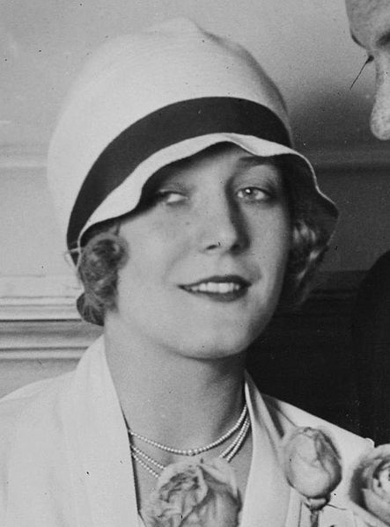
Soon after the First World War, a radical change came about in fashion. Fancy hairstyles gave way to short bobs, dresses with long trains gave way to above-the-knee pinafores. Corsets were abandoned and women borrowed their clothes from the male wardrobe and chose to dress like boys. Although, at first, many designers were reluctant to adopt the new androgynous style, they embraced them wholeheartedly from around 1925. A bustless, waistless silhouette emerged and aggressive dressing-down was mitigated by feather boas, embroidery, and showy accessories. The flapper style became very popular among young women. The cloche hat was widely-worn and sportswear became popular with both men and women during the decade
The 1920s was the decade in which fashion entered the modern era. It was the decade in which women first liberated themselves from constricting fashions and began to wear more comfortable clothes (such as short skirts or pants). Men likewise abandoned overly formal clothes and began to wear sport clothes for the first time. The suits which men wear today are still based, for the most part, on those which were worn by men in the late 1920s.
Cloche hat
The great couturier* Coco Chanel was a major figure in fashion at the time, as much for her magnetic personality as for her chic and progressive designs. Chanel helped popularize the bob hairstyle, the little black dress, and the use of jersey knit for women's clothing and also elevated the status of both costume jewelry and knitwear.
In menswear there was a growing mood of informality, among the Americans especially, which was mirrored in fashions that emphasized youthfulness and relaxation. In the past, there was a special outfit for every event in the well-dressed gentleman's day, but young men in the Twenties, no longer afraid to show their youthfulness, began to wear the same soft wool suit all day long. Short suit jackets replaced the old long jackets of the past which were now only worn for formal occasions. Men had a variety of sport clothes available to them, including sweaters and short pants, commonly known as knickers. For evening wear a short tuxedo was more fashionable than the tail-coat, which was now seen as somewhat old-fashioned. The London cut, with its slim lines, loose-fitting sleeves, and padded shoulders, perfected by the English tailor Scholte, was very popular.
The lighthearted, forward-looking fashions of the 1920s gradually came to halt after the Wall Street Crash of 1929, and succumbed to a more conservative style.
* A couturier is a person involved in the clothing fashion industry who makes original garments to order for private clients. A couturier may make what is known as haute couture. He or she usually hires patternmakers and machinists for garment production, and is either employed by exclusive boutiques or is self-employed.
1930s

In the 1930s, as the public began to feel the effects of the Great Depression, many designers found that crises are not the time for experimentation. Fashion became more compromising, aspiring to preserve feminism's victories while rediscovering a subtle and reassuring elegance and sophistication. Women's fashions moved away from the brash, daring style of the Twenties towards a more romantic, feminine silhouette. The waist was restored to its proper position, hemlines dropped, there was renewed appreciation of the bust, and backless evening gowns and soft, slim-fitting day dresses became popular. The female body was remodeled to a more neoclassical shape and slim, toned, and athletic bodies came into vogue. The fashion for outdoor activities stimulated couturiers to manufacture what would nowadays be called sportswear. The term 'ready-to-wear' was not yet widely used, but the boutiques already described such clothes as being 'for sport'.
Two of the most prominent and influential fashion designers of the 1930s were Elsa Schiaparelli and Madeleine Vionnet. Elsa Schiaparelli showed her first collection in 1929 and was immediately hailed by the press as 'one of the rare innovators' of the day. With her exciting and inventive designs, Schiaparelli did not so much revolutionize fashion as shatter its foundations. She consistently turned out breathtaking collections thereafter.
Toward the end of the decade, women's fashions took on a somewhat more imposing and broad-shouldered silhouette, possibly influenced by Elsa Schiaparelli. Men's fashions continued the informal, practical trend that had dominated since the end of the First World War.
Mid-twentieth century

The Second World War created many radical changes in the fashion industry. After the War, Paris's reputation as the global center of fashion began to crumble and off-the-peg and mass-manufactured fashions became increasingly popular. A new youth style emerged in the Fifties, changing the focus of fashion forever. As the installation of central heating became more widespread the age of minimum-care garments began and lighter textiles and, eventually, synthetics, were introduced.
1940s

Many fashion houses closed during occupation of Paris during World War II, including the Maison Vionnet and the Maison Chanel. Several designers permanently relocated to New York. In contrast to the stylish, liberated Parisian, the Vichy regime promoted the model of the wife and mother, the robust, athletic young woman, a figure who was much more in line with the new political criteria.
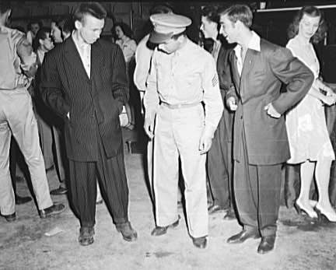
Due to the difficult times, the number of models in shows was limited to seventy-five, evening wear was shortened and day wear was much skimpier, made from substitute materials whenever possible. From 1940 onward, no more than four meters (thirteen feet) of cloth was permitted to be used for a coat and a little over one meter (three feet) was all that allowed for a blouse. No belt could be over 3 centimeters (one and a half inches) wide.
During the Second World War, Vera Maxwell presented co-ordinates in plain, simply cut outfits and also introduced innovations to men's work clothes. Among young men in the War Years the zoot suit became popular.
The couturier Christian Dior created a tidal wave with his first collection in February 1947. The collection contained dresses with tiny waists, majestic busts, and full skirts swelling out beneath small bodices, in a manner very similar to the style of the Belle Époque. The extravagant use of fabric and the feminine elegance of the designs appealed greatly to a post-war clientèle and ensured Dior's swift rise to fame. The sheer sophistication of the style incited the all-powerful editor of the American Harper's Bazaar, Carmel Snow, to exclaim 'This is a new look!'.
Zoot suit
1950s

Fashion in the 1950s, far from being revolutionary and progressive, bore strong nostalgic echoes of the past. Despite the fact that women had the right to vote, to work, and to drive their own cars, they chose to wear dresses made of opulent materials, with corseted waists and swirling skirts to mid-calf.
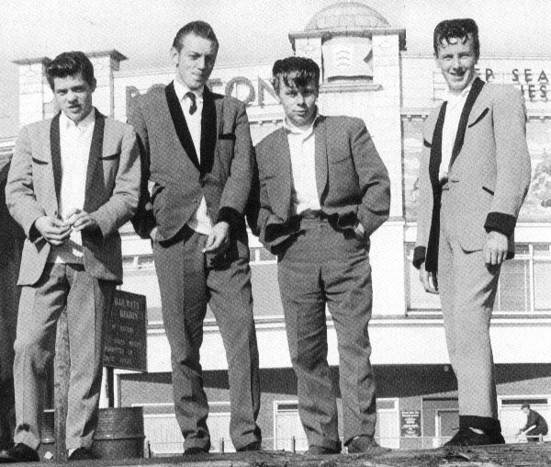
After the war, the American look (which consisted of broad shoulders, floral ties, straight-legged pants, and shirts with long pointed collars, often worn hanging out rather than tucked in) became very popular among men in Europe. Certain London manufacturers ushered in a revival of Edwardian elegance in men's fashion, adopting a tight-fitting retro style that was intended to appeal to traditionalists. This look, originally aimed at the respectable young man about town, was translated into popular fashion as the Teddy boy style.
The designers of Hollywood created a particular type of glamour for the stars of American film, and outfits worn by the likes of Marilyn Monroe, Lauren Bacall, or Grace Kelly were widely copied. Without even trying to keep track of all the Paris styles, its costume designers focused on their own version of classicism, which was meant to be timeless, flattering, and photogenic. Using apparently luxurious materials, such as sequins, chiffon, and fur, the clothes were very simply cut, often including some memorable detail, such as a low-cut back to a dress which was only revealed when the actress turned her back from the camera or some particularly stunning accessory. The most influential and respected designers of Hollywood from the 1930s to the 1950s were Edith Head, Orry-Kelly, William Travilla, Jean Louis, Travis Banton, and Gilbert Adrian.
Teddy boy style
By the end of the decade mass-manufactured, off-the-peg clothing had become much more popular than in the past, granting the general public unprecedented access to fashionable styles.
1960s

Until the 1960s, Paris was considered to be the center of fashion throughout the world. However, between 1960 and 1969 a radical shake-up occurred in the fundamental structure of fashion. From the 1960s onward, there would never be just one single, prevailing trend or fashion but a great plethora of possibilities, indivisibly linked to all the various influences in other areas of people's lives. Young people, with a power and culture that were all their own, now at an age to speak out, were a force to be reckoned with and had a powerful impact on the fashion industry. For perhaps the first time in history, there was an independent youth fashion that was not based on the conventions of an older age group. In the past, failure to follow fashion merely meant that you were poor, but in the Sixties it became just as much a statement of personal freedom.
In stark contrast to their mature, ultra-feminine mothers, the women of the 1960s adopted a girlish, childlike style, with short skirts and straightened curves, reminiscent of the look of the 1920s. At the start of the decade skirts were knee-length, but steadily became shorter and shorter until the mini-skirt emerged in 1965. By the end of the decade they had shot well above the stocking top, making the transition to tights inevitable.
The basic shape and style of the time was simple, neat, clean cut, and young. Synthetic fabrics were very widely-used during the Sixties. They took dyes easily and well, giving rise to colors that were both clear and bright, very much mirroring the mood of the period. Hats suffered a great decline and by the end of the decade they were relegated to special occasions only. Lower kitten heels were a pretty substitute to stilettos. Pointed toes gave way to chisel shaped toes in 1961 and to an almond toe in 1963. Flat boots also became popular with very short dresses in 1965 and eventually they rose up the leg and reached the knee.
The principal change in menswear in the '60s was in the weight of the fabric used. The choice of materials and the method of manufacture produced a suit that, because it was lighter in weight, had a totally different look, with a line that was closer to the natural shape of the body, causing men to look at their figures more critically. The spread of jeans served to accelerate a radical change in the male wardrobe. Young men grew their hair down to their collars and added a touch of color, and even floral motifs, to their shirts. The polo neck never succeeded in replacing the tie, but the adoption of the workman's jacket in rough corduroy, and especially the Mao jacket proved to be more than simply a political statement. A few futuristic rumblings were set off by Pierre Cardin and Andre Courrèges, but the three-piece suit still survived intact.
Early in the decade, culottes were in style and the bikini finally came into fashion in 1963. The hippie and psychedelic movements late in the decade also had a strong influence on clothing styles, including bell-bottom jeans, tie-dye and batik fabrics, as well as paisley prints.
1970s

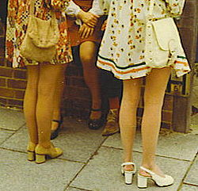
Nick-named the 'me' decade; 'please yourself' was the catchword of the 1970s. Some saw it as the end of good taste, while many perceived it as the beginning of awesome taste. The decade began with a continuation of the hippie look of the late 1960s, with afghans, Indian scarves, and flower-print tunics. Jeans remained frayed, tie dye was still popular, and the fashion for unisex mushroomed. An immense movement claiming civil rights for blacks combined with the influence of soul music from the USA created a nostalgia for Africa and African culture. A radical chic emerged, influenced by the likes of James Brown, Diana Ross, Angela Davis, and the Black Panthers, in everything from afro hairstyles to platform soles. During the Seventies, brands greatly increased their share of the international market. Hems began dropping in 1974 to below the knee, until finally reaching the lower mid calf in 1977 and shoulder lines were dropped.
In the United States, the general trend in fashion was towards simplification and longer skirts, although many women reacted negatively to the mid-length, which they felt to be aging. Pants, on the other hand, earned unanimous approval. Jeans profited most from becoming an accepted part of the American fashion scene in the 1970s, their new-found respectability deriving from their inclusion in collections under the heading of sportswear. The new stars of American ready-to-wear adapted the best of what they learned from Europe to the massive American clothing industry. Calvin Klein and Ralph Lauren rose from anonymity more or less simultaneously to tackle the question of designing clothes for the men and women of a new world. Two opposing movements dominated fashion in the U.S.A. during the Seventies. On one hand, there was the tailored, unisex look; on the other hand, a fluid, unstructured style with a strong feeling of Thirties glamour.
Fashionable skirt styles of 1972
In popular fashion the glam rock style of clothing, worn by such rock performers as David Bowie and Marc Bolan, was very influential, particularly in the United Kingdom. The designer Elio Fiorucci had a very similar look. His boutique in Milan sold such things as brightly colored rubber boots, plastic daisy sandals, fake fur, and Pop Art-inspired jackets.
Men's appearance changed more in the Seventies than it had done in a whole century. Popular styles were narrow shoulders, tight-fitting lines, no tie, no interfacing, zip-up boiler suits, waisted jackets or tunics, and sometimes no shirt. Work clothes supplied inspiration for a less formal style, encouraging designers to look beyond the traditional suit and, for example, adopt a unisex look or investigate the massive supply of second-hand clothes.
Late twentieth century

During the late twentieth century, fashions began to criss-cross international boundaries with rapidity. Popular Western styles were adopted all over the world, and many designers from outside of the West had a profound impact on fashion. Synthetic materials such as Lycra, Spandex, and viscose became widely-used, and fashion, after two decades of looking to the future, once again turned to the past for inspiration.
1980s

The society of the Eighties no longer criticized itself as consumerist, but was, instead, interested in 'the spectacle'. The self-conscious image of the decade was very good for the fashion industry, which had never been quite so à la mode. Fashion shows were transfigured into media-saturated spectaculars and frequently televised, taking high priority in the social calendar.
Known for his awe-inspiring combinations, Azzedine Alaia greatly influenced the silhouette of the woman of the Eighties. The master of all kinds of techniques that had previously been known only to haute couture, he experimented with many new and underused materials, such as Lycra and viscose. The finish, simplicity, and sheer sexiness of Alaia's look made women of every generation identify with his seductive style, and during the 1980s he achieved a certain glory and was held in high regard by members of his own profession.
In 1971 Ralph Lauren opened a boutique for both men and women in Beverly Hills. His aristocratic style at prices the average American could afford created a sensation. For an elite faced with all kinds of avant-garde fashions, it represented a rallying point, endorsing a classic look that had been adopted for an active life. The number one of American ready-to-wear, Lauren was equally successful with his sportswear and jeans, which allowed him to reach the widest possible range of social classes and age groups.
Norma Kamali, with her short skirts made of sweatshirting, leotards, headbands, and leg warmers, made jogging look fashionable. Kamali also created the popular 'rah-rah skirt'. Also notable is the extreme popularity of the Adidas sports label, which achieved an incredible level of ‘street cred’ in the '80s, inciting the hip hop group Run DMC to release the single 'My Adidas' in 1986. The multiplicity of trends that bloomed during the 80s were curtailed by the economic recession that set in at the beginning of the 1990s. The 1990s opened our eyes to a fresh look.
1990s

Fashion in the '90s united around a new standard, minimalism, and styles of stark simplicity became the vogue. Despite the best efforts of a few designers to keep the flag for pretty dresses flying, by the end of the decade the notion of ostentatious finery had virtually disappeared. As well as the styling of the product, its promotion in the media became crucial to its success and image. The financial pressures of the decade had a devastating effect on the development of new talent and lessened the autonomy enjoyed by more established designers.
Fashion at the end of the 20th century tackled themes that fashion had not previously embraced. There was a dramatic move away from the sexy styles aimed at the glamorous femme fatale of the Eighties and many designers, taken with a vision of romantic poverty, adopted the style of the poverty-stricken waif, dressed in a stark, perversely sober palette, with a face devoid of make-up. Clothes by ready-to-wear retailers such as The Gap, Banana Republic, and Eddie Bauer came to the forefront of fashion, managing to tap into the needs of women who simply wanted comfortable, wearable clothes. Retro clothing inspired by the 1960s and 1970s was popular for much of the 1990s.
In America, three of the most influential fashion designers of the time were Michael Kors, Marc Jacobs, and Calvin Klein. Michael Kors set up his own business in 1980. However, it was not until the Nineties that the designer reached the peak of his popularity. His knowledge and consciousness of trends enabled him to produce simple well-cut garments, whose sophistication and elegance appealed to a whole new breed of wealthy American customers. One of the first fashion designers to anticipate the globalization of world markets, the already well-known designer Calvin Klein started to market his fashions, perfumes, and accessories not only right across the US, but also in Europe and Asia, achieving an unequaled success. A brilliant artistic director, Klein used carefully constructed advertisements containing images tinted with eroticism to promote his sophisticatedly functional mass-produced designs, which won massive popularity among the urban youth of the 1990s.
Music was a prominent influence on popular and street fashion during the early- and mid-Nineties. Followers of hip hop adopted huge baggy jeans, similar to those worn in American prisons, with big patterned shirts and heavy black shoes. The sports label Nike had great popularity and materials such as Lycra and Spandex were increasingly used for sportswear. Increasing eco-awareness and animal rights made even top couture houses such as Chanel introduce fake fur and natural fibers into their collections.
2000s

The 2000s are often described as a "mash-up" decade. For the most part, the decade did not have one particular style like the decades from the '40s to '80s, but rather a recycling of styles from past decades, which was common in 1990s fashion. Many 1990s styles continued into the 2000s, but became more polished. The minimalist aesthetic of 1990s fashion continued in the first years of the decade, but fashion moved away from minimalism from 2003 onwards. But on a less mainstream note, the 2000s still shared the minimalistic "anything goes" mentality.
In women's fashion, dressy, feminine styles were reintroduced over the course of the decade, as women's fashion moved away from the more unisex styles of the 1990s. Dresses and skirts were increasingly popular, especially in the second half of the decade. Youth fashion was strongly influenced by many youth subcultures such as Emo, Scene, Preppy, Skater and Hip-Hop.
For many of the own-label designers who emerged in the early years of the twenty-first century, financial factors became increasingly critical. Many new young talents found they now depended on investors (to whom, in extreme cases, they would even surrender their names) and were always burdened by the risk that their partners, motivated by market realism and the desire for quick returns, would severely restrict their autonomy.
Leggings returned as a women's fashion item in 2005. Leggings rose in popularity in 2007 after introduction by brands such as American Apparel. Initially available mostly in black and grey, leggings gradually became available again in a wide variety of colors. These were often worn with long, fitted tunic tops, or baby-doll dresses and shirts with empire waists. As in the 1980s, they were sometimes paired with mini skirts.

License & Verification
Text is available under the Creative Commons Attribution-ShareAlike License; additional terms may apply. See Terms of Use for details. - http://creativecommons.org/licenses/by-sa/3.0/

Wikipedia® is a registered trademark of the Wikimedia Foundation, Inc., a non-profit organization.
This document, originally from Wikipedia, has been modified
and the information has been independently verified.

