Action Buttons
You can easily make a PowerPoint presentation interactive by adding Action Buttons.

To add Action buttons to a presentation:
- Pull down the Slide Show menu
- Choose Action buttons
- Choose a button from the fly out menu

- The mouse pointer changes to a black cross.
- Move the mouse pointer where you want the button and click and drag the mouse to draw the button
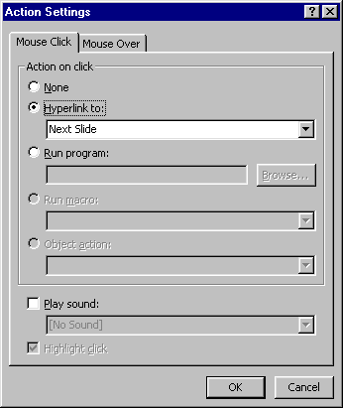
Tip:
You can use graphics (pictures) as action buttons:
- Insert the graphic
- Right-click on the graphic and choose Action Settings
- Choose Hyperlink to:
- Choose an option
- Click on OK
- Choose the desired Action Setting and click on OK.

