How to Make a Screen Shot

You can “snap” a picture of what’s currently displayed on your monitor to use as a graphic in your document. If you have more than 1 document open, the active window will be the portion of the screen you capture. (The active window has a dark blue title bar, while the title bars of other windows have dimmed title bars. The active window is usually the one on top.)
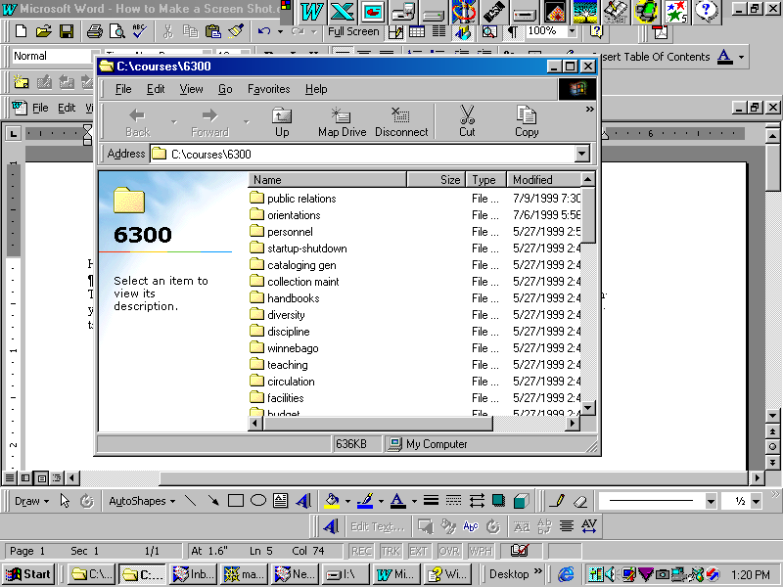
Title bars
Active window
Steps to get your screen shot:
- Open the document to receive your screen shot, such as a Word document or a PowerPoint slide.
- Manipulate the view on your monitor until it’s the shot you want to capture.
- Find the “Print Screen” key on your keyboard. Push it. This causes the monitor picture to be captured as a graphic on your computer’s “Clipboard.”
- Switch back to your document. Position the cursor where you want the picture to appear.
- Choose Edit/Paste OR right click and choose the Paste option.
- Your screen shot should appear in the document.
- Depending on the program, you can edit the screen shot to a certain extent. If you click on the picture, a border appears around the graphic, signifying that the picture is ready to be edited. You should be able to resize and re-position the graphic.

