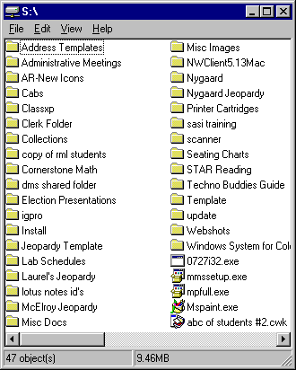
To get to the Template to set up your game:

- Go to Shared Drive
- Look for Jeopardy Template Folder
- Open Jeopardy Template folder
- Open game1.ppt

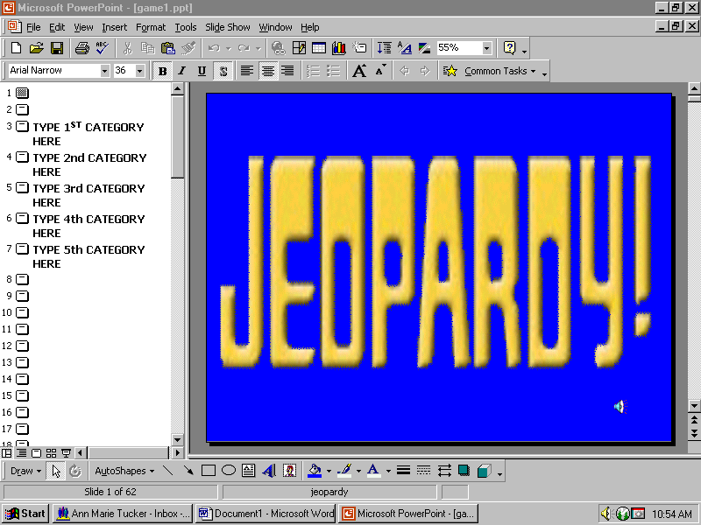
Your screen should now look like this:
You are now ready to start putting in your information. I suggest printing out the whole game so you can become familiar with the layout.

Slide 1: Do not change or edit this slide
Slide 2: Do not change or edit this slide
Slides 3-7: Type in the name of each category {one per each slide}
Slide 8: Click inside “Type in Cat 1” box. Type in the name of your category here.
Repeat this step for each of the other four categories
You can get to each slide by clicking on the number or by paging down
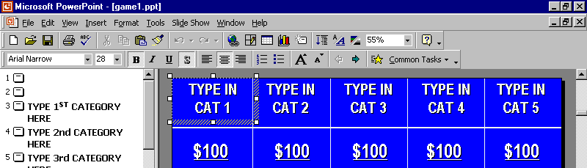

Slide 9: Here is where you start putting in your Answers {for them to give you question}

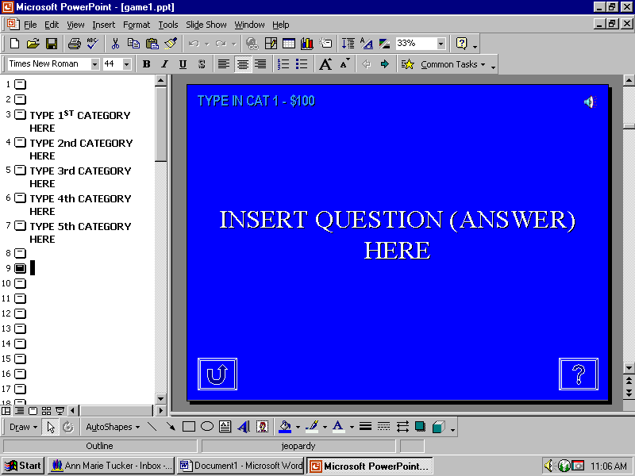
Make sure you click in here & put in the name of your category
Click in here to put in your information

Slides 10-12: Repeat steps followed in Slide 9
Slide 13: Do not change or edit this slide
Slide 14: Repeat steps followed in Slide 9 LOOK BELOW!

DO NOT EDIT
THIS
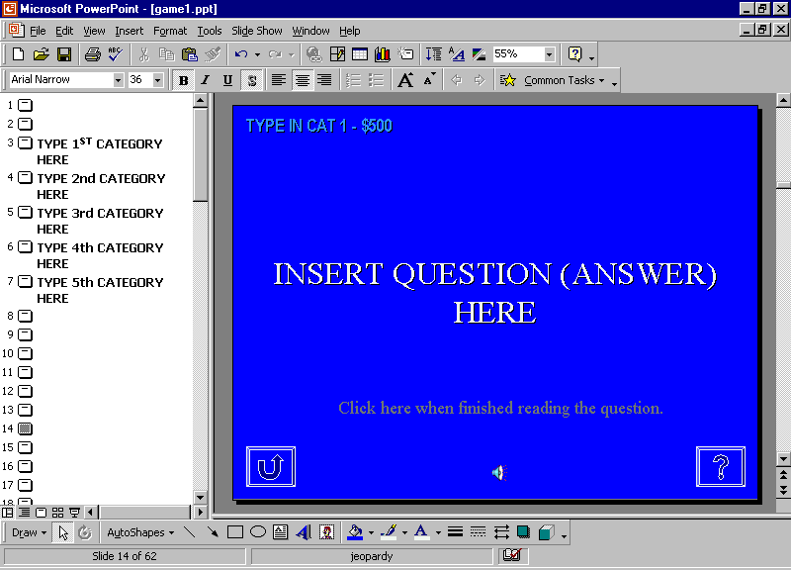

DO NOT TYPE
IN HERE

Slides 15-29: Repeat steps followed in Slide 9
Slide 30: Do not change or edit this slide
Slide 31: Repeat steps followed on slide 14
Slides 32-35: Repeat steps followed in Slide 9
Slides 36-60: Repeat steps followed in Slide 9 – BUT WITH THE ANSWERS {Question you want asked}
Slides 61-62: Do not change or edit these slides

You are now ready to save. Go to File, Save As, use your personal {H:\} directory, name the file & Save.

You should print out your entire game and couple the questions & answers to make sure that the categories match and that the answer {question} is correct.
To play the game:

Once you have set up your answers and questions, named your categories and double-checked yourself, you are ready to view your game for playing.

- Go back to Slide 1 & click on it.
- Go to Menu Bar, Slide Show, then View Show
- Jeopardy music should start {mouse click at any time}
- Alex voice will sound and game board will show without Category names
- Mouse click – 1st Category will show, continue mouse clicks through all five categories
- Now you should be looking at your game board with the category names on it. You are ready to begin playing.

  - Once the kids have picked the Category and $ amount – all you do is click on that box.
  - You will automatically be sent to that question {answer}.
  - There is an automatic BUZZER that sounds when their time is up for answering the question.
  - If they answer {in the form of a question} and you want to view the answer {question} – click on the arrow pointing to the right at the bottom right hand corner of slide.



Click here
This will automatically take you to the answer {question}. After you have viewed this screen you need to click on the little House {home} at the bottom right hand corner of the screen. This will take you back to the game board {HOME}.

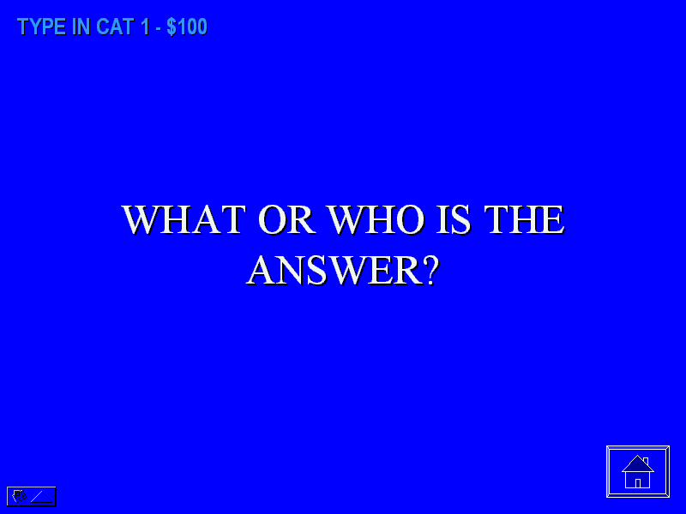

Click here

If you do not have your cursor over the house and you click, you will go to the next slide in the “presentation”. You don’t want to do that.

Now, just as in the television game, you will have two Daily Doubles. The Daily Double will pop up and Alex will say “Answer – Daily Double” & a Daily Double screen will appear. {look below}



Click here

When you get this screen – BE SURE TO CLICK ON THE ARROW AT THE BOTTOM RIGHT HAND CORNER TO GET TO THE CORRECT SLIDE! THIS IS VERY IMPORTANT!

Once you have clicked on that arrow – the question {answer} will appear.

After you read the question {answer}, be sure to click on the sentence that reads, “Click here after the question is read”. This is important – it plays the jeopardy music and gives them a little more time to answer the question.

Click here

After the music ends or they answer the question {answer}, you can go to the answer {question} by clicking on the Question mark at the bottom right corner. Then the answer {question} will come up – then click on the House to back to the game board.

Follow these same steps until all questions have been completed.

Helpful Hints when playing:

Laurel Kinsey & Kim McElroy have used this game for two totally different subjects. Laurel used it for Health and Kim for Algebra. This game can be adapted for any subject.

- Laurel had 4 groups and 4 different “ringers” for each group to “ring in” if the group answering the question did not get it correct. Worked very well.

Laurel tried two different ways when scoring the points:

- She did not take points away for any wrong answers. More noise, less control.
- Subtracted points for any wrong answer, from any group. Kids seemed to put more serious thought into the answers. Rang in only when pretty sure of answer. This came across more like the actual game.

  - Laurel had points showing on the board so kids could see what they would “wager” when it came to Daily Doubles.

- Laurel used a Scan It for viewing with the class. It was sufficient {you could not see complete board} – the projector from the Media Center would have a greater impact.

Helpful Hints when setting up:

- Feel free to ask Ann Marie to help you with any part of setting this up.
- It works just like a PowerPoint presentation.
- Make sure you try not to move slides around.
- If you are out of sequence – call Ann Marie to help you fix – you don’t need to start over.

