Are you smarter than a 5th grader?

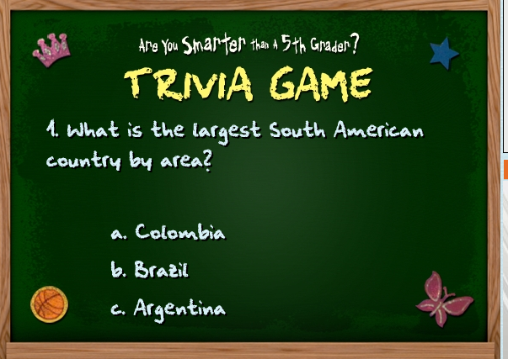
Purpose:
To create a quiz of facts that a 5th grade student would learn that demonstrates your ability to hyperlink in presentation software

Instructions:
You have been hired to create a game to see if high school students are smarter than the typical questions learned in 5th grade. If you have never played this game before, refer to the site… http://www.fox.com/areyousmarter/features/index.htm

You should create 10 questions that fall within the following topics: simple math, basic science, governmental social studies, US Presidents, maps, grammar and punctuation rules, and school based facts you think a 5th grade student would learn. All material should be school appropriate.

Using PowerPoint create a 10 question true/false or multiple choice interactive quiz.
- Include a title slide, direction slide, game board slide, 10 slides that are linked to answer choices, and have the option to go to the next question.
- To format the game follow these guidelines:
  - After a correct answer, contestants should be linked back to game board to select next question. If answer is wrong, game is over.
  - You should have a choice on every question to PEEK, COPY, or DROPOUT. Each of these words should be linked to a slide that has directions on what each choice means! Refer to online game instructions for games rules!
  - When question 10 is answered correctly, you should have a slide that looks like a certificate for 5th Grade HONOR ROLL and has a place for the participate to hand write their name. Provide instructions for the winner to print their certificate for the HONOR ROLL.
- Your game should have a theme of school throughout the presentation.
- Save your work are you smarter than a 5th grader.
- Be prepared to show your presentation to the class and have a classmate play your game! You should print only slides 1 and 2. These slides should be your title slide that includes your name and your direction slide.

Sample questions:

What month is Columbus Day? Who was the first president impeached? What is a pronoun?

Are you smarter than a 5th grader? Question Research
Question 1: Topic: Geography _______________________________________________________________

A. ____________________________________________
B. ____________________________________________
C. ____________________________________________
D. ____________________________________________
Resource: _______________________________________________________

Question 2: Topic: Math _______________________________________________________________

A. ____________________________________________
B. ____________________________________________
C. ____________________________________________
D. ____________________________________________
Resource: _______________________________________________________

Question 3: Topic: Science _______________________________________________________________

A. ____________________________________________
B. ____________________________________________
C. ____________________________________________
D. ____________________________________________
Resource: _______________________________________________________

Question 4: Topic: US Government/Social Studies _______________________________________________________________

A. ____________________________________________
B. ____________________________________________
C. ____________________________________________
D. ____________________________________________
Resource: _______________________________________________________

Question 5: Topic: US Presidents _______________________________________________________________

A. ____________________________________________
B. ____________________________________________
C. ____________________________________________
D. ____________________________________________
Resource: _______________________________________________________

Question 6: Topic: Grammar/Punctuation _______________________________________________________________

A. ____________________________________________
B. ____________________________________________
C. ____________________________________________
D. ____________________________________________
Resource: _______________________________________________________

Question 7: Topic: Poetry/Novels/Reading _______________________________________________________________

A. ____________________________________________
B. ____________________________________________
C. ____________________________________________
D. ____________________________________________
Resource: _______________________________________________________

Question 8: Topic: Music _______________________________________________________________

A. ____________________________________________
B. ____________________________________________
C. ____________________________________________
D. ____________________________________________
Resource: _______________________________________________________

Question 9: Topic: Computer/Technology _______________________________________________________________

A. ____________________________________________
B. ____________________________________________
C. ____________________________________________
D. ____________________________________________
Resource: _______________________________________________________
Question 10: Topic: Physical Education/Health _______________________________________________________________

A. ____________________________________________
B. ____________________________________________
C. ____________________________________________
D. ____________________________________________
Resource: _______________________________________________________

