Creating Mouseover Effects
- Start with two slides: one “before” the mouseover effect and one “after.” | 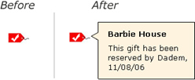

- On the “before” slide, right-click on the item that will trigger the mouseover effect, and select “Action Settings…” | 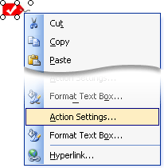

- In the Action Settings dialog, click on the “Mouse Over” tab.  - Select the “Hyperlink to” radio button.  - Choose “Slide…” from the drop-down menu. | 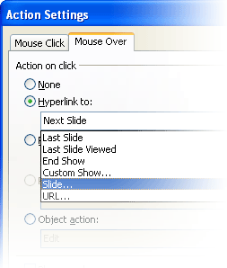

- second dialog box will let you select the “After” slide. | 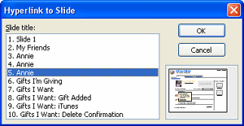

Now, in slide show view, mousing over the item you selected will switch to the target slide: the one that shows the “after” mouseover effect.
Hint: There’s no “mouse out” effect in PowerPoint. The best way I’ve found to simulate it is a bit clunky, but it gets the job done:
- On the “After” slide, draw some boxes around the item you want to apply the mouse-out effect to.
- Apply a mouseover action to the boxes around the object. (For example, if you want to return to the previous slide when you mouse off an item, give the boxes around the item a mouseover effect that returns to the previous slide.)
- Make the surrounding boxes transparent.
Mouseover behaviors can get out of control quickly in PowerPoint. This is partly because creating the mouse-out behavior is awkward, and partly because you need to create “after” screens for each individual mouseover effect. PowerPoint can help you try out a mouseover behavior (e.g., wire up a single example), but for prototypes with lots of dynamic effects—or many instances of the same effect—you’re probably better off with another tool.

