Cut these strips and give one to each student. While you give oral instructions the student will follow the instructions. The catch is that they should do literally what you say rather than make any inferences.

- For the first box, instructions are to put a dot on the “I”. Answer: on “I” itself not above the “I”.
- For the second box, instructions are to write the word “Xerox” in the spaces. Answer: not on the lines but in the spaces between the lines.
- For the third box, instructions are: A baby bull is trapped and can’t get over the fence. Who will he call to help him? Papa Bull or Mama Bull. Answer: Papa Bull because there is no Mama Bull because Bull is not female.
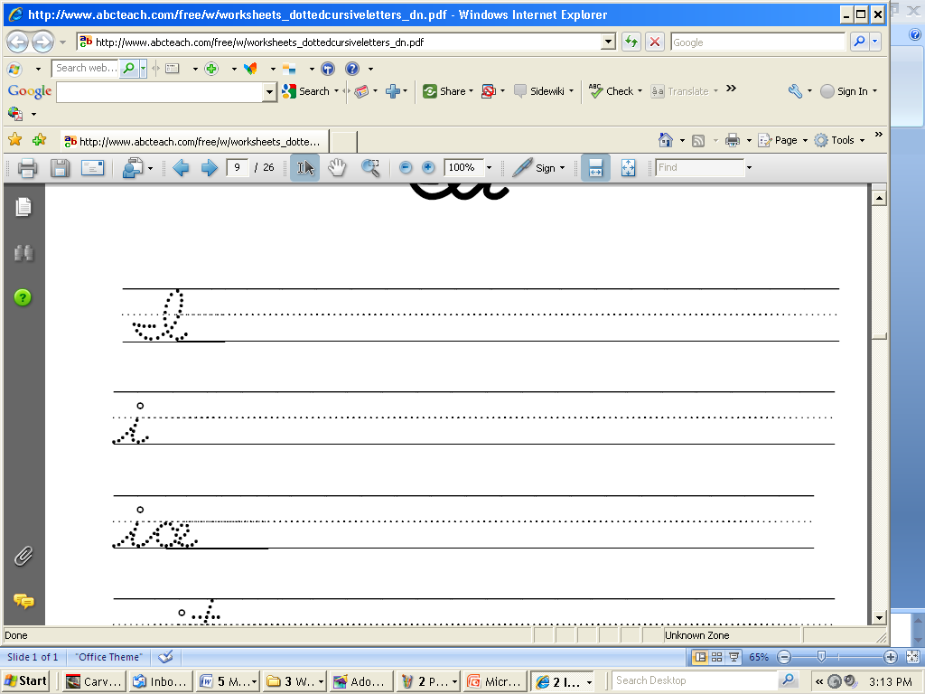

___ ___ ___ ___ ___

PB MB BB

___ ___ ___ ___ ___

PB MB BB

___ ___ ___ ___ ___

PB MB BB

