
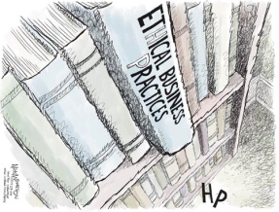

Business Ethics Presentation

Content | Not Demonstrated | Does Not Meet Expectations | Meets Expectations | Exceeds Expectations | Points Earned
Situation is clearly stated and defined | 0 | 1-5 | 6-10 | 11-15
Ethical dimensions (problems) are clearly defined | 0 | 1-5 | 6-10 | 11-15
Team’s position is clearly stated | 0 | 1-5 | 6-10 | 11-15
Effective ethical solution(s) offered | 0 | 1-5 | 6-10 | 11-15
Thoughts and statements are well-organized; appropriate business language used. | 0 | 1-5 | 6-10 | 11-15
Team members demonstrate self-confidence, poise, and good voice projection | 0 | 1-5 | 6-10 | 11-15
All team members actively participated in the presentation | 0 | 1-5 | 6-10 | 11-15
Questions answered completely and effectively | 0 | 1-5 | 6-10 | 11-15
Total Points and Comments
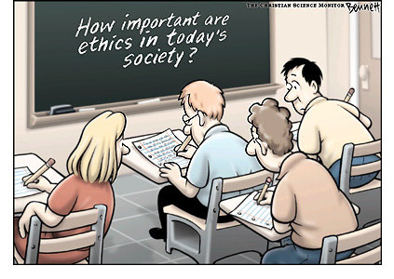

State the situation clearly and define what the problem is
List EVERY ethical problem
What is the team’s position on the situation? (agree/disagree)
Name as many solutions as your team can think of
Write any additional statements you wish to make
Each Team members assignment/part of presentation | Member 1:  Member 2:  Member 3:
Write down possible questions the audience will ask
Business Ethics Worksheet

