To Delete a White Background from a Picture

Name: __________________________ Date: _____________

1. Open Photoshop

Start→ Programs→Adobe→Photoshop→Adobe Photoshop

2. In Photoshop, open the picture that you want to edit

File→ Open (and then navigate to your picture)

3. Use the “magic wand” (red box below) to select all of the white portions in the image background . Do this by first clicking on the magic wand and then clicking on a
white portion of the picture. After the first click, hold the shift key and click on
another white portion. Note: Sometimes the entire white background is selected
after only one click with the magic wand.

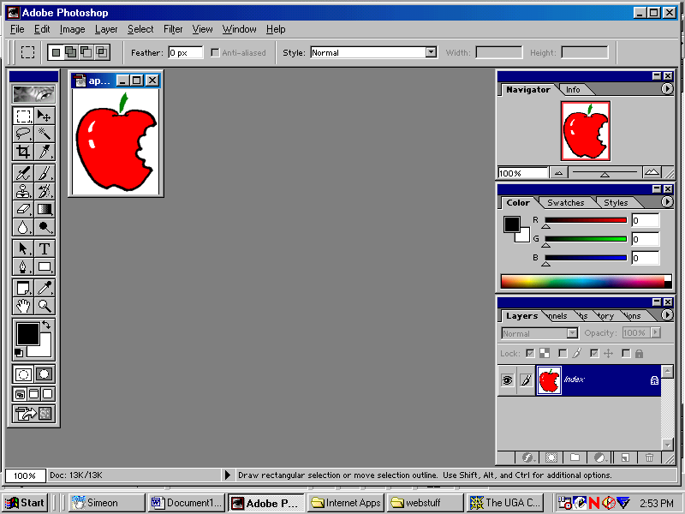

4. Make sure that all of the white portions (that you do not want) are selected by a dotted line as in the picture below:

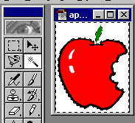

5. On the Photoshop menu bar choose Select→ Inverse. Now, only the apple should be selected by the dotted lines as seen in the picture below.

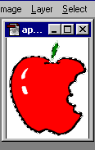

6. On the Photoshop menu bar, select Edit→ Copy (this copies just the apple, without the white background to the clipboard).

7. On the Photoshop menu bar, select File→ New. Make sure that “transparent” background is selected (at bottom of screen), and click OK.

8. On the Photoshop menu bar, select Edit→ Paste (this copies the apple to the new Photoshop image).

9. On the Photoshop menu bar, select Image→Mode→ Index Color. Make sure that transparency is checked and click OK.

10. On the Photoshop menu bar, select File→ Save as (navigate to location to which you would like to save your file to).

- In the file name “box,” give your new image a name.
- In the save as “box,” use the pull down menu to save your new file as a GIF or JPEG.
- Click “save.”
- GIF options dialogue box will display. Select “normal” and click OK.

11. Paste you new image without a white background into your website or document.

