Nikon CoolPix P1 Digital Camera: External Controls
Name: __________________________________ Date: ______________
 | Shutter Button | Just to the left of the power switch, sets the camera's exposure when halfway pressed, and releases the shutter when fully pressed.
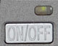 | Power Switch | Nestled in a small recess behind the power LED and to the right of the Shutter button, the Power Switch turns the camera on and off with a push.
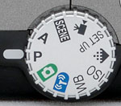 | Mode Dial | Behind the Shutter Button, this ribbed dial selects the camera's main operating mode. When taking digital photos, set at P. When recording Movie, set for Movie Modes.
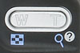 | Zoom (W and T) Buttons | Located in the top right corner of the camera's back panel, this rocker button controls optical and digital zoom in any Record Mode. In Playback Mode, the "W" button activates the index image display mode, while the "T" button controls digital enlargement of the captured image.
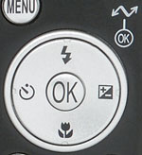 | Multi-Directional Five-Way Navigator (Flash, Self-Timer, Exposure Compensation, and Macro Buttons) | Just right of the LCD, this button features four arrows, one pointing in each direction. In any Settings menu, the arrow keys navigate through menu selections, and the center button selects.  In Playback Mode, the right and left arrows scroll through captured images.  In Record Mode, the arrow keys control specific exposure features. The Up Arrow controls the camera's flash mode, producing a popup menu of options (Auto, Red-Eye Reduction, Anytime Flash, Slow Sync, Rear-Curtain, and Flash Cancel). The Left Arrow activates the camera's Self-Timer mode, and the Right Arrow activates exposure compensation control (also giving control over aperture or shutter speed in P and A shooting modes), while the Down Arrow activates the Macro (and other) focus modes. All of these settings are confirmed by pressing the central button once a selection has been made.
 | Playback Button | Above and to the right of the Multi-Directional Button, this button accesses the camera's Playback Mode.
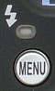 | Menu Button | Left of the Playback Button, this button displays the settings menu in any camera mode. It also dismisses the menu display.
 | Erase Button | Just above the LCD monitor, this button pulls up the Erase Menu while in Playback or Record Mode

