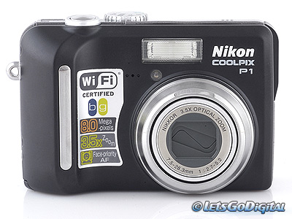
Nikon CoolPix P1 Digital Camera

Name: ___________________________ Date: ____________

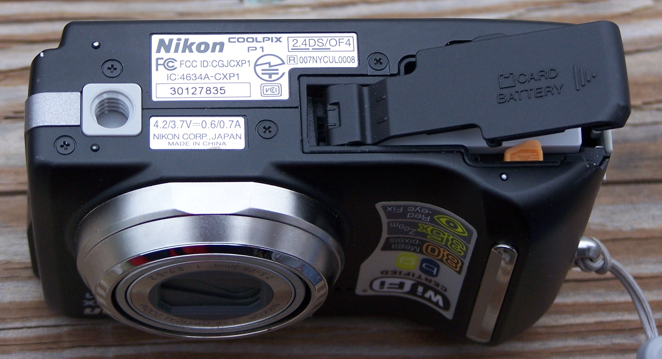 | Battery and Digitial Card Storage Door:  Slide to the right to open
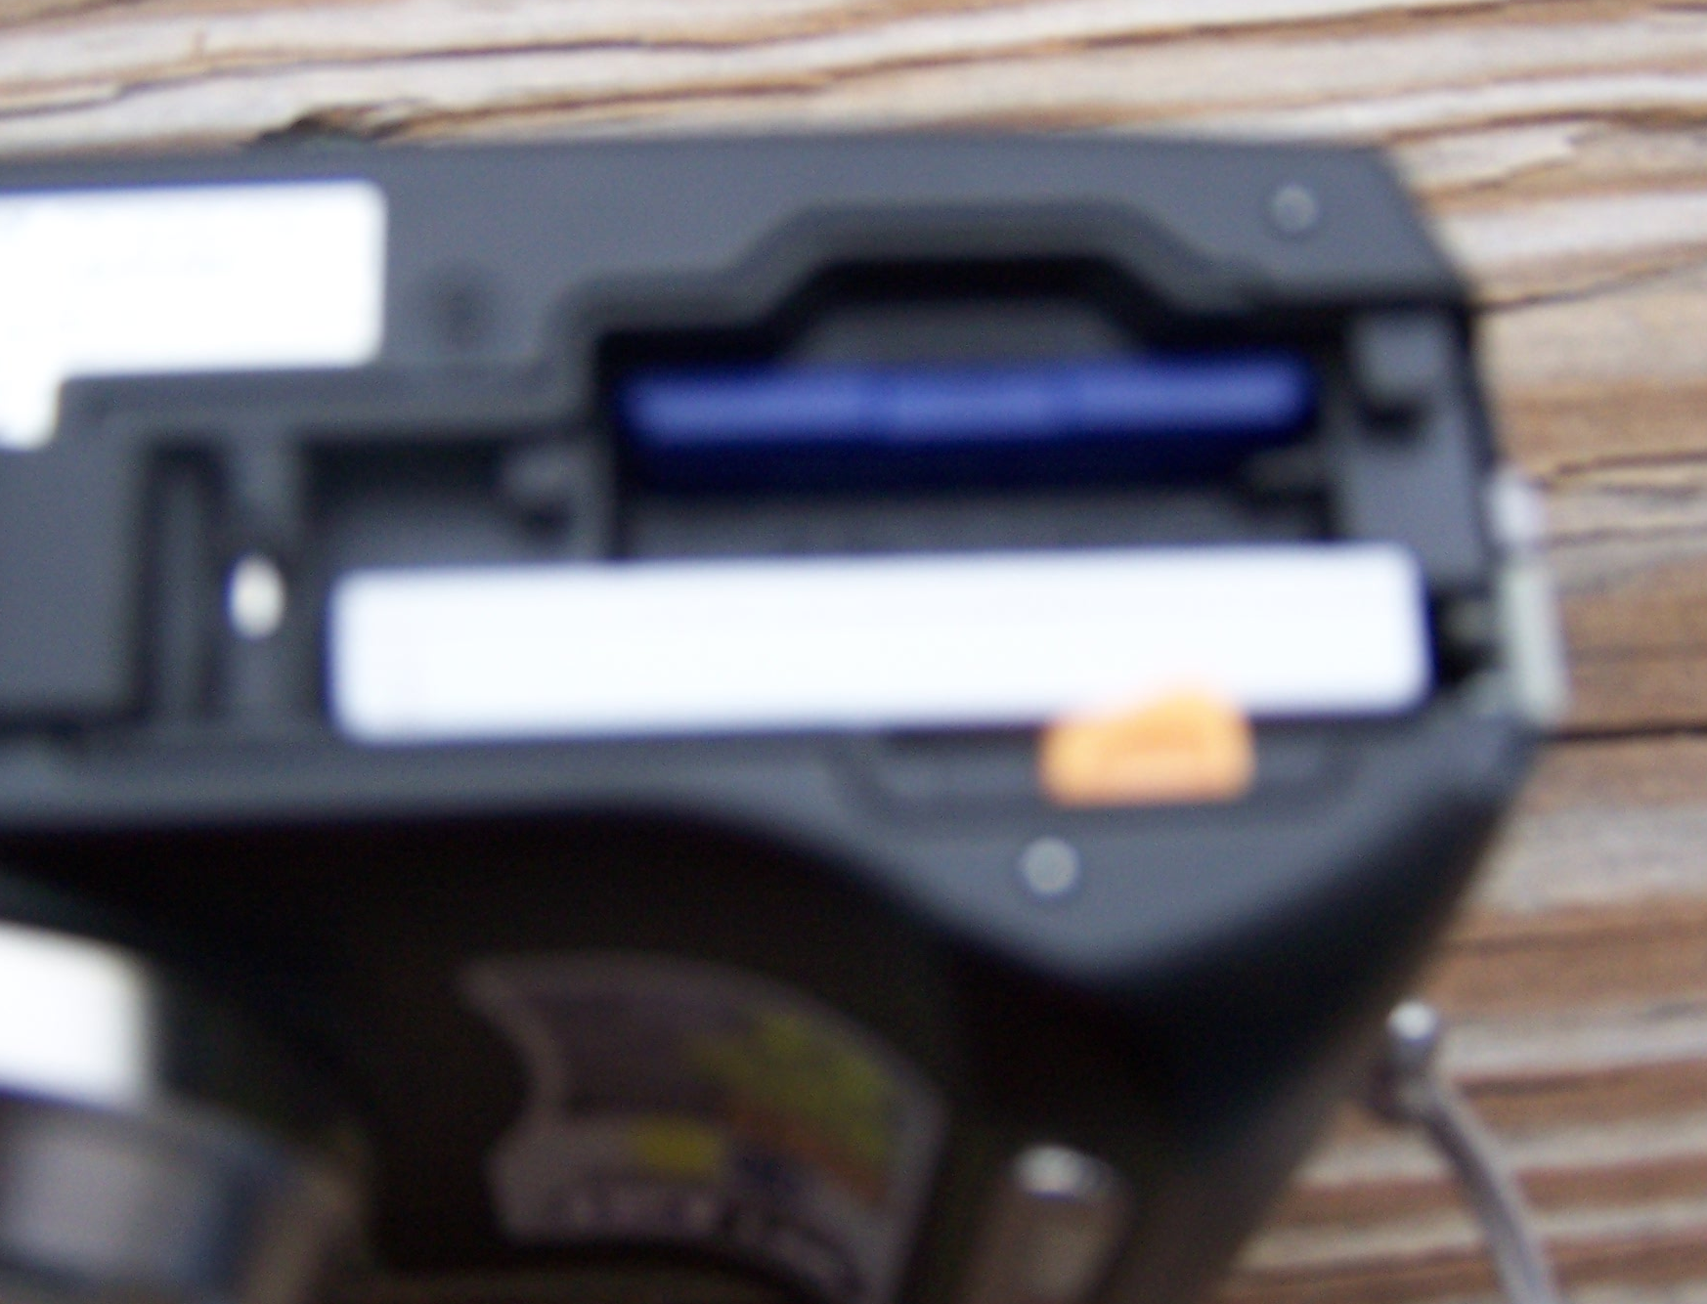 | Push Digital Card—Pops up for removal  Insert the digital card (only goes one way—do not force) until is clicks.  Battery:  Push the orange button. Battery pops up for removal; Replace battery when charged by inserting battery (only goes one way—do not force) until the orange button catches.
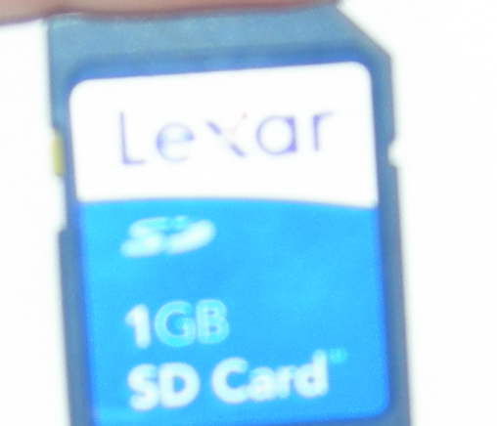 | Camera Card: Handle with care
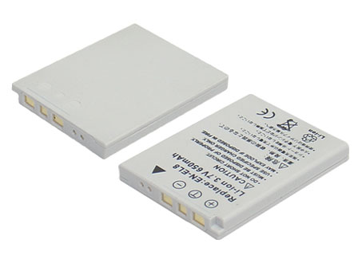 | Camera Battery
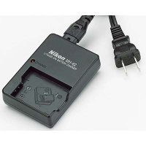 | Battery Charger:  Insert battery so that the Positive and Negative charges on the battery align with the silver bars inside the battery charger.  Make sure the charger is plugged in.  When you charge the battery, a light should appear on the charger.

