Photoshop Tools

Purpose: To identify and use the marquee, lasso, magic wand, and move tools.
Instructions: Complete the table and the questions below.
Identify the tools used in Photoshop:
Photoshop  Tool | Write the name and function of the tool. | Photoshop  Tool | Write the name and function of the tool.
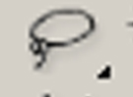 |  | 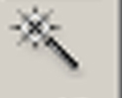
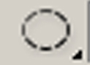
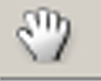 |  | 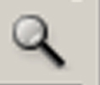
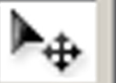

Answer the following questions:
- How do I make the selected area not be selected?
____________________________________________________________________________________
____________________________________________________________________________________
- What happens when I use the spacebar with my mouse with the elliptical tool?
____________________________________________________________________________________
____________________________________________________________________________________

- What effect happens when I hold down Alt while using the elliptical tool?
____________________________________________________________________________________
____________________________________________________________________________________
- What is Step Backwards?
____________________________________________________________________________________
____________________________________________________________________________________
- How do I copy a selected piece?
____________________________________________________________________________________
____________________________________________________________________________________
- How do I move a selected piece one pixel at a time?
____________________________________________________________________________________
____________________________________________________________________________________
- What is tolerance?
____________________________________________________________________________________
____________________________________________________________________________________
- Using the lasso tool, how do I make straight lines while free handing the selection?
____________________________________________________________________________________
____________________________________________________________________________________
- When using the lasso tool, what does Shift allow you to do?
____________________________________________________________________________________
____________________________________________________________________________________
- When using the lasso tool, what does Alt allow you to do?
____________________________________________________________________________________
____________________________________________________________________________________
- With the lasso tool selected and a portion of the picture selected, what does Alt+Crtl allow you to do?
____________________________________________________________________________________
____________________________________________________________________________________
- When using the magnetic lasso tool, what happens when you double-click?
____________________________________________________________________________________
____________________________________________________________________________________
- How do you re-size a graphic?
____________________________________________________________________________________
____________________________________________________________________________________
- How do you flip horizontally?
____________________________________________________________________________________
____________________________________________________________________________________
- How do I get rid of unwanted portions of the image?
____________________________________________________________________________________
____________________________________________________________________________________

