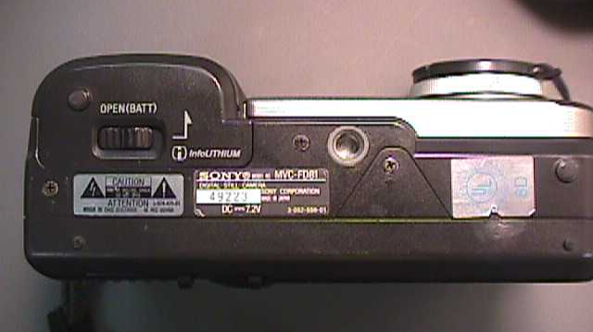
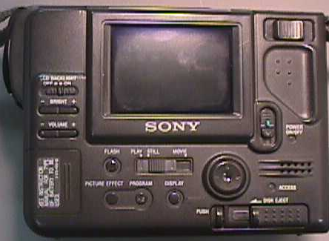
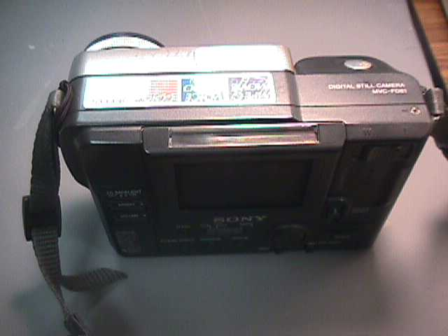
Name: _________________________________ Date: ______________
6.
1.
7.
3.
2.
8.
4.
5.

Sony Mavica Digital Camera #2

Components

11.
9.
10.

