YN Movie Theatre/Cinema
(Substitute your initials for YN—your name, get it?)

Name: ________________________________ Date: ___________

PROJECT OVERVIEW SHEET/EXAMPLES—SEE SCORING GUIDE FOR SPECIFIC CRITERIA

Logo: Design a logo for your movie theatre to be used on all projects using Photoshop.





Samples of real logos

Special Screening Ticket: Design a ticket for a special one-time screening of a holiday film (your choice). You decide the date and time. Set up similar to a concert or theme park ticket. Make it 5” by 2” (landscape).
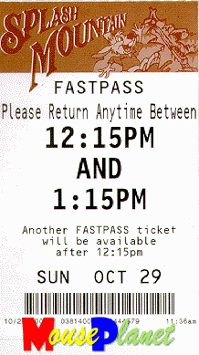
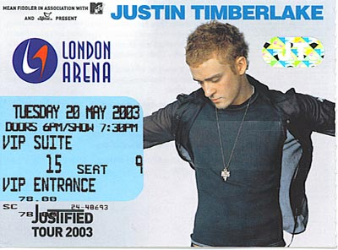
Samples of real tickets

Concession Stand Flyer: Create a concessions special buy. Flyer (letter size/portrait) must contain a page border, outlined text filled with a pattern, rotated text, polygon or other shape, drop shadow, and must advertise a deal that includes popcorn, a drink, and a candy item. Your choice on specifics and price. Be creative, but professional.

Tri-fold Brochure for Theatre Rental: Create a c-fold brochure. Set up landscape, .2” margins, 3 columns, .4” gutter. Include various packages for rentals. See scoring guide for panel requirements. Use the following websites for ideas:
- http://www.chateautheatres.com/
- http://www.amctheatres.com/meetingandevents/index.html
- Want a challenge? Try to create an angle fold brochure. See
http://www.graphic-design.com/DTG/DTG-Solutions/Brochure/default.html

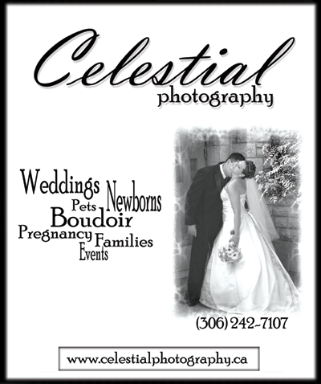
Advertisement for Yellow Pages (Phone Book): Create a 2 x 3 inch advertisement suitable for a telephone book. Include an overview of services and telephone number at a minimum. See scoring guide for requirements. Must be black and white.
Samples of telephone advertisements
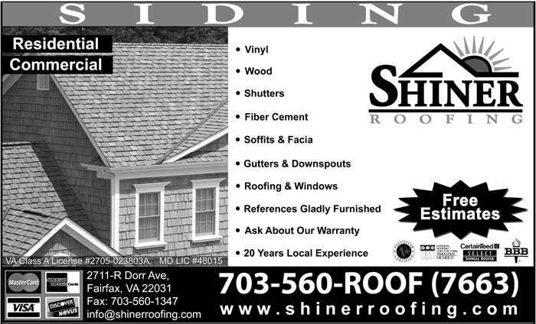


Advertisement for Classified Ads (job opening): Create an employment advertisement suitable for the newspaper. Select from assistant manager, concessions attendant, or theatre host. Ad should be 2” x 4” (tall advertisement). Include rotated text, at least three fonts, use of shapes/lines, and another advanced text feature (bullets, kerning, outlines, etc.).
Samples of employment advertisements

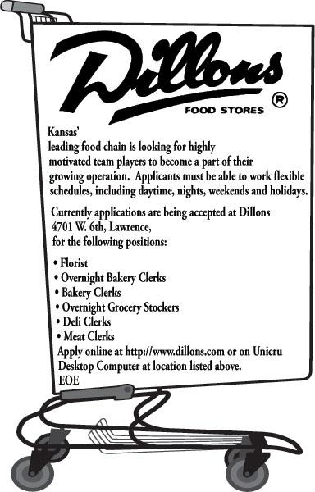

Coupon (popcorn): Create a 4” x 2” coupon with a dashed border
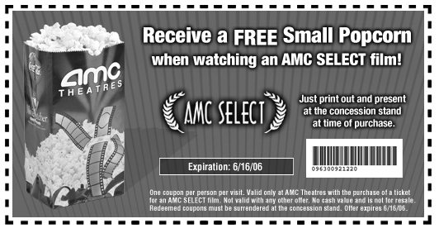
Samples of coupons
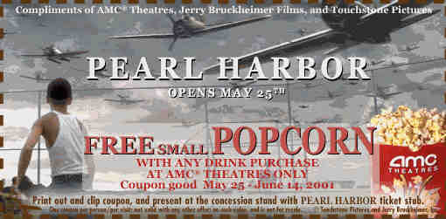

Gift Card/Certificate (credit card sized—ID-1--3.370 × 2.125 inches) or Movie Bucks (dollar size-- 6.14 x 2.61 inches).
Samples of gift cards/certificates

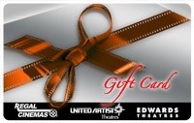
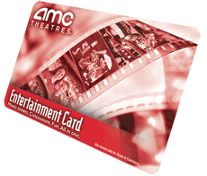
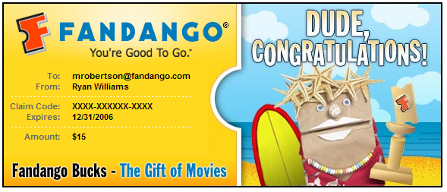

Movie Times Newsletter: Create a one page, front/back, newsletter. Have three main sections: FEATURED FILM (find a current hot film, write a short review, and include a photo from the movie); DID YOU KNOW? (find information about your favorite actor/actress, look up on IMDB, and write a summary; include a photo); and JUST FOR FUN (can include any “fun” movie stuff, but include some “movie mistakes” as well). For fun, include a word search of your favorite movies. Use the site below. You can even export the finished movie to PDF. Helpful sites:
- http://www.armoredpenguin.com/wordsearch/
- http://reelmistakes.com/
- http://www.imdb.com

YN Movie Theatre Project
SCORING GUIDE/REQUIREMENTS

Logo Project: Size is up to student, but should make it somewhat large and scale it down as needed to maintain clarity.
Required | Points Possible | Deduction
Logo uses two of the following advanced features: drop shadow, outlined text, vector drawn graphic/shape, gradient, transparency, letter kerning, scale, or rotation (circle features used) | 10
Originality | 5
Professionalism/Quality | 10
Total Points Possible | 25

Special Screening Ticket
Required | Points Possible | Deduction
Ticket uses two of the following advanced features: drop shadow, outlined text, vector drawn graphic/shape, gradient, transparency, letter kerning, scale, text on a line, or rotation (circle features used) | 10
Correct size: 5” wide by 2” tall | 5
Includes required information: name of film, date/time, seat number (optional) | 5
Graphic (photo) from movie selected | 5
Logo included (quite small) | 5
Professionalism/Quality (spelling/grammar included) | 10
Total Points Possible | 40

Concession Stand Flyer
Required | Points Possible | Deduction
Flyer uses each of the following advanced features: drop shadow, outlined text filled with a pattern, page border (set margins to .25” and put border over the margin guide), rotated text, and a shape (circle features used) | 15
Correct size: 8 ½” wide by 11” tall (portrait) | 5
Includes required information: name of deal, price, food items (popcorn, drink, and candy item) | 5
Use of color/fonts that match tone | 5
Logo included (sized appropriately) | 5
Professionalism/Quality (spelling/grammar included) | 10
Total Points Possible | 45

Yellow Pages Advertisement
Required | Points Possible | Deduction
Ad uses two of the following advanced features: drop shadow, outlined text filled with a pattern, ad border, rotated text, reverse text, kerning, feathering, and a shape (circle features used) | 10
Correct size: 2” wide by 3” tall | 5
Includes required information: name of business, phone number, and overview of services | 5
Black and white/grayscale | 5
Logo included (sized appropriately) | 5
Professionalism/Quality (spelling/grammar included) | 10
Total Points Possible | 40
OR Classified Advertisement (Newspaper)
Required | Points Possible | Deduction
Ad uses rotated text, at least three fonts, shapes/lines, and an advanced text feature (bullets, kerning, outlines) | 10
Correct size: 2” wide by 4” tall | 5
Includes appropriate information AND a “movie reel” graphic | 10
Logo included (sized appropriately) | 5
Professionalism/Quality | 10
Total Points Possible | 40
Tri-Fold Brochure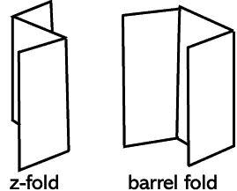
Required | Points Possible | Deduction
Ticket uses three of the following advanced features: drop shadow, outlined text, vector drawn graphic/shape, gradient, transparency, letter kerning, scale, text on a line, or rotation (circle features used) | 15
Correct size: 11” wide by 8 1/2” tall (landscape) set up as brochure (.2” margins, 3 columns, .4” gutter) | 5
Includes required information:  Panel 5—Testimonials or teasers (why should I read this)  Panel 6—Rotated mailer with stamp placeholder  Panel 1—Cover that includes logo and your name as manager  Panel 2 & 3—Details about the various options for your customers (include prices)  Panel 4—Form (use a table) for people to fill out if they are interested in reserving your theatre for a party/private showing, etc., (tabs with leaders used for lines can be used instead of tables) | 25
Use of symbol/glyphs for check boxes (on form) | 5
Use of graphics/color/fonts that match tone | 10
Logo included (sized appropriately) | 5
Professionalism/Quality (spelling/grammar included) --printed/folded properly | 15
Total Points Possible | 80
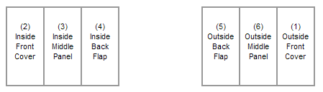

Helpful website for making good brochures--http://www.vtaide.com/gleanings/BrochureLayout.htm

Movie Coupon (concession stand)
Required | Points Possible | Deduction
Ad uses at least one of the following advanced features: drop shadow, shape, feathering, or transparency | 5
Correct size: 4” wide by 2” tall | 5
Dashed border around edges | 5
Includes appropriate information (free popcorn), location, and expiration date | 5
Color scheme/readability | 5
Logo included (sized appropriately) | 5
Professionalism/Quality (spelling/grammar included) | 10
Total Points Possible | 40

OR Gift Card/Movie Bucks
Required | Points Possible | Deduction
Ad uses at least one of the following advanced features: drop shadow, shape, feathering, or transparency | 5
Correct size: Either credit card (3.370x2.125) or dollar size (6.14x2.61) | 5
Rounded rectangle border (on credit card) or solid border (dollar) | 5
Includes appropriate information, value, and expiration date | 5
Color scheme/readability | 5
Logo included (sized appropriately) | 5
Professionalism/Quality (spelling/grammar included) | 10
Total Points Possible | 40

Movie Times Newsletter (2 pages—printed on one page front and back)
Required | Points Possible | Deduction
Newsletter uses multiple columns in three different sections, outlined words for title, divider lines, and a shape | 10
Correct size: 8 ½” wide by 11” tall (.25” margins) | 5
Includes required information: month/year of publication, your name for contact information, movie prices, and brief overview of other services (detailed on the brochure) | 10
Required content:  FEATURED FILM (film review) with graphic  DID YOU KNOW? (info about an actor) with graphic  JUST FOR FUN (including movie mistakes)  WORD SEARCH (created at the armoredpenguin.com website/pdf) | 20
Printed front/back | 5
Logo included (sized appropriately) | 5
Professionalism/Quality (spelling/grammar included) | 20
Total Points Possible | 75

OVERALL PROJECT GRADE
Name: _________________________

NOTE: Bonus points possible for completing optional projects. If time permits, continue to work on other projects to include in your portfolio.

Project | Points Earned | Comments
Logo | /25
Special Screening Ticket | /40
Concession Stand Flyer | /45
Yellow Pages Advertisement OR  Classified News Advertisement | /40
Tri-fold Brochure | /80
Movie Coupon OR  Gift Card/Movie Bucks | /40
Movie Times Newsletter | /75
Grade Sheet Included (with name on it!) | /5
DEDUCTION: Late work -10 per day
+BONUS WORK
PROJECT TOTAL | /350

