Southeast United States

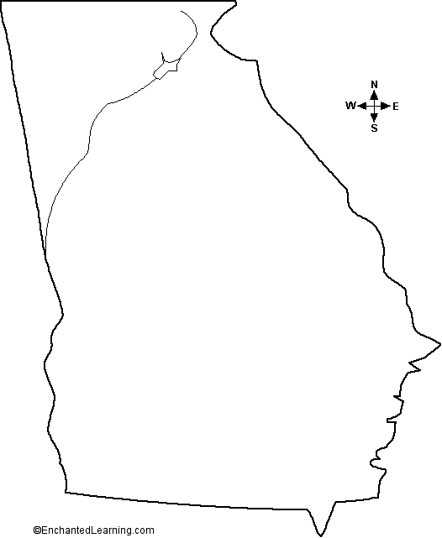          GEORGIA  GRAPHIC/WEB DESIGNER  www.uberprints.com/jobs | 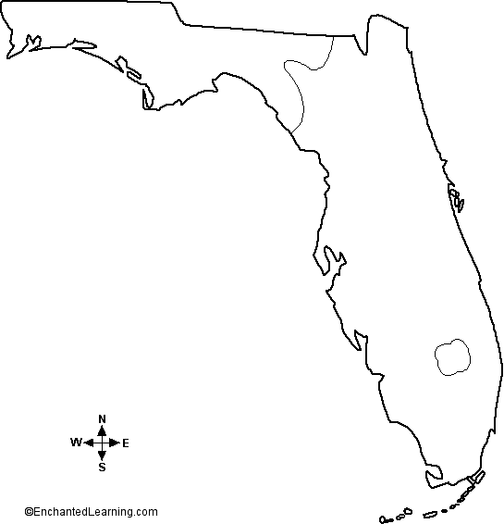  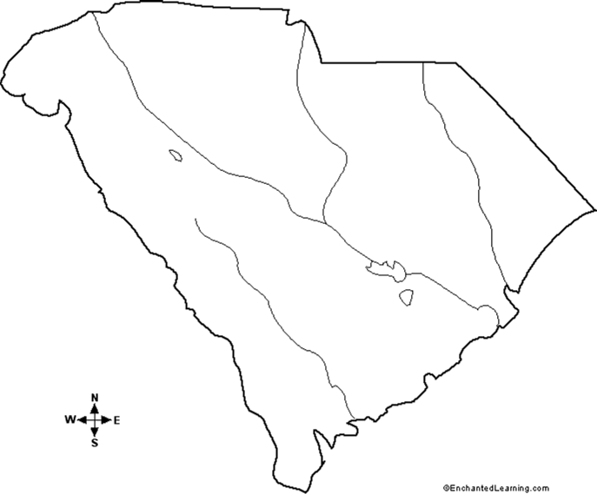          FLORIDA  IT Technical Writer  Adecco Group has an immediate opening for an IT Technical Writer on a four month contract opportunity with a leading bank in Tampa, Florida, 33610.  $24/hr contract  Required:  5+ years of Technical Writing in an IT environment, 5+ years experience with Adobe Acrobat, great communication skills and a reputation for on time delivery  www.florida.computerjobs.com  job number:  36075617: SUS_EN_2_107870_137361
  Company Name | UberPrints.com
  Job Category | Retail; Internet
  Location | Athens, GA
  Position Type | Full-Time, Employee
  Experience | 2-5 Years Experience
  Date Posted | December 10, 2009
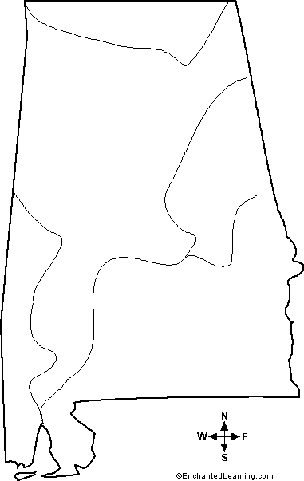          ALABAMA  JAVA DEVELOPER  Precision Resources has an immediate need for Java Developers with 5+ years experience with JAVA, J2EE, JSP*s, EJB*s  Bachelor’s Degree in computer science preferred, but not required.  Robojob.com |         SOUTH CAROLINA  Senior Systems Engineers  Serve as technical lead on projects involving servers, storage, clients, LAN/WAN connectivity, peripheral devices. Respond to/investigate end user issues and will recommend/perform actions to correct problems. Positions will focus on support and implementation of Vmware, EMC, Citrix, Microsoft and Cisco products.  eGroup provides an excellent compensation plan with full health benefits, expenses, and retirement plan.  More information: eGroupSSE-2009  To apply: hr@eGroup-us.com

