Windows Operating System Project

Name: ____________________________________________ Date: ___________________ Period: _______

A Word Document – Comparing and Contrast Operating Systems
Directions You are going to use the internet to create a table about operating systems. Your table should include the following topics:
The three operating systems you should describe are: Vista, Windows XP, OS

- Date released
- General description
- Installation requirements
- New improvements released with latest version available
- Advantages and disadvantages operating system
- Price
- Save the file with the name “Operating systems”. And password, save early, saves often!
- You may choose to set the page to landscape (File, Page set up).
- Proofread your document for spelling or grammar errors. (Run spell check!)

Part 2
Operating System Layers
Directions:
Read this summary of the operating system layers taken from http://ezinearticles.com/?The-Elements-of-an-Operating-System&id=2575762. Complete the sections included in the form below.
Operating systems are broken down into five layers.
Layer 1: The Kernel--the bottom most layer
The kernel is the heart of the operating system. Amongst it's responsibilities are ensuring that each running process is given a fair amount of time to execute while a controlling the amount of resources each process can use.
* TASK-Search the internet for a working definition (this means in words that you understand) of KERNEL (in terms of computing).
Write the definition: (include a visual graphic if found for explanation).
Source: _______________________________________________________________________
Layer 2: Memory Management-- act of managing computer memory.
The name of this layer gives you a good idea what it is all about. It is the responsibility of this layer to share the computers physical memory among the processes which want to use it. It also has to manage such situations where there may not be enough physical memory to share out.
Layer 3: Input/Output
On this layer all the physical communication between the computers hardware.
* TASK-Complete the chart below on input and output devices by searching the internet.
Input Device | Picture of Input Device | How does input get “IN” to computer with this device?
1.

2.

3.

4.

5.

Output Device | Picture of Output Device | How does input get “OUT” of the computer with this device?
1.

2.

3.

4.

5.

Layer 4: File Management.
Again the name of this layer may give you a clue as to what it does. It is the job of this layer to control how the files on your computers hard drive are stored and accessed by any application seeking to use them.
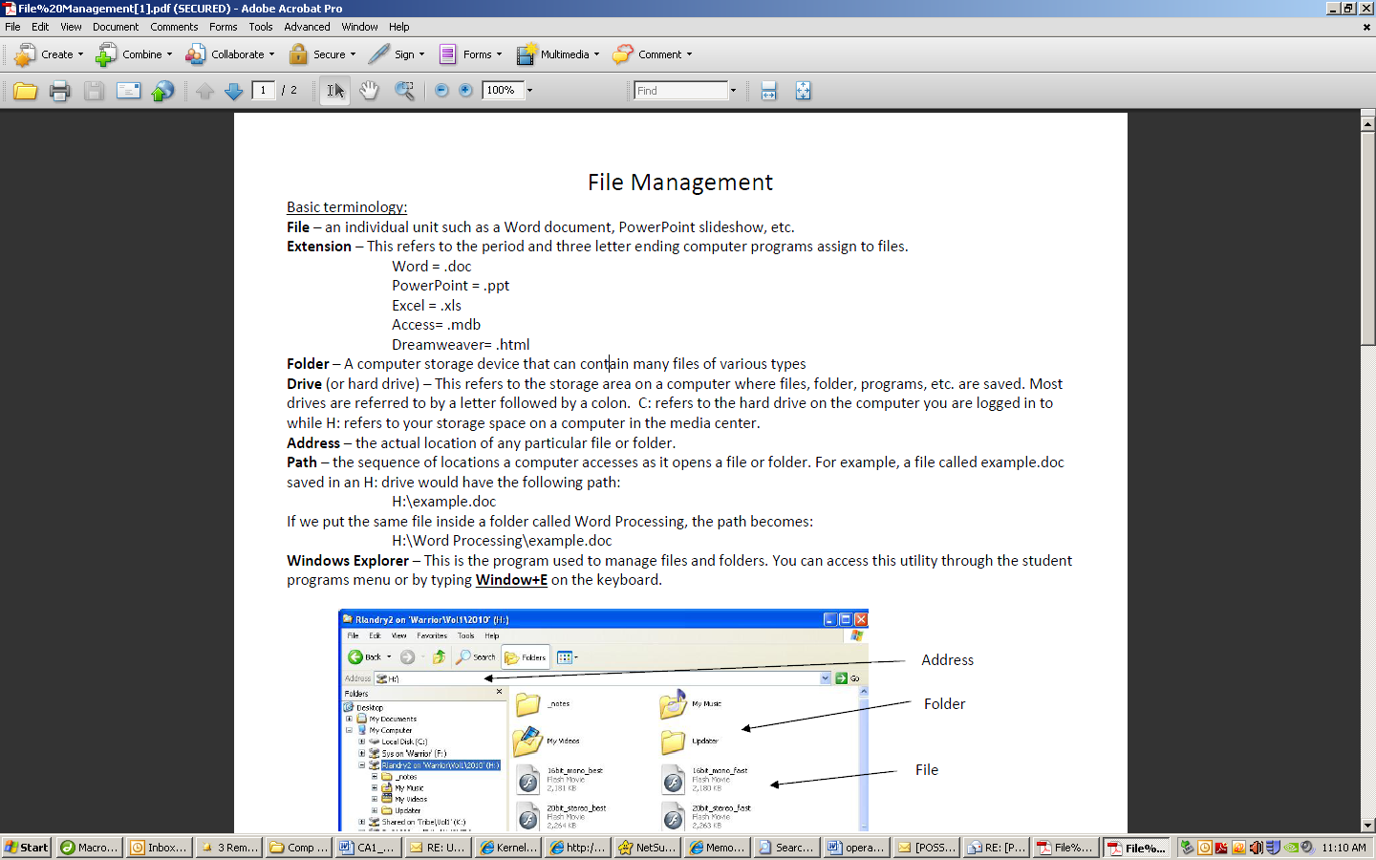
* TASK-How do you organize files on your computer? Draw the folder structure of your computer.

Layer 5: The User Interface.
The last element or layer as we have been calling them, of an operating system is the User Interface. This layer is probably the easiest of all to understand since it is the first thing you see when your operating system has logged you in. It is the job of this layer to provide a means for the user to actually interact with the rest of the layers and as such the system as a whole.
Keep in mind there are two different types of User interfaces. The first one is probably the one you are most familiar with, the graphical user interface, which is where you see windows and icons for each of your files and so on.
The second is a command line interface, or text based interface where a user would interact with the system using text based commands.
* TASK-This information is simple but we need visual examples. Find further explanation in terms that are easy to understand about the graphical user interface and a command line interface. Write an explanation of when you would use a command line interface.

