Name________________________________

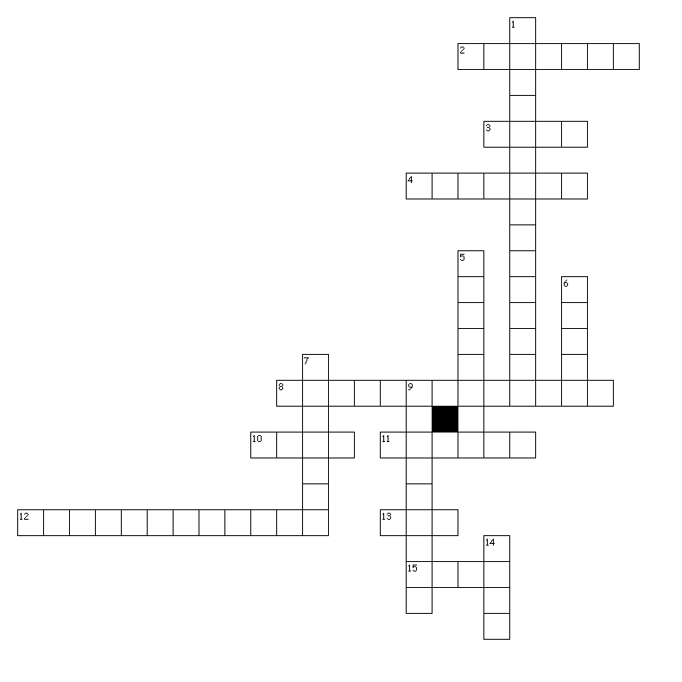
Word Processing Fundamentals Vocabulary
Vocabulary Terms
- Font
- Undo
- Thesaurus
- Paste
- Margins
- Cut
- Borders
- Format painter
- Template
- Indentations
- Page orientation
- Copy
- Shading
- Repeat
- Redo

Across
2. used to draw reader's attention by adding color to the background
3. place a copy of selected text on the Office clipboard
4. blank spaces around the top, bottom, and sides of a page
8. command used to copy the format of selected text to other text
10. command used to reverse an action that you undid
11. command used to repeat the most recent action
12. space between text and the margins
13. remove selected text and place on the Office clipboard
15. command useful when reversing a recent action
Down
1. portrait or landscape
5. A predesigned file that you can use to create a new file
6. to copy an item stored on the Office clipboard to a new location
7. used to draw reader's attention by adding lines around text or a page
9. command used to find a synonym
14. The design of text Ex: Arial

