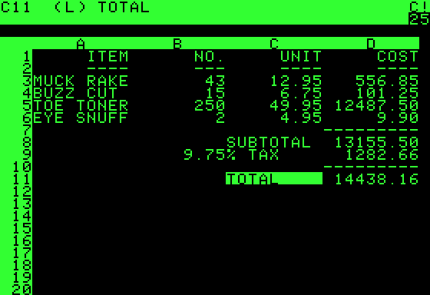
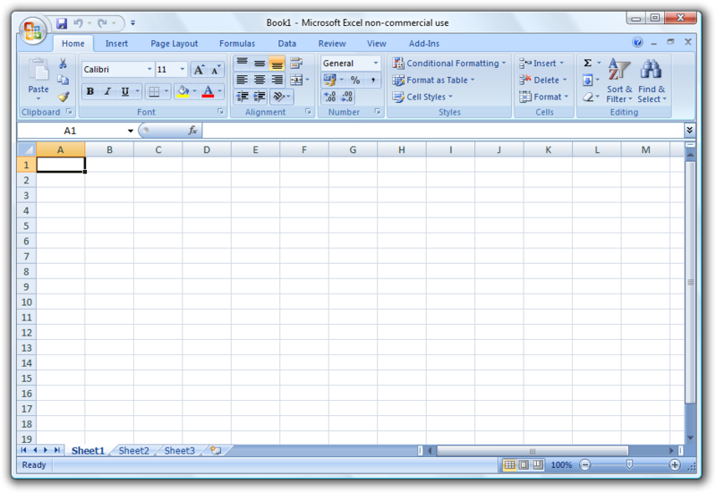
3000 BC:
Abacus – first device used for calculations – invented by the Chinese
1961: Professor Richard Mattessich was the first to develop a computerized spreadsheet used mainly for accounting.
1978:
Dan Bricklin & Robert Frankston designed and created the first electronic spreadsheet. It was named VisiCalc after the phrase “visible calculator”. It was sold with the Apple computer.
1983: Mitch Kapor developed Lotus 1-2-3. Lotus became a more complex calculation tool. It was the first spreadsheet to name cells, cell ranges and macros.
1984:
The first version of Excel was introduced for the Apple McIntosh.
1985:
Lotus 1-2-3 version 2 was introduced and VisiCalc was discontinued.
1987: Microsoft launched the first Windows version of Excel. The new version introduced the Graphical User Interface (GUI) concept which allowed for using graphics.
1989:
Excel Version 3 was known as the most widely accepted Microsoft product.
1985:
Other spreadsheet programs (TWIN and VP Planner) copied Lotus and claimed to work with the program but were not successful.
1995:
IBM buys Lotus Corporation which makes Excel the market leader.
2001:
Spreadsheet programs in use are Excel, AppleWorks, FileMaker, WordPerfect Quattro Pro and Lotus Smart Suite.
The History of Spreadsheets

