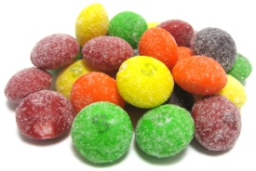
EXCEL CHARTS
“MY FAVORITE CANDY”
Candy Charts Assignment

- Students will use an absolute address and the chart feature in Excel to create this assignment.

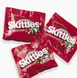
- Students will learn to create charts in Excel through a fun activity using candy items such as regular skittles, sour skittles, peanut M & Ms and plain M&Ms.

- Students are given four types of candy treats. Open the first package of candy. Count and divide items by color. Create a spreadsheet in Excel listing each color and how many of each color was in your packet. After making the spreadsheet, use Auto sum to find the total number of pieces of candy in your packet.

- Enter a formula using the number of the first colored item divided by the total number of items to find the percentage of items in that color. Format the percentage column to percent with no decimals.

- Highlight the spreadsheet information in columns for color and percentage. Create a chart to graph your color results. Add an appropriate title, x and y axis, and data labels. Resize the chart to fit in the area beside the spreadsheet data. Change the colors in the chart to match the candy colors represented for each category.

- Create three more charts for each of the other types of candy treats. You should have a total of four spreadsheet tables and charts. Remember to change candy colors to match spreadsheet data represented.

- Because there are 20 students in the class and 4 different types of candy, I divide the students into 4 groups of 5 people each. After all individual candy charts are complete; each person in the group will take one candy treat and calculate the totals of the color pieces for each type candy. Person 1 takes peanut M&Ms and creates a spreadsheet listing all the colors and then takes all the totals for each color from each person in the group and then prepares a chart to illustrate the color distribution. Titles, legends, and data labels should be included. The fifth person in the group should prepare a chart that shows the color preferences of the four types of candy and the number of pieces of each candy. Chart examples and spreadsheet files are included as examples.

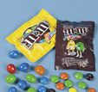
- Students should see that the distribution of candy is different based on the weight and size of the candy. Also students should see that colors vary and some may be used more than others. This is a fun way to learn about percentages and distribution.

