Creating Reports
Directions: Make sure the FBLA database is open. You will follow the steps below to learn how to create reports and labels.

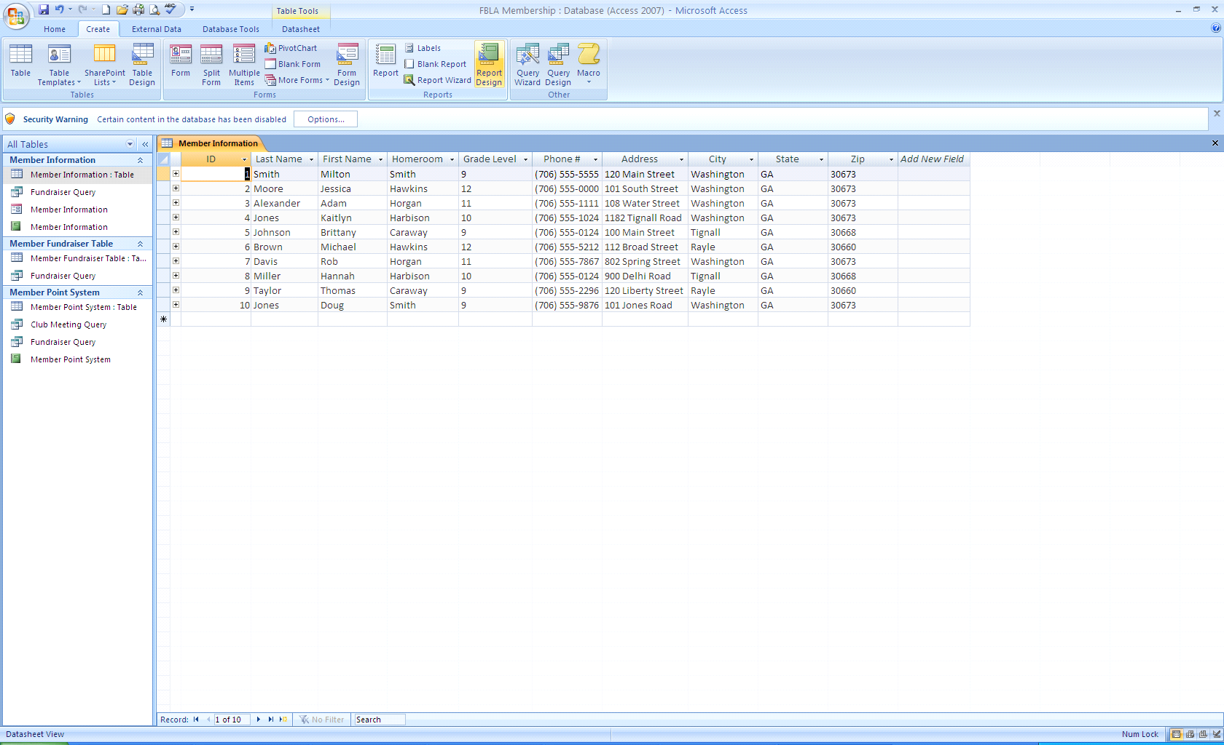
Report Tool
1. If the Security Warning appears below the Ribbon, Click Options, click the Enable this content option button, then click OK.
2. You will create a report for the Member Fundraiser Table using the Report Tool.
3. The Report Tool creates a simple report that includes all the fields in the selected table or query, uses a simple columnar format, and includes a title with the same name as the record source.
4. Open the Member Fundraiser Table and click on the Report Tool on the Create Tab
5. This creates a simple report – save it as Fundraiser Report
Creating a Report Using the Report Wizard
1. You need a list of students and their phone numbers grouped by homeroom
2.
Click on the Create Tab and choose the Report Wizard button in the Reports section
3. Choose the Member Information Table
4. In the Available Fields – move the following fields to Selected Fields
a. First Name
b. Last Name
c. Homeroom
d. Phone #
5. Next
6. Group by Homeroom by using the right arrow to move Homeroom to the Grouping level
7. Next
8. Sort in Ascending order by Last name – then by first name in Ascending order
9. Next
10. Choose a Layout and leave in portrait orientation
11. Choose any style
12. Name it Member by Homeroom Report
Creating a Report Using Multiple Tables
1. You need a report grouped by Homeroom listing students and the amount they raised in the 3rd Fundraiser
2. Click on the Create Tab and choose the Report Wizard button in the Reports section
3. Choose Table: Member Information in the Tables/Queries Section
4. Double-click the First Name, Last Name, and Homeroom Fields to add them to the Selected fields
5. Then, Choose Table: Member Fundraiser Table in the Tables/Queries Section
6. Double-click the Fundraiser 3 field to add it to the selected fields
7. Next
8. Group by Homeroom by double-clicking on the Homeroom Field or use the right arrow
9. Next
10. Sort in Ascending order by Last name
11. Next
12. Choose the Block Layout and Landscape Orientation and Next
13. Pick a style of your choice and next
14. Name it Fundraiser 3 Report
Creating a Report Using the Label Wizard
1. You will need to send a packet of information to all FBLA members during the summer and labels will be needed.
2.
Select the Member Information Table and Click on the Create Table and choose the Labels button.
3. You will use the most common type of mailing labels by choosing Avery as the manufacturer.
4. Choose the C2160 product number and Next
5. Change the Font to Times New Roman, size 10 and Next
6. Double click the First Name field and press the spacebar
7. Double click the Last Name field and press the Enter key
8. Double click the Address field and press the Enter key
9. Double click the City field – type a comma and press the spacebar
10. Double-click the State field and press the spacebar
11. Double-click the Zip field and Next
12. Double-click the City field to sort by city in ascending order and Next
13. Name in Member Mailing Labels and Finish

