Name: ________________________________________________ Date: ____________
The Missing Dollar
Three students checked into a hotel room during a school trip. The room cost was $130 total. The school paid $100 in advance for the room, leaving a balance of $30. The students paid $10 each at check-in to cover the $30 balance. After they went to the room the manager realized that he had overcharged them since the convention rate was $125 for the room. The manager gave a clerk $5 in $1 bills to return to the students. On the way to their room the clerk could not decide how he was going to split $5 among three people. He decided to keep $2 for his trouble and to make the math easier. The clerk gave $1 to each student. The three students had now paid $9 each, or a total of $27. This, plus the $2 the clerk kept for himself, makes a total of $29. What happened to the other dollar?
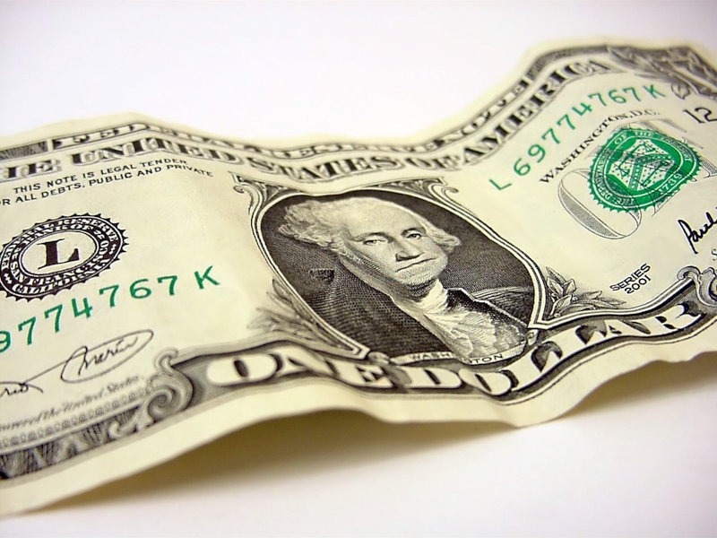
1. Write an explanation of what happened to the missing dollar.

2. Determine how much each member should have received if the clerk had split the $5 among the three members?

