Name: _________________________________________________ Date: ____________________

Software Licensing Crossword

Pathway: Administrative Information Support
Course: Computer Applications II
Unit 1: Information Research
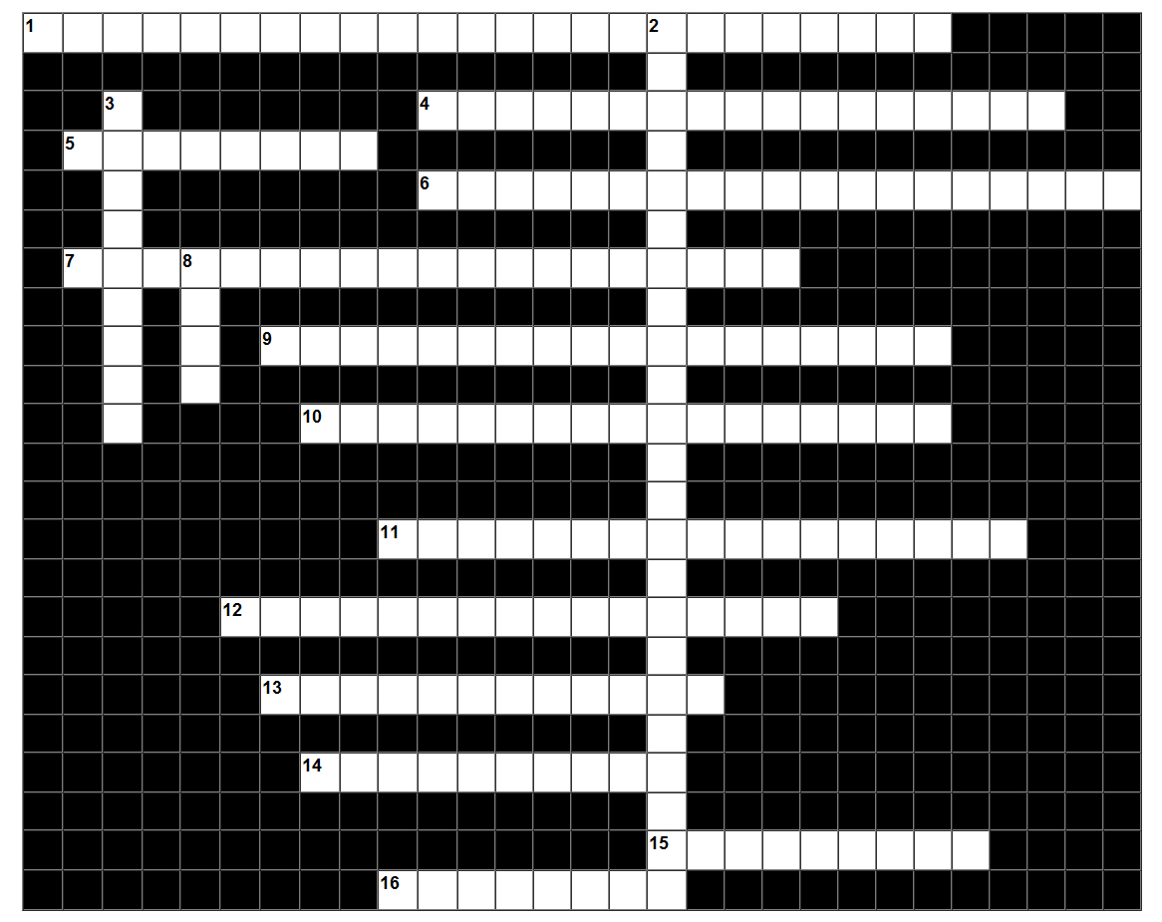

Across:

1 A contract between a software company and the purchaser/user of that software. The license grants the user specific rights to use the software in particular ways and allows a developer or a publisher to continue to own the software.
4 A copyright license for computer software that makes the source code available under terms that allow for modification and redistribution without having to pay the original author.
5 A play on the word copyright, and usually refers to a copyright licensing scheme in which an author surrenders some but not all rights under copyright law.
6 Software that is owned by an individual or a company (usually the one that developed it). There are almost always major restrictions on its use, and its source code is almost always kept secret.
7 A software license which grants recipients rights to modify and redistribute the software which would otherwise be prohibited by copyright law.
9 A contract between two parties that does not allow for negotiation.
10 A software license agreement which is enclosed within a software package and is inaccessible to the customer until after purchase.
11 A limitation on copyright. The doctrine allows the purchaser to transfer a particular lawfully made copy of the copyrighted work without permission once it has been obtained.
12 A license that is accepted on-screen during installation of the software.
13 Materials (including software) that are not owned or controlled by anyone. The materials are "public property", and are available for anyone to use freely for any purpose.
14 Any collection of statements or declarations written in some human-readable computer programming language. It is the mechanism used to specify the actions to be performed by computers.
15 Proprietary software that is provided to users without payment on a trial basis and is often limited in its features.
16 Computer software that is available for use at no cost or for an optional fee.

Down:

2 A widely used free software license. Under this philosophy, the GPL grants the recipients of a computer program the rights of the free software definition and uses copyleft to ensure the freedoms are preserved, even when the work is changed or added to.
3 A form of intellectual property that gives the author of an original work exclusive right for a certain time period in relation to that work, including its publication, distribution and adaptation.
8 A legal document that governs the use of all software applications. The document outlines the terms of the software license.
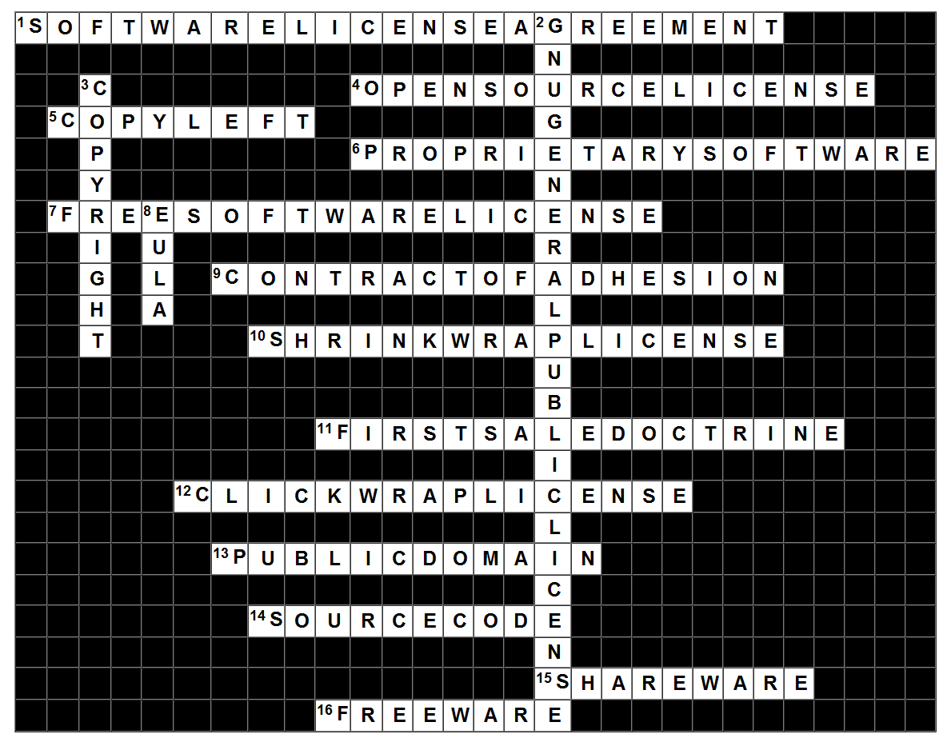
Answer Key

