Creating a Template
- Click on the J symbol on the Quick Access Toolbar to run the MyStyle Macro
- Create a letterhead similar to the sample below.
- Replace the italicized text with your information (school name/your name)
- You can use the address given or your school address.
- You can find an image of a school or use an actual picture of your school!
- As it is complete, click on the Office Button and Choose Save as
- Change the Save as Type to Word Template
- Save to your student files as Prom Letterhead Template
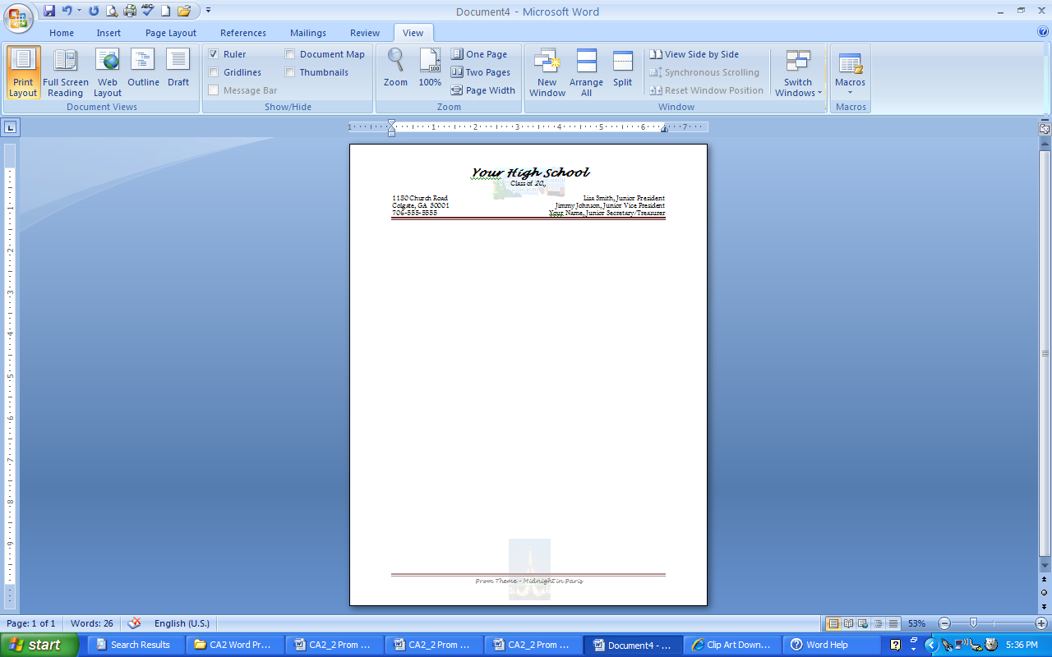
- You will use this template in later activities

