Prom Committee Project
Final Evaluation/Production Test

Directions:
This is a one-hour production test. You will demonstrate your ability to use a template, use an on-screen form, use a macro, create a table/data source, create a form letter, merge documents, create merged labels, and enhance a table. Your teacher will let you know when to begin. The Point Value for each part of this project is listed. A grading rubric follows. PROOFREAD CAREFULLY AND SPELL CHECK. Major errors (missing information, spelling/grammar, incorrect format and/or procedures) will result in a 5 point deduction. Minor errors that don’t change the intent of the message will result in a 3 point deduction.

Activity 1 Data source/Table: (40 pts)
- Run your MyStyle Macro
- Change to Landscape orientation and Narrow Margins
- Create the data source/table below:
- Save to your student data files as Silent Auction Recipients.
- Proofread and spell check your document.
- Close this file before completing the next document.

Name | Address | City | State | Zip | Item | Amount Bid | Value
Ms. Tess Moriah | 21 Dallas Drive | Dearborn | GA | 30002 | HDTV | $300 | $350
Mr. Ty Berry | 55 Wire Road | Colgate | GA | 30001 | Market Tote | $150 | $225
Mr. Spencer Alcorte | 44 Stagecoach Road | Colgate | GA | 30001 | Spa Special | $100 | $225
Mr. Devin Sisemore | 107 Yancy Ct. | Colgate | GA | 30001 | Movie Night Basket | $130 | $150
Mrs. Rafael Wade | 12 Hinkle Road | Colgate | GA | 30001 | Data Night Basket | $150 | $215
Miss Sarah Scarborough | 106 Water Street | Dearborn | GA | 30002 | Market Gift Card | $175 | $200
Mr. Jack Garrett | 901 Pennsylvania Ave. | Rockdale | GA | 30003 | Jewelry Basket | $100 | $168.5
Ms. Kate Cortez | 803 Washington Road | Colgate | GA | 30001 | Necklace Set | $125 | $150
Mrs. Ashley McNeal | 101 Main Street | Rockdale | GA | 30003 | Men’s/Women’s Watch Set | $200 | $225
Mrs. Jacob Kilmer | 602 Broad Street | Rockdale | GA | 30003 | Day at the Salon | $75 | $125
Mr. Brent Rayburn | 205 Forest Lane | Colgate | GA | 30001 | 2-night Hotel Package | $150 | $275
Mrs. Riley Karr | 120 Pine Street | Rockdale | GA | 30003 | Fun in the Sun Package | $50 | $75
Ms. Vanessa Pritchard | 513 Southeast Street | Colgate | GA | 30001 | Mother’s Day Out Special | $75 | $125

Activity 2 Using Mail Merge to Create Mailing Labels: (20 pts)
- Using the Silent Auction Recipients table/data source and mail merge features, create mailing labels.
- Use the Avery 5160 labels Product number
- Include on the Name, Address, City, State, and Zip on the labels
- The merge fields will appear like example below:
«Name»
«Address»
«City», «State» «Zip»
- Don’t forget to Update Labels!
- Save the merged labels to your student folder as Auction Recipient Labels
- Print the merged labels

Activity 3 Form Letter Using Letterhead Template: (40 pts)
- Using your Letterhead template and mail merge features, type the following form letter
- Remember to use merge fields in place of the information in brackets.
- Replace italicized information (Date, School Name and Your Name) with your information.
- Proofread and spell check
- Use the thesaurus to change additional in the 3rd paragraph with an appropriate replacement.
- Save to your student folder as Silent Auction Letter
- Preview Results & print one of your merged letters.
- Also, print your letter showing the merge fields.
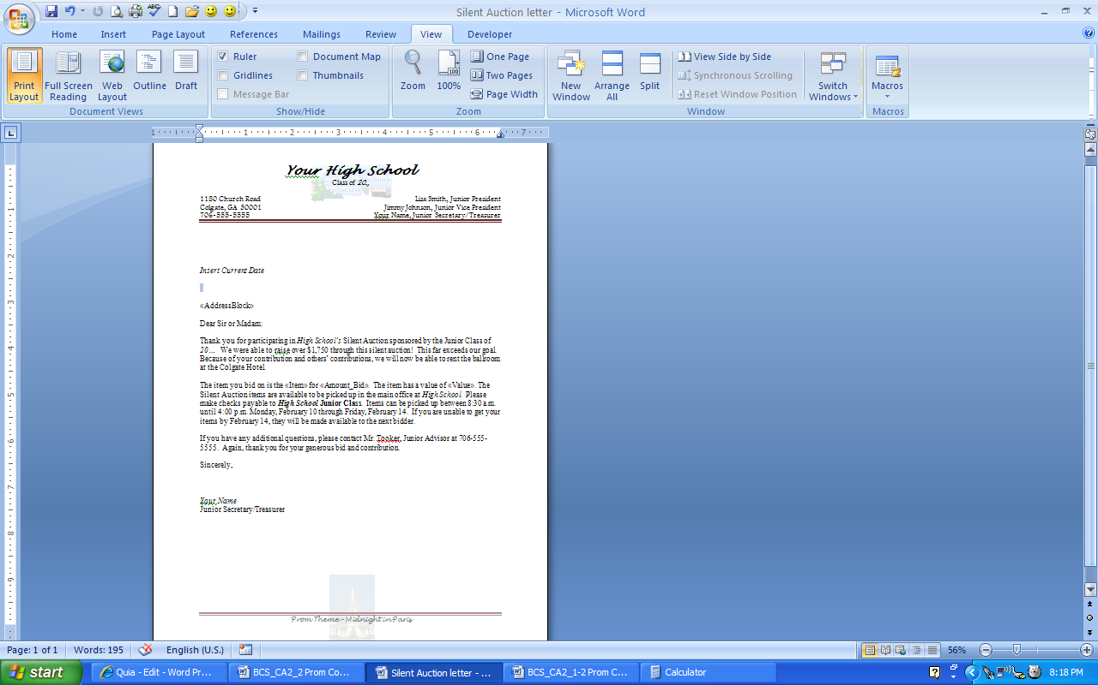

Activity 4 Create a Receipt Using an On-screen Form: (25 pts)
- Your adviser needs you to create a receipt for the Silent Auction bidders as the pick up their items. The bidder of the Market Tote is picking up his item and needs a receipt.
- Go to the Office Button and click Receipts – use the Sales Receipt (Simple Lines Design) form
- Remember to substitute your information with the italicized items.
- Create the form below.
- Increase the font size of the text as needed.
- To get the total at the bottom – use the Formulas button
- Save to your student folder as Market Tote Receipt
- Proofread and Print
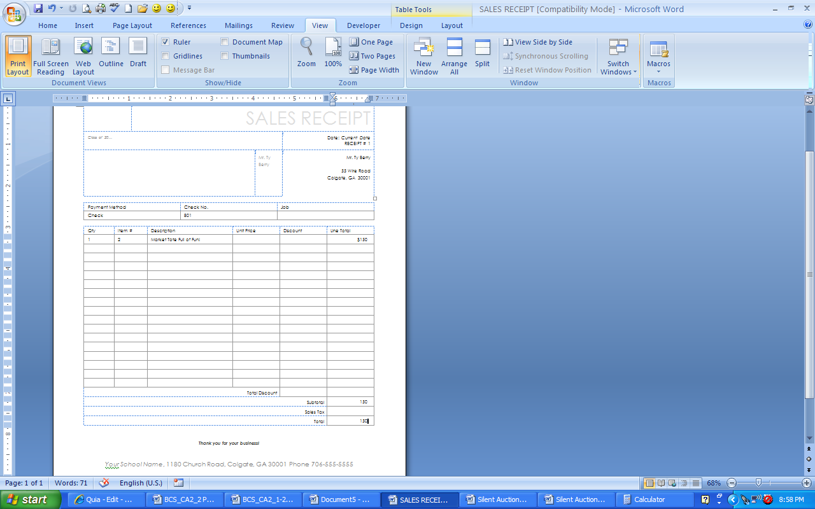

Activity 5 - Enhancing a Table: (25 pts)
- Open your Silent Auction Recipients Table/Data source from Activity 1 and save it as Recipients Revised
- Sort the table in Ascending Order by City
- Insert a new row after the last row in the table
- Merge the first six cells of the new row and type Totals in bold and aligned right.
- Use the formula button to total the Amount Bid column and the Value column.
- Apply any Table Style
- Print

Activity | Point Value | Points Earned
#1 Table  Deductions: | 40
#2 Merged Labels  Deductions: | 20
#3 Form Letter  Deductions: | 40
#4 Receipt  Deductions: | 25
#4 Enhanced Table  Deductions: | 25
Total Points | 150 Possible Points
Additional comments:

