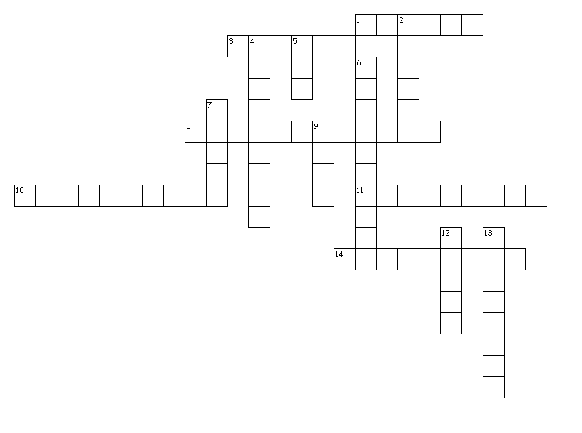
Word Processing Vocabulary
Across
Vocab. Terms
Table | Field
Row | record
column | Main document
Cell | Form letter
gridlines | thesaurus
Descending | macros
template | Data source
ascending | Merge field

1. Complete set of data that appears in rows
3. Bunch of commands grouped together to automate tasks
8. Contains info. that does not change in a mail merge
10. Contains records and fields used in another document
11. Built-in reference for finding synonyms
14. Outline of rows and columns in a table
Down
2. Vertical stack of cells in a table
4. Type of sort that sorts from A to Z or smallest to largest
5. Horizontal placement of cells in a table
6. Contains merge fields to indicate where to print data from data source
7. Arrangement of text or numbers in rows and columns
9. Intersection of a column and a row
12. Single characteristic that appears in columns
13. Predesigned files that can be used to create a new file

Directions: Write the best answer in the blank provided.
- Explain how to insert a row into a table.

- Explain how to delete a column in a table.

- Which feature will allow you to join selected cells into one cell?

- What are three choice to start a template?

- What is a merge field?

- What feature allows Word to break lines between syllables of words?

