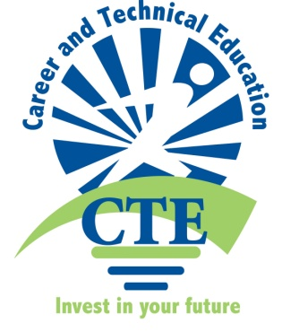
Lowndes County and Valdosta City Schools Observe . . .
National Career and Technical
Education Month

What is Career and Technical Education (CTE)?
Lowndes & Valdosta CTE Programs
Students and faculty in the Career, Technical and Agricultural Education programs in Lowndes County and Valdosta City Schools will celebrate February as National Career and Technical Education Month. Among the special activities scheduled are: school board appreciation dinner, Mr. and Miss CTE contest, student organization social-events, teacher appreciation, and radio and television promotion. The theme of this month’s celebration, CTE: Invest in Your Future, highlights the importance of career and technical education in providing the essential skills necessary to succeed in the future.
“With our activities over the month, we will highlight our students and programs and show appreciation to those who support the programs,” said Lynne Wilson, Director of CTAE and Public Relations for Lowndes County Schools. “We would like the public to understand the variety of skills students are acquiring. By partnering with the business community, CTE prepares students to become successful employees as well as future leaders.”
According to the Association for Career and Technical Education, there are 15.6 million secondary and postsecondary career and technical education students in the U.S. Career. For more information about Lowndes County Schools, call Lynne Wilson at 229-316-1854; Valdosta City Schools, call George Ward at 333-8540.

CTE has a long and rich history in the United States. Today’s CTE has evolved from a limited number of vocational programs available at the turn of the 20th century into a broad system that encompasses a variety of challenging fields in diverse subject areas which are constantly evolving due to the changing global economy.
Today’s CTE provides students:
- Academic subject matter taught with relevance to the real world
- Employability skills, from job-related skills to workplace ethics
- Career pathways that link secondary and post-secondary education
- Second-chance education and training
- Education for additional training and degrees, especially related to workplace training, skills upgrades and career advancement


