Desktop Publishing Terminology
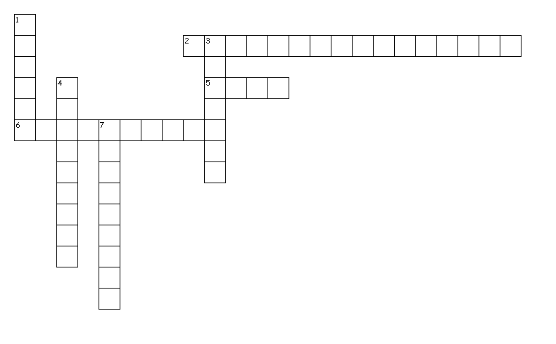
Across
2. specific information and the publication
5. meat of newsletter; usually formatted in column
6. used to separate areas of newsletter
Down
1. top part of the newsletter that usually contains the name and information about the issue
3. heading contained in body of newsletter
4. Text that is pulled from body of newsletter; adds visual interest
7. contains information about issue
7 of 7 words were placed into the puzzle.
Created by Puzzlemaker at DiscoveryEducation.com


