Make a copy of your nursing Home Database file and change its name to NursingHome-SwitchMacro. Doing this will hold our database in tact and allow us to experiment with the database to create macros and a switchboard.
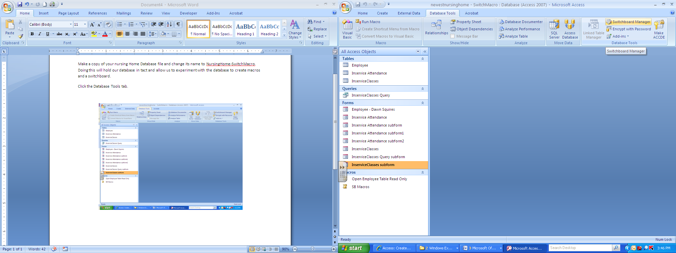
Click the Database Tools tab and click the Switchboard Manager in the Database Tools grouping.

Click the Yes button.
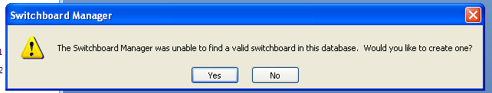

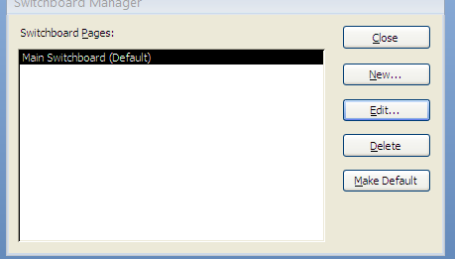
When the Switchboard Manager dialog box opens, click the Edit button.

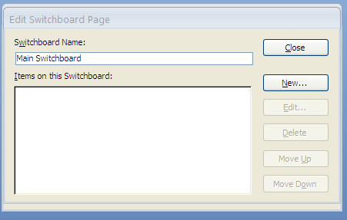
Next we need to add buttons to the Database Manager. Click the New button.

Enter the text that will appear on the button adjacent to the Text: heading: Open Employee Form in Edit View.
Click the drop-down arrow next to Command: and select the option: Run a Macro.
Next to Switchboard choose Main Switchboard and click OK.

Repeat the steps to add another button to the Switchboard for the OpenInserviceAttendanceForm macro.
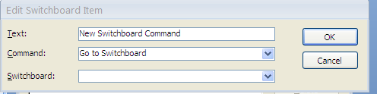

The general idea for a switchboard is that it should open when the database opens. This would make the switchboard the first thing the user sees and help the user get to the desired function quickly and easily. In order for the switchboard to open when the database opens, we have to change some settings in Access.
Click the Office Button and click the button Access Options.
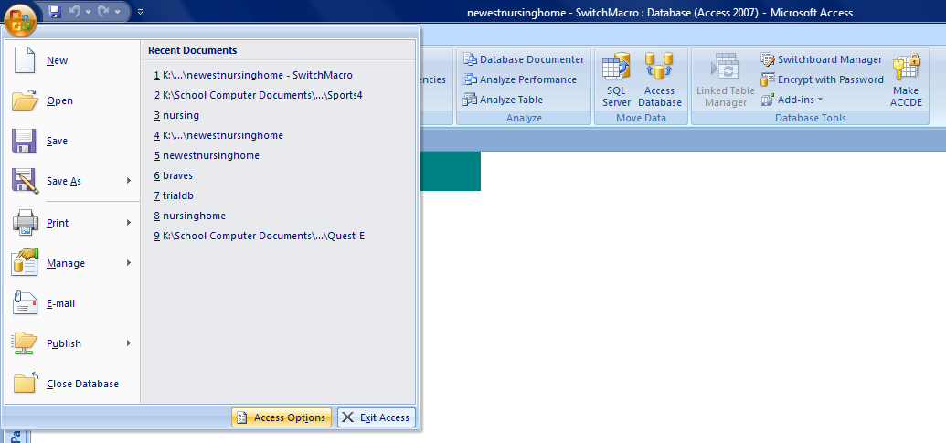

In the new dialog box that opens, select Current Database in the left column. In the right task pane (options for the current database), select the drop-down arrow adjacent to Display form. Choose Switchboard. Click Okay. You should receive an error message stating that the database will need to be closed and reopened for the changes to take effect. Close and reopen the database.
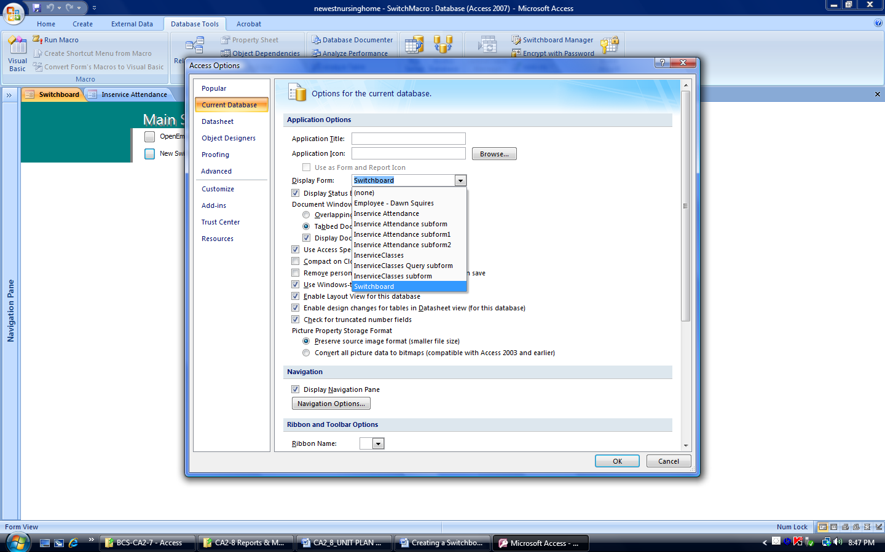

Practice clicking on the buttons on the database to ensure that they function correctly.

