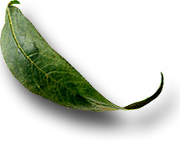
Unit: 1.4 Careers in Animal Science

 Introduction

Course: 02.421 Introduction to Animal Science Technology/Biotechnology
Unit 1: Animal Agriculture as Science

Unit Development Template Annotation
(Briefly describe the topics, methods, technology integration, etc.)
In this unit students will be able to discuss career opportunities in animal science and be able to report on selected animal science technology/biotechnology careers.

Grade(s)
- 9-Ninth
- 10-Tenth
- 11-Eleventh
- 12-Twelfth

Time: (Enter time in number of 50 minute periods)
- 2

Author

Notes to the Teacher (optional)

Students with disabilities: For students with disabilities, each instructor should refer to the student's IEP to be sure that the accommodations specified in the IEP are being provided within the classroom setting. Instructors should also familiarize themselves with the provisions of Behavior Intervention Plans that may be part of a student's IEP. Frequent consultation with a student's special education instructor will be beneficial in providing appropriate differentiation within any given instructional activity or requirement.

Standards

GPS Focus Standards:
AG-ASB-1-j. Investigates and reports on selected animal science technology/biotechnology careers.

GPS Academic Standards:
ELA10RC4 (c) Determines strategies for finding content and contextual meaning for unfamiliar words or concepts
SCSh3 Students will identify and investigate problems scientifically.
SCSh4 Students use tools and instruments for observing, measuring, and manipulating scientific equipment and materials.
SCSh6 Students will communicate scientific investigations and information clearly.
SCSh8 Students will understand important features of the process of scientific inquiry.
SCSh9 Students will enhance reading in all curriculum areas.

Understanding and Goals

Unit Understandings, Themes, and Concepts: Provide the deep understandings and concepts the student should retain as a result of this Unit. These are the enduring understandings.
Students will learn about the various careers in agriculture and how agriculture encompasses a wide variety of careers and job opportunities.

Primary Learning Goals: Provide a list of the Essential Questions, Knowledge and Skills the student will know, understand, and be able to answer or demonstrate as a result of this Unit. All Primary Goals must be related to standards addressed in the Unit.
- What careers are available in agriculture?
- What thoughts go into choosing a career?

Balanced Assessment

Assessment Method/Type:
 | Constructed Response |  | Peer Assessment
x | Combined Methods |  | Selected Response
 | Informal Checks |  | Self Assessment

Assessment Title:

Description/Directions: Provide detailed description & directions so it will provide accurate results for any teacher wishing to replicate it.

Attachment – Supplemental Resource Title: (Optional) List the title of any attachment associated with the assessment.
Herren, Ray V. The Science of Animal Agriculture:
Gillespie, James R. Modern Livestock and Poultry Production.
Instructional Material Services. University of Missouri-Columbia. Plant Science.
GA AG ED PowerPoint – Careers_in_Animal_Science_course_02421-02.4

Web Resources: (Optional) List the title of the web resource associated with this Unit Development Template Assessment.

Unit Performance Task(s)

Performance Task Title:

Description/Directions: Provide detailed description & directions so it will provide accurate results for any teacher wishing to replicate it.

Rubric for Performance Task: Attach rubric used in the assessment of this Unit Performance Task or submit as separate file.

Sequence of Instruction and Learning

Sequence of Instruction and Learning: List the sequence of instruction and learning for this Unit Development Template.

Introduction and Mental Set
Show the video series, Career in Agriculture or take the students to the
library and assign them an agricultural career. Each student should research the career and present the information to the class orally. This will really increase student self-concept. Grade the students on written and oral presentation.

Discussion
1. What are career opportunities which require knowledge of animal science? Possible student responses:
A. marine biologist
B. zoo keeper
C. veterinarians
D. cattle producer
E. hog producer
F. horse producer
G. sheep producer
H. Ag teacher
I. farmer

2. Lead into employment opportunities for college graduates in the food and agricultural sciences. Display and discuss handout 1.4.1. Explain the percentages of each of the six areas of employment.

3. What is the career decision making process? Have them determine what type of job might be suitable for them. Display and discuss handouts 1.4.2 - 1.4.8.
A. Explain to students the importance of making goals and working toward them.
B. Explain that now is the time to make decisions as to the rest of life. College, career, etc.

4. How can we determine a persons capacity to perform?
A. Areas of self analysis that help us better understand our capabilities:
Talent
Physical make-up
Previous experience
Interests
Educational aspirations
Attitudes and values
Self concept
Flexibility
Personality

5. Define biotechnology and animal technology?
A. Biotechnology: The management of biological systems for the benefit of humans
B. Animal Technology: The practical use of animal science

C. Discuss careers that are directly related to biotechnology and
animal technology. List each on the chalkboard.

Summary
Summarize the lesson with a discussion about the many careers in agriculture. Show the transparencies of application of agriculture careers under the broad areas such as science, engineering, life sciences, and education just to mention a few.

Evaluation
Written test
Written and oral reports

1.4.1

Employment Opportunities in Food and Agriculture Science

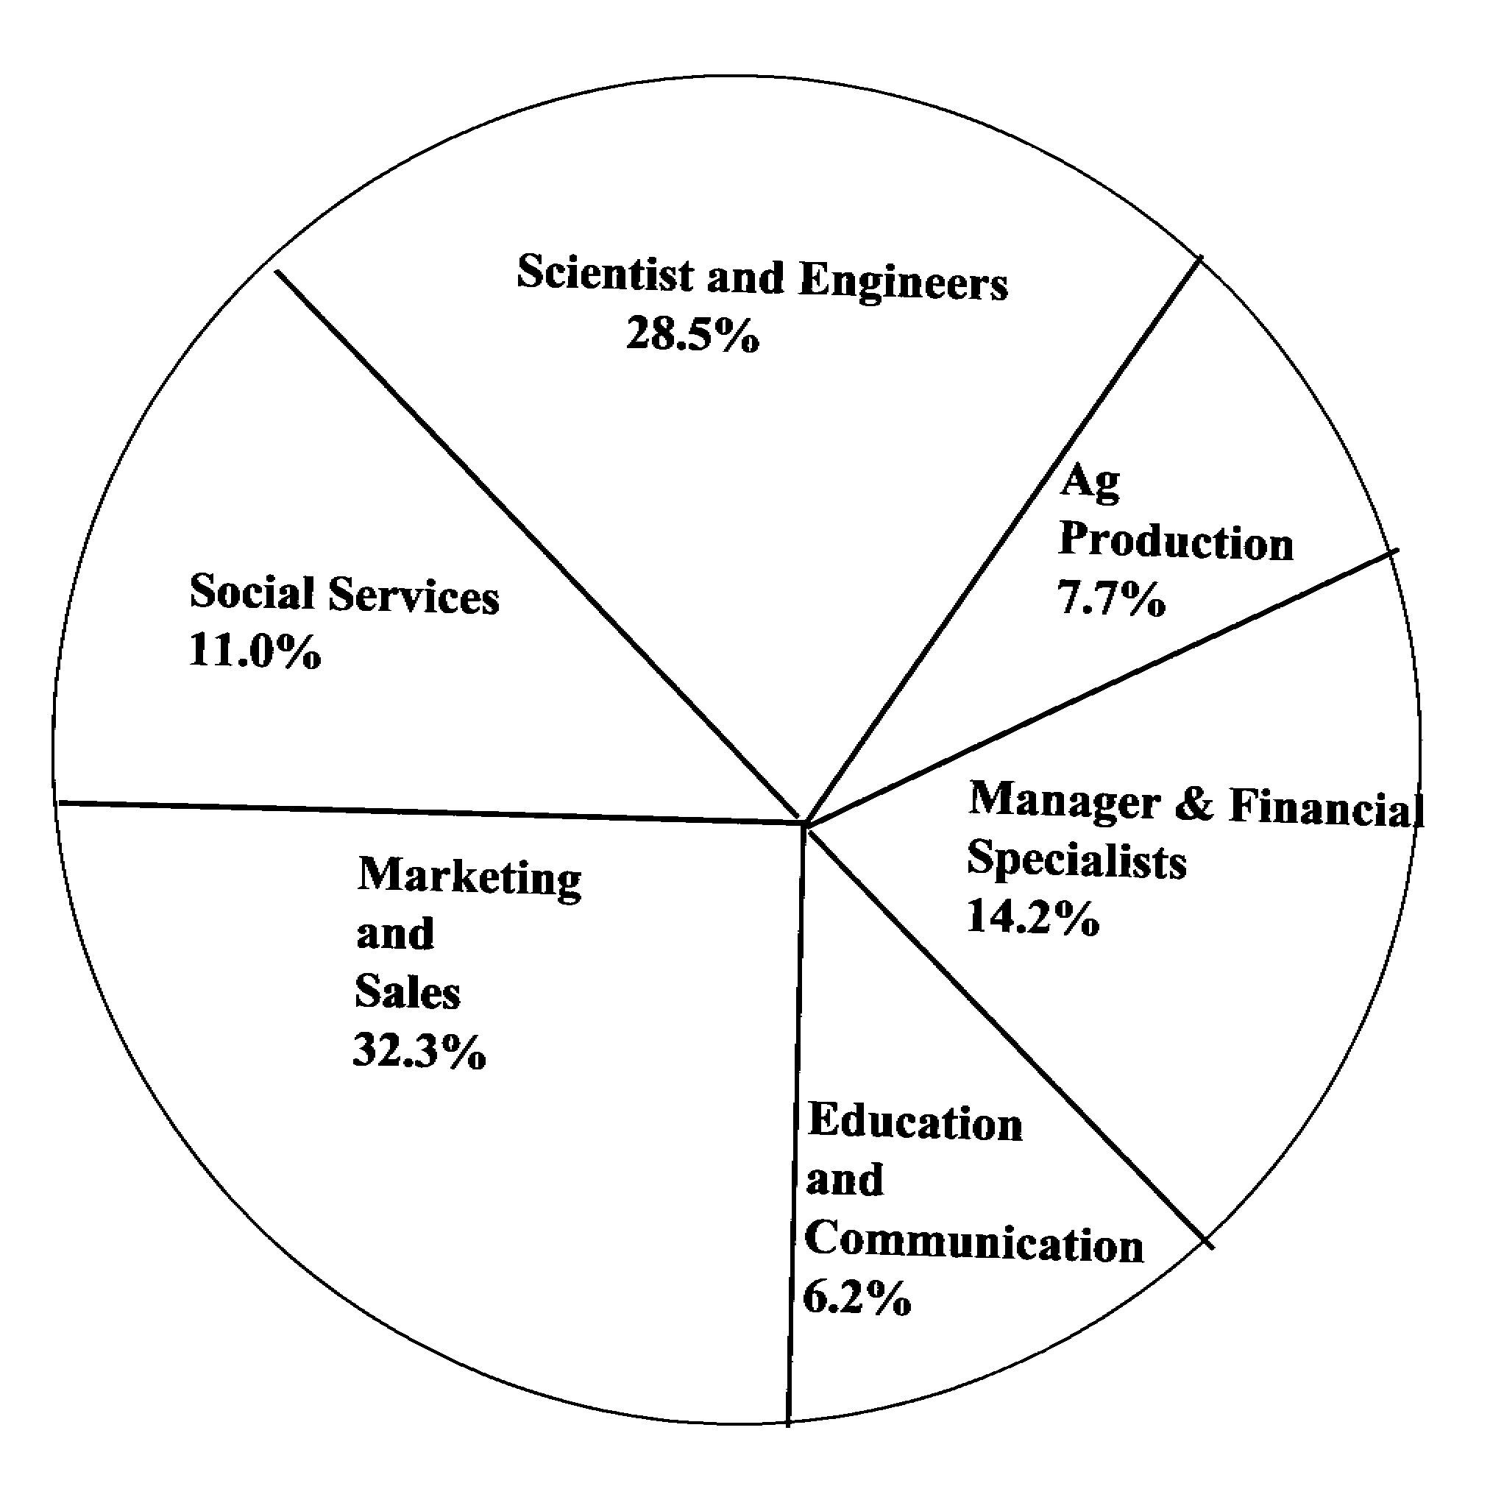
1.4.2

Step #1 In the Career Decision - Making Process
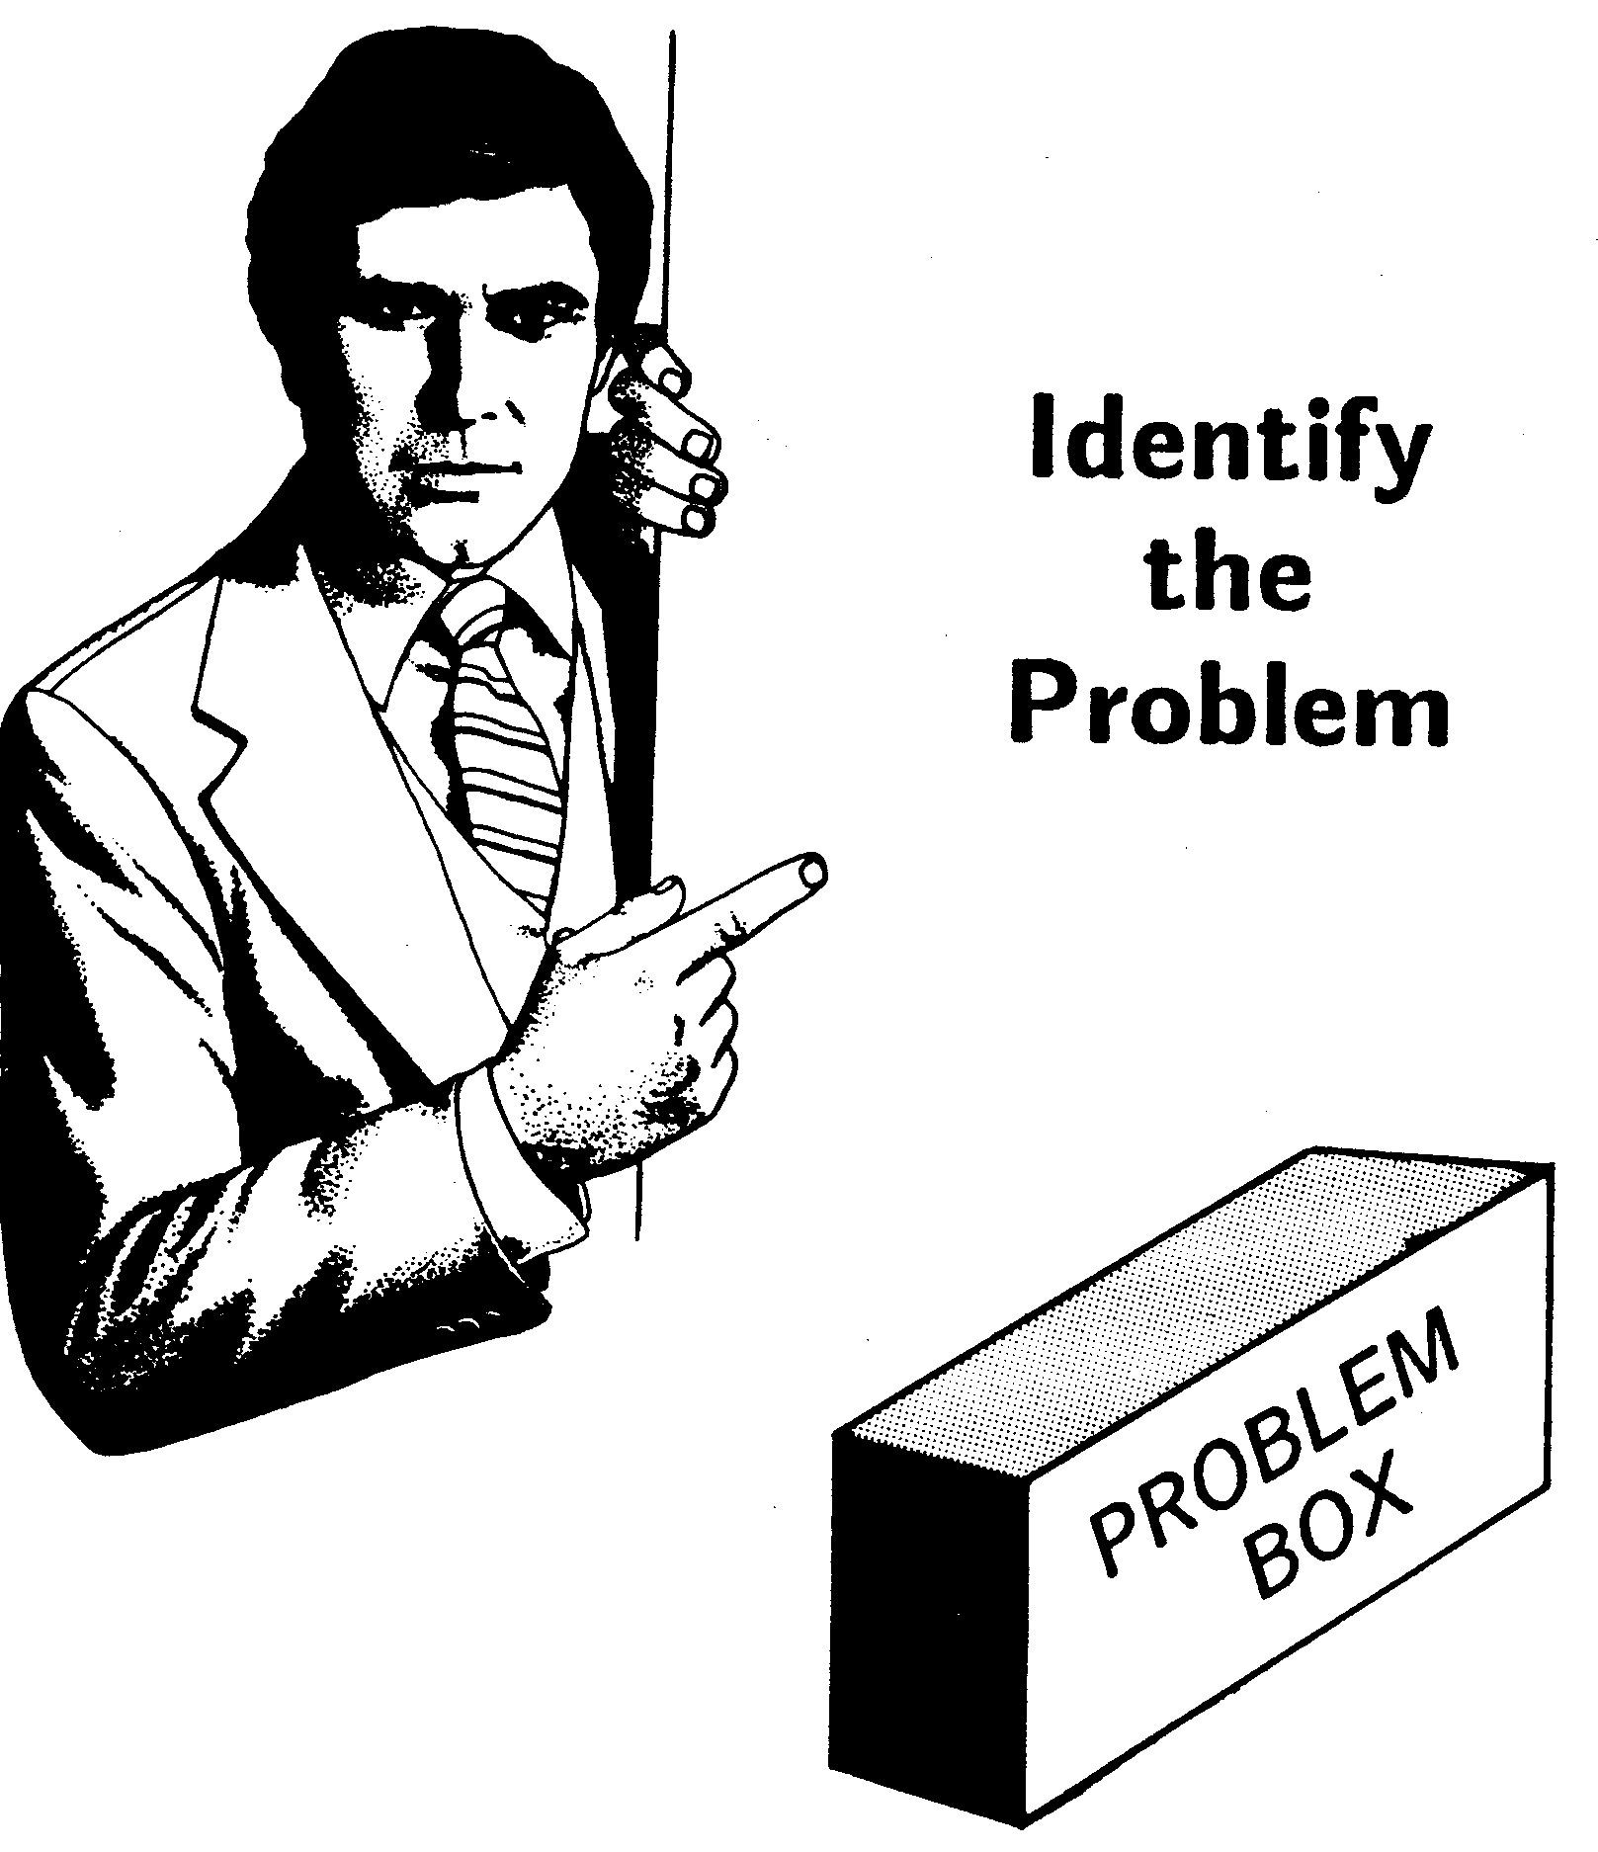

1.4.3

Step #2 In the Career Decision - Making Process



Gather Information

People

Places

Things
1.4.4

Step #3 In the Career Decision - Making Process



Identify
Alternatives

Alternative # 1

Alternative # 2

Alternative # 3

1.4.5

Step #4 In the Career Decision - Making Process

Weigh the Evidence

Pro Good Yes

Con Bad No



Step #5 In the Career Decision - Making Process

No Alternative # 1

 Alternative # 2

? Alternative # 3



Select From Among
the Alternatives

Step #6 In the Career Decision - Making Process



Date & Time Things to Do

People to Meet Place

1.4.7

Step #7 In the Career Decision - Making Process

Review the Action

If the alternative chosen
is not suitable, proceed
to Step # 3 again!
1.4.8

Basic Concepts Related to
Career Decision - Making

 Career decision - making is continuous

 Career decisions involve compromises

 Actions take precedence over certainty

 Time is an ally

 Flexibility to change is a plus

 Happiness is independent of success

 Most people are multipotentialed

