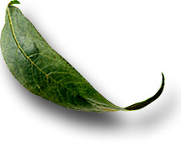
Unit: 4.1 Introduction to the Dairy Industry

 Introduction

Course: 02.421 Introuction to Animal Science Technology/Biotechnology
Unit 4: Dairy Science

Unit Development Template Annotation
(Briefly describe the topics, methods, technology integration, etc.)
In this unit students will identify the major areas of dairy production in the United States and compare dairy production among the states. The students will also discuss breeds of dairy cows their characteristics and demonstrate the steps used to milk cows in the modern dairy. Lastly, students will Assess the uses of milk from species other than cows in the dairy industry and identify dairy products.

Grade(s)
- 9-Ninth
- 10-Tenth
- 11-Eleventh
- 12-Twelfth

Time: (Enter time in number of 50 minute periods)
- 3.5

Author

Notes to the Teacher (optional)
Students with disabilities: For students with disabilities, each instructor should refer to the student's IEP to be sure that the accommodations specified in the IEP are being provided within the classroom setting. Instructors should also familiarize themselves with the provisions of Behavior Intervention Plans that may be part of a student's IEP. Frequent consultation with a student's special education instructor will be beneficial in providing appropriate differentiation within any given instructional activity or requirement.

Standards

GPS Focus Standards:
AG-ASB-4-a. Identifies the major areas and characteristics of dairy production in the United States and compares dairy production among the states.
AG-ASB-4-b. Discusses breeds of dairy cows and their characteristics.
AG-ASB-4-c. Demonstrates the steps used to milk cows in the modern dairy.
AG-ASB-4-d. Determines the per capita consumption of various dairy products.
AG-ASB-4-e. Assesses the uses of milk from species other than cows and their importance in the dairy industry
AG-ASB-4-f. Identifies dairy products, their use and their economic importance.

GPS Academic Standards:
ELA10RC3 (c), Explores understanding of new words found in subject area texts.
SCSh9, Students will enhance reading in all curriculum areas.
SCSh4, Students use tools and instruments for observing, measuring, and manipulating scientific equipment and materials.
SCSh6, Students will communicate scientific investigations and information clearly
SSEM12, Define the Law of Supply and the Law of Demand.

Understanding and Goals

Unit Understandings, Themes, and Concepts: Provide the deep understandings and concepts the student should retain as a result of this Unit. These are the enduring understandings.
- Students will explain the use of technology in the modern dairy industry and its influence in the production of dairy products.

Primary Learning Goals: Provide a list of the Essential Questions, Knowledge and Skills the student will know, understand, and be able to answer or demonstrate as a result of this Unit. All Primary Goals must be related to standards addressed in the Unit.
- What are the major characteristics of dairy production in the United States? How does this compare to dairy production in individual states?
- What are the different characteristics and breeds of dairy cattle?
- How are cow milked in a modern dairy facility?
- What is the per capita consumption of different dairy products?
- What are other sources of milk derived from and how is it used?
- What are the different dairy products available and how are they each important?

Balanced Assessment

Assessment Method/Type:
 | Constructed Response |  | Peer Assessment
x | Combined Methods |  | Selected Response
 | Informal Checks |  | Self Assessment

Assessment Title:

Description/Directions: Provide detailed description & directions so it will provide accurate results for any teacher wishing to replicate it.

Attachment – Supplemental Resource Title: (Optional) List the title of any attachment associated with the assessment.
Herren, Ray. The Science of Animal Agriculture. Delmar Publishers, Inc. Albany, NY. ISBN: 0-8273-4546-1.
Flanders, Frank & Ray Herren. The Science of Animal Agriculture Lab Manual. Delmar Publishers, Inc. Albany, NY.
National Dairy Council Website <www.nationaldairycouncil.org>

Web Resources: (Optional) List the title of the web resource associated with this Unit Development Template Assessment.

Unit Performance Task(s)

Performance Task Title:

Description/Directions: Provide detailed description & directions so it will provide accurate results for any teacher wishing to replicate it.

Rubric for Performance Task: Attach rubric used in the assessment of this Unit Performance Task or submit as separate file.

Sequence of Instruction and Learning

Sequence of Instruction and Learning: List the sequence of instruction and learning for this Unit Development Template.

Materials and Equipment
Materials listed in the lab manual
Ag Ed Worksheets (see below) and Power Point Presentation

Introduction and Mental Set
Ask students to read the introduction to dairy production in the text (Herren).

Discussion
1. Review and discuss major areas of milk production in the United States.
A. Determine the five leading milk-producing states in the U.S. Ask students to guess one of the states before reading the answers.
i. Wisconsin
ii. California
iii. New York
iv. Minnesota
v. Pennsylvania
B. Discuss why they are the highest producing states.
i. These states produce more forage for proper feeding
than other states.
ii. They also have high concentrations of population in large cities located in these states.

2. Introduce breeds of dairy cows and general characteristics
A. Review quickly the six major breeds. Ask students to name the breeds before revealing them.
i. Holstein
ii. Jersey
iii. Milking Shorthorn
iv. Aryshire
v. Guernsey
vi. Brown Swiss
B. Discuss why Holstein’s are the #1 breed in the U.S.
i. High producing
ii. Low milk fat

3. Introduce the equipment and processes of a modern dairy.
A. Use of a milking parlor and its design
B. Milking equipment
C. Milk transport equipment
D. Use the “Dairy Farm Project” worksheet to visualize costs and operating procedures that are required for managing a dairy farm, or use “to the Dairy Industry Activity” template. See below.

4. Discuss the nutritive value of milk (from the National Dairy Council website).
A. See chart below.

5. Review the per capita consumption of dairy products.
A. Ask students to come up with all the different dairy products they can buy in the grocery store. Write answers on the board and discuss.

6. Introduce the parts of the cow’s digestive system.
A. Include rumen, reticulum, omasum, abomasum, and their functions.
B. Compare the relative sizes of the compartments of a newborn calf verses an adult cow.

7. Discuss the role of other species’ milk in the dairy industry.
A. Ask students to list animals other than dairy cows, whose milk we use for our food supply, and in what products we utilize the milk.

8. Activity
Have students complete the laboratory activity titled, The Value of the Dairy Industry, from the reference lab manual (Herren and Flanders).

Summary
Review key points with students. Play millionaire game – available on Georgia Ag Ed CD titled: Game 19 & 20 – Dairy Quiz Bowl

Evaluation
Written test
Laboratory activity

Break-Down of the Nutritive Value of Milk (From the National Dairy Council)

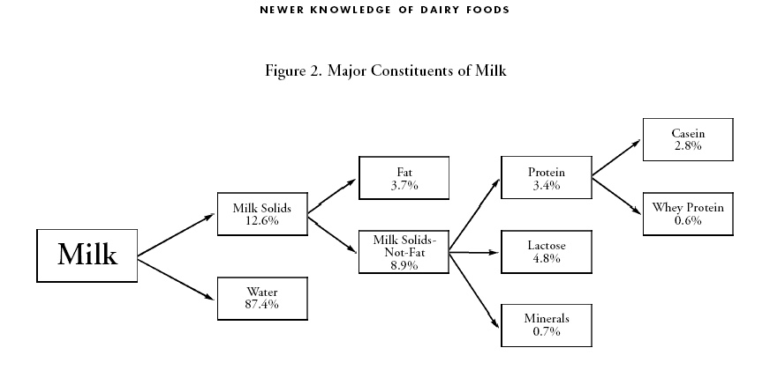

Dairy Farm Project Activity

You have inherited a small, 100 acre / 50 head of cattle dairy farm in Georgia. It is your job to make good management decisions so that your farm will make a profit. From the choices listed below, choose what you think would be the best management decisions and the worst management decisions, and find out how much profit you would make from each set of decisions by adding your choices to the worksheet.
In order to get your dairy up-and-running, you first need to decide what type of cows you would like to be milking at your farm, based on what you have learned about the breeds. This will determine how many pounds of milk are produced. Pick a breed from #1.

1. Type of cow:
Holstein: 17,000lbs. milk
Jersey: 15,000lbs. milk

To get your income from milk, multiply the pounds of milk produced from your breed by the price/pound of milk ($.1050). For example, if you picked Holstein’s:
17,000 lbs./milk *$.1050/lb= $1,785 income from milk
Put your answer in Section A of the budget under “your farm”. Add up your income from A and B and put it in C. This is the income you will recieve from one cow per year.

Now it is time to figure out your expenses. First determine your feed cost (See #4). For example, if you picked Holstein’s, your feed cost is going to be more because you are feeding a higher producing/larger framed cow. Add your feed cost to section D under “your farm”.

4. Feed cost:
Holstein: $1,000
Jersey: $800

Now you need to decide if you will use artificial insemination or a bull for breeding (See #5). If you use artificial insemination, your health costs will be lower because you have less risk of disease and less damage to cows by the bull. Add your costs under sections E and F of “your farm”.

5. Breeding and Health Costs:
Artificial Insemination: Breeding cost: $30 Health cost: $0
Bull: Breeding cost: $25 Health cost: $10

Health costs should also include vaccinating for certain diseases. You and your veterinarian can come up with a herd health program. Please choose from one of the herd health programs and add it to your health costs found in #5.

6. Health:
Complete coverage of all diseases: $35
Coverage of only the basic diseases: $20
(If you choose this option you must subtract 1000 lbs. of milk from your total production and you must refigure your income. Losses are due to sick and non-producing cows.)

Total your expenses by adding rows D-M. This is how much it will cost you to run your dairy.

BUDGET FOR A DAIRY COW OPERATION-YEAR 1

Example($/cow) Your Farm($/cow)
Income:
A. Milk @ $10.50/lb. 1,785 (.1050*17000lbs)
B. Cull cow and calf sales 230 230
__________________________________________________________________
C. Total $2015 $

Expenses:
D. Feed $1,000
E. Bedding 32 32
F. Breeding 30
G. Health 35
H. Supplies 30 30
I. Utilities 50 50
J. Records 22 22
K. Machinery 85 85
L. Capital investment: 460 460
(interest, depreciation, taxes)
__________________________________________________________________
N. Total $1,744 $

Now figure out the profit per cow by subtracting the expenses from your income (N-C), and place it in section O under “your herd.”
O. Profit $271 per cow $
P. Profit per herd per year $13,500 $

Introduction to Dairy Industry Activity

Have students research on the web or call local dairy farmers to find basic costs incurred on a dairy farm. For example:

1. Cost of 1 dairy cow $_____
2. How much milk does an average cow produce? _____ lbs./day
3. Cost of feed for 1 cow ______$/day
4. Amount a farmer much can sell a gallon of milk for_____$/gal.
5. Total cost of equipment $_____
6. Cost of antibiotics_____$/animal/month of year

Sample questions for written evaluation
Taken from Georgia 4-H Dairy Quiz Bowl
Written by Warren Gilson, University of Georgia

-The stomach of a ruminant has how many compartments? FOUR
-What is the second or “honeycomb” portion of the dairy cow’s stomach? RETICULUM
-Which stomach compartment is sometimes called the “manyplies”? OMASUM
-Which of the 4 compartment’s of a cow’s stomach is considered the true stomach? ABOMASUM
-The majority of total digestion in a mature cow occurs in which compartment? RUMEN
-Which compartment of the cow’s digestive system is known as the fermentation vat? RUMEN
-What is the primary function of the omasum? DEHYDRATION OF PARTIALLY DIGESTED FOOD
-The major compartment of a mature cow’s stomach is the: rumen, reticulum, omasum, or abomasum? RUMEN
-The major compartment of a newborn calf’s stomach is which one of these: rumen, reticulum, omasum, abomasum? ABOMASUM
-Name several input costs on a dairy farm. FEED, LABOR, DEPRECIATION, SEED, FERTILIZER, UTILITIES, RENT, ETC.
-What is the largest solid component of whey? LACTOSE
-Milk is approximately what percent water? 87%
-What is the largest component of milk? WATER
-What is milk sugar called? LACTOSE
-Which of the major dairy goat breeds produces milk with the highest average butterfat? NUBIAN
-Which of the following is not a breed of dairy goat: Nubian, French Alpine, Angora, Toggenburg, or Saanen? ANGORA

