

Agriscience

PATHWAY: Agriculture
COURSE: Basic Agricultural Science and Technology
UNIT 1.1: People Have Needs

Introduction
Annotation:
Students will learn the three basic human needs; food, fiber and shelter. The students will also learn types of fiber and forestry products.

Grade(s):
X | 9th
X | 10th
X | 11th
X | 12th

Time:
14 50-minute periods
Author:
Agricultural Education and CTAE Resource Network
Additional Author(s):

Students with Disabilities:
For students with disabilities, the instructor should refer to the student's IEP to be sure that the accommodations specified are being provided. Instructors should also familiarize themselves with the provisions of Behavior Intervention Plans that may be part of a student's IEP. Frequent consultation with a student's special education instructor will be beneficial in providing appropriate differentiation.

Focus Standards
GPS Focus Standards:
AG-BAS-1-a Explains the three basic human needs and sources of food, clothing and shelter
AG-BAS-1-b Identifies major categories of food and fiber products

GPS Academic Standards:
SSEF4 The student will compare and contrast different economic systems, and explain how they answer the three basic economic questions of what to produce, how to produce and for whom to produce

ELA10RL5 (c) Uses general dictionaries, specialized dictionaries, thesauruses, or related references as need to increase learning

Understandings & Goals
Enduring Understandings:
- Students will learn how agriculture affects their daily lives.
- Students will know the three basic needs humans need to survive food, fiber, and shelter.
- Students will get a better understanding of where these basic needs come from and how they are produced.
Essential Questions:

- Where does the food you eat come from, besides the grocery store?
- What industry is involved with all the basic humans needs?
- How does a farmer determine which crop to produce?

Knowledge from this Unit:
- Students will understand the basic needs of human survival.
- Students will understand the involvement that Agriculture plays in these needs.
- Students will understand how food is produced.
Skills from this Unit:
- Students will be able to explain the three basic human needs.
- Students will be able to describe the important needs and sources of food and fiber.
- Students will be able to name important forestry products.

Assessment(s)
Assessment Method Type: Select one or more of the following. Please consider the type(s) of differentiated instruction you will be using in the classroom.

 | Pre-test
 | Objective assessment - multiple-choice, true- false, etc.
__ Quizzes/Tests
__ Unit test
 | Group project
X | Individual project
 | Self-assessment - May include practice quizzes, games, simulations, checklists, etc.
__ Self-check rubrics
__ Self-check during writing/planning process
__ Journal reflections on concepts, personal experiences and impact on one’s life
__ Reflect on evaluations of work from teachers, business partners, and competition judges
__ Academic prompts
__ Practice quizzes/tests
 | Subjective assessment/Informal observations
__ Essay tests
__ Observe students working with partners
__ Observe students role playing
 | Peer-assessment
__ Peer editing & commentary of products/projects/presentations using rubrics
__ Peer editing and/or critiquing
X | Dialogue and Discussion
__ Student/teacher conferences
_X_ Partner and small group discussions
_X_ Whole group discussions
__ Interaction with/feedback from community members/speakers and business partners
X | Constructed Responses
_X_ Chart good reading/writing/listening/speaking habits
_X_ Application of skills to real-life situations/scenarios
X | Post-test

Assessment(s) Title:
My Food Journal
Assessment(s) Description/Directions:
Students keep a journal of everything they eat for a 5-7 day period. Have the students input the data into My Pyramid Tracker on www.mypyramid.gov and print out the results of the weeks worth of food consumed. The students should make sure to keep track of basic nutrients. Students should be prepared to give an oral report on their diet choices and what changes they think should be made to their diets to become a more healthy diet.
Attachments for Assessment(s): Please list.

Learning Experiences
Instructional planning: Include lessons, activities and other learning experiences in this section with a brief description of the activities to ensure student acquisition of the knowledge and skills addressed in the standards. Complete the sequence of instruction for each lesson/task in the unit.

Sequence of Instruction
- Identify the Standards. Standards should be posted in the classroom for each lesson.
AG-BAS-1-a Explains the three basic human needs and sources of food, clothing and shelter
AG-BAS-1-b Identifies major categories of food and fiber products
- Review Essential Questions.
  - Where does the food you eat come from, besides the grocery store?
  - What industry is involved with all the basic humans needs?
3. How does a farmer determine which crop to produce?
- Identify and review the unit vocabulary.
Nutrients plant sources animal sources
Energy shelter fiber Forestry
- Introduction and Mental Set.
Ask the students if they have ever witnessed a natural disaster such as a tornado or flood. Have them share their stories. Why were these natural disasters devastating? The students will most likely mention the loss of life; personal property; jobs; contamination of, or no food source. The natural disaster disrupts our daily living and our basic human needs.

- Discussion.
1. What are the three basic human needs?
A. Food
B. Fiber
C. Shelter

2. What substance is derived from plants and is necessary for an organism to live and grow? Nutrients

3. What are the nutrient needs of humans?
A. Energy
B. Growth and repair
C. Good Health
D. Body Processes

4. Distribute handout 1.1.1 and discuss.

5. What are the sources of food?
A. Plant sources - the cereal grains of wheat, rice, and corn are the major food items
B. Animal sources - four kinds of animals are raised in large numbers: cattle, hogs, chickens, and sheep

6. What are the plant sources of food?
A. Leaves - lettuce, cabbage
B. Seeds - beans, wheat, corn
C. Roots - potatoes, carrots, onions
D. Fruits - apples, strawberries, pears
E. Flowers - cauliflower and broccoli
F. Stems - celery, asparagus
G. Multiple parts - turnips (leaves and roots)

7. What are the animal sources of food?
A. Meat - muscles, organs, etc. of hogs, cattle, chickens, fish and others
B. Eggs - chicken, fish
C. Milk - cheese, ice cream, and liquid milk of cattle and other animals
D. Display and discuss 1.1.2

8. What are the primary uses of fiber?
A. Clothing
B. Shelter

9. What are the types of fibers?
A. Natural
B. Synthetic

10. How are fibers produced?
A. Animals
B. Plants
C. Manufacturing

11. What types of fibers are produced by animals?
A. Wool
B. Silk
C. Furs

12. What types of fiber are produced by plants?
A. Cotton - clothing, upholstery goods
B. Flax - linen for table napkins and clothing
C. Hemp - twine, cord, rope
D. Jute - twine, cord, rope
E. Sisal - twine, cord, rope

13. What types of fiber are manufactured and mineral fibers?
A. Nylon
B. Polyester

14. Why is shelter important? Shelter provides protection from the elements and other pests.

15. What are some important materials used in building shelters?
A. Wood
B. Masonry
C. Steel

16. What is the practice of growing trees for wood? Forestry

17. List several forest products.
A. Lumber
B. Plywood
C. Veneer
D. Composition board
E. Paper

- Assessment Activity.
Attachments for Learning Experiences: Please list.
1.1.1
Per Person Yearly Consumption
of Selected Foods in the
United States

Commodity | Pounds Consumed Annually in U.S.
Red Meats (beef, veal, lamb, and pork) | 163.0
Poultry (chicken and turkey) | 61.1
Fish and shellfish (wild catch) | 14.9
Eggs | 30.1
Dairy products and milk | 572.2
Fresh fruit and melons | 124.3
Vegetables | 243.7
Potatoes | 135.7
Rice, flour and cereal products | 189.2

1.1.2 The Food Guide Pyramid
A Guide to Daily Food Choices
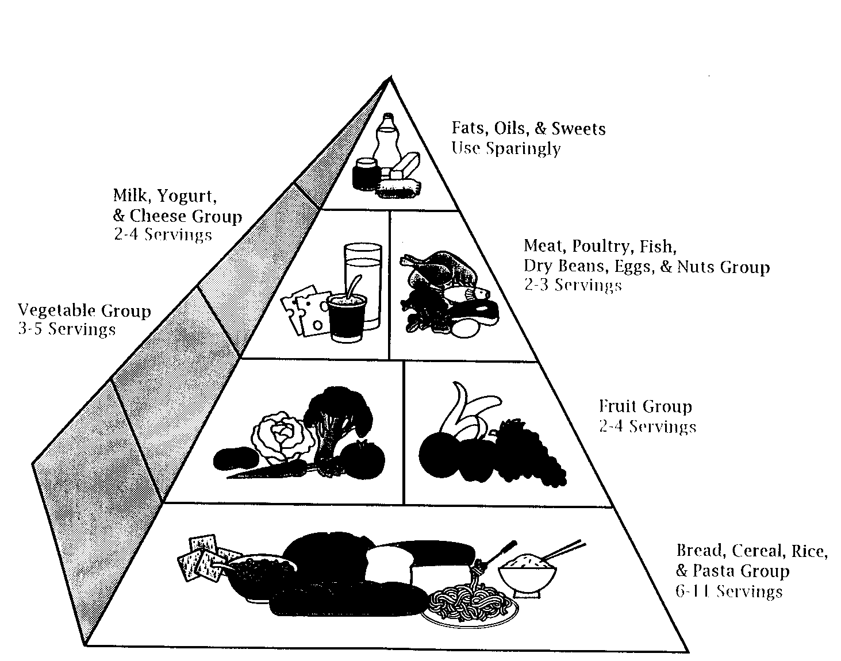

The Food Guide Pyramid is an outline of what to eat each day based on the Dietary Guidelines. It's not a rigid prescription, but a general guide that allows you to choose a healthful diet that's right for you.

The Pyramid calls for eating a variety of foods to get the nutrients you need and at the same time the right amount of calories to maintain healthy weight.

Use the Pyramid to help you eat better every day . . . the Dietary Guidelines way. Start with plenty of breads, cereals, rice, pasta, vegetables, and fruits. Add 2-3 servings from the milk group and 2-3 servings from the meat group. Remember to go easy on fats, oils, and sweets, the foods in the small tip of the Pyramid.

What Counts as One Serving?

The amount of food that counts as one serving is listed below. If you eat a larger portion, count it as more than 1 serving. For example, a dinner portion of spaghetti would count as 2 or 3 servings of pasta.

Be sure to eat at least the lowest number of servings from the five major food groups listed below. You need them for the vitamins, minerals, carbohydrates, and protein they provide. Just try to pick the lowest fat choices from the food groups. No specific serving size is given for the fats, oils, and sweets group because the message is USE SPARINGLY.

1.1.3

Milk, Yogurt, and Cheese
1 cup of milk or yogurt | 1 2 ounces of natural cheese | 2 ounces of processed cheese

Meat, Poultry, Fish, Dry Beans, Eggs, and Nuts
2-3 ounces of cooked lean meat, poultry, or fish | 2 cup of cooked dry beans, 1 egg, or 2 tablespoons of peanut butter count as 1 ounce of lean meat

Vegetable
1 cup of raw leafy vegetables | 2 cup of other vegetables, cooked or chopped raw | 3/4 cup of vegetable juice

Fruit
1 medium apple, banana, orange | 2 cup of chopped, cooked, or canned fruit | 3/4 cup of fruit juice

Bread, Cereal, rice, and Pasta
1 slice of bread | 1 ounce of ready-to eat cereal | 2 cup of cooked cereal, rice, or pasta

Notes & Reflections: May include notes to the teacher, pre-requisite knowledge & skills, suggestions, etc.

Please note that the Food Pyramid has changed, be sure to use the new model. The Food Pyramid and other activities are available at: www.mypyramid.gov.

Culminating Performance Task (Optional)
Culminating Unit Performance Task Title:
A Survival Simulation Game
Culminating Unit Performance Task Description/Directions/Differentiated Instruction:
You and your companions have just survived the crash of a small plane. It is mid-January, and you are in Northern Canada. The daily temperature is below zero. There is snow on the ground. The nearest town is 20 miles away. Before the plane crashed you radioed for help, and you were told to stay near the crash site. They had sent help and it would arrive after the weather clears in 24 hours. You are all dressed in city clothes appropriate for a business meeting. Your group of survivors managed to salvage the following items:
- A loaded .45-caliber pistol
- Newspapers (one per person)
- Extra shirt and pants for each survivor
- Blankets
- Portable video game player
- Air mattress
- 20 x 20 ft. piece of heavy- duty canvas
- A compass
- Family-size chocolate bars (one per person)
- Tent
- Winter Coats

Rank the list above in order of importance for your survival.
Students should rank items of importance by shelter, fiber, and food.

Rubric for Scoring Performance Task
Student Displayed Logical Thought | Unsatisfactory | Satisfactory | Excellent
Appropriate Choices Made by Student

Student Defended Response and Showed Reasoning Ability

Attachments for Culminating Performance Task: Please list.
Unit Resources
Web Resources:
www.mypryamid.gov
Attachment(s): Supplemental files not listed in assessment, learning experiences, and performance task.

Materials & Equipment:
computer access, internet access, hand-out materials, projector

What 21st Century Technology was used in this unit:
Top of Form
 | Slide Show Software |  | Graphing Software |  | Audio File(s)
X | Interactive Whiteboard | X | Calculator | X | Graphic Organizer
 | Student Response System | X | Desktop Publishing | X | Image File(s)
 | Web Design Software |  | Blog |  | Video
 | Animation Software |  | Wiki |  | Electronic Game or Puzzle Maker
 | Email | X | Website
Bottom of Form

