

Agriscience

PATHWAY: Agriculture
COURSE: Basic Agricultural Science and Technology
UNIT 4.5: Determining Area

Introduction
Annotation:
In this unit students will define area and how it is to be measured
Grade(s):
X | 9th
X | 10th
X | 11th
X | 12th

Time:
1 Hour
Author:
Agricultural Education and CTAE Resource Network
Additional Author(s):

Students with Disabilities:
For students with disabilities, the instructor should refer to the student's IEP to be sure that the accommodations specified are being provided. Instructors should also familiarize themselves with the provisions of Behavior Intervention Plans that may be part of a student's IEP. Frequent consultation with a student's special education instructor will be beneficial in providing appropriate differentiation.

Focus Standards
GPS Focus Standards: Please list the standard and elements covered.
AG-BAS-4-c. Provides weights and measurements used in agriculture

GPS Academic Standards:
MM4P1 Students will solve problems (using appropriate technology).
SCSh4 Students use tools and instruments for observing, measuring, and manipulating scientific equipment and materials
National / Local Standards / Industry / ISTE:
Understandings & Goals
Enduring Understandings:

- Students will understand the importance of area.
- Students will understand that area not only refers to agriculture but to everyday life.
- Students will understand that area can be used to find the space inside buildings, land plots, and other structures.
Essential Questions:

- What is area?
- What are the shapes and formulas used by scientist to determine area?
- How is area used in agriscience?
Knowledge from this Unit:
- Students will define area.
- Students will describe how area is applied to agriscience.
Skills from this Unit:
- Students will be able to apply the five area shapes to find the measurements of various objects, both regularly and irregularly shaped.
- Students will be able to describe and use the units of land measurement.

Assessment(s)
Assessment Method Type: Select one or more of the following. Please consider the type(s) of differentiated instruction you will be using in the classroom.

 | Pre-test
X | Objective assessment - multiple-choice, true- false, etc.
X_ Quizzes/Tests
__ Unit test
 | Group project
 | Individual project
 | Self-assessment - May include practice quizzes, games, simulations, checklists, etc.
__ Self-check rubrics
__ Self-check during writing/planning process
__ Journal reflections on concepts, personal experiences and impact on one’s life
__ Reflect on evaluations of work from teachers, business partners, and competition judges
__ Academic prompts
__ Practice quizzes/tests
 | Subjective assessment/Informal observations
__ Essay tests
__ Observe students working with partners
__ Observe students role playing
 | Peer-assessment
__ Peer editing & commentary of products/projects/presentations using rubrics
__ Peer editing and/or critiquing
X | Dialogue and Discussion
__ Student/teacher conferences
__ Partner and small group discussions
X_ Whole group discussions
__ Interaction with/feedback from community members/speakers and business partners
 | Constructed Responses
__ Chart good reading/writing/listening/speaking habits
__ Application of skills to real-life situations/scenarios
 | Post-test

Assessment(s) Title:

Assessment(s) Description/Directions:

Attachments for Assessment(s): Please list.

Learning Experiences
Instructional planning: Include lessons, activities and other learning experiences in this section with a brief description of the activities to ensure student acquisition of the knowledge and skills addressed in the standards. Complete the sequence of instruction for each lesson/task in the unit.

Sequence of Instruction
- Identify the Standards. Standards should be posted in the classroom for each lesson.
AG-BAS-4-c. Provides weights and measurements used in agriculture.

- Review Essential Questions.
- What is area?
- What are the shapes and formulas used by scientist to determine area?
- How is area used in agriscience?
- Identify and review the unit vocabulary.
- Introduction and Mental Set.
Discuss with the students about the area in the room. Measure the distances in the classroom and the dimensions of the laboratory and determine the area. Explain to the students that space is determined by area.

- Discussion.
1. What is meant by area?
Area is the amount of space within linear measurements.

2. How is the square area reported?
It is reported in square units.

3. What are the five area shapes used by agriscientists?
A. Square
B. Rectangle
C. Triangle
D. Trapezoid
E. Circle

4. What are the formulas for various shapes?
A. Square: A=l x w
B. Rectangle: A=l x w
C. Triangle: A=2 bh
D. Trapezoid: A=2 bh x altitude
E. Circle: A=1/2 Πr2

Show transparency made from chart 4-8 on page 97 of text.

5. How is the area determined from irregular shapes?
Regular shapes must be formed from the irregular shapes.

6. What are the units of land measurement?
A. Acre--United States
B. Hectare--elsewhere in the world

7. Activity
Develop sample problems/areas for the students to measure and calculate the area. It is suggested that irregular areas be laid out on the school land for the students to measure and then calculate the area

Summary

The shape of the surface determines how area is calculated. Common shapes are square, rectangle, triangle, trapezoid and circle.

- Assessment Activity.
Written Exam
Activity Sheet

Attachments for Learning Experiences:
Figure 4.5.1
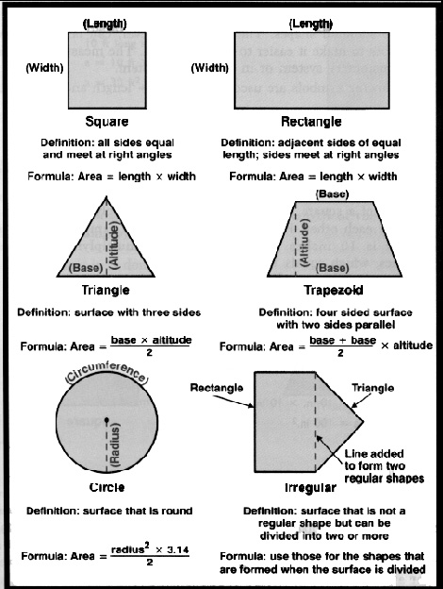

Notes & Reflections: May include notes to the teacher, pre-requisite knowledge & skills, suggestions, etc.

Culminating Performance Task (Optional)
Culminating Unit Performance Task Title:
Finding Area Calculations
Culminating Unit Performance Task Description/Directions/Differentiated Instruction:
Develop sample problems/areas for the students to measure and calculate the area. It is suggested that irregular areas be laid out on the school land for the students to measure and then calculate the area.
Attachments for Culminating Performance Task: Please list.
Unit Resources
Web Resources:
www.gaaged.org

Attachment(s): Supplemental files not listed in assessment, learning experiences, and performance task.

Materials & Equipment:
Computer access, internet access, various measuring tools
What 21st Century Technology was used in this unit:
Top of Form
 | Slide Show Software |  | Graphing Software |  | Audio File(s)
 | Interactive Whiteboard |  | Calculator |  | Graphic Organizer
 | Student Response System |  | Desktop Publishing |  | Image File(s)
 | Web Design Software |  | Blog |  | Video
 | Animation Software |  | Wiki |  | Electronic Game or Puzzle Maker
 | Email |  | Website
Bottom of Form

