

Agriscience

PATHWAY: Agriculture
COURSE: Basic Agricultural Science and Technology
UNIT 4.8: Conversion Formulas

Introduction
Annotation:
In this unit students will learn to use conversion formulas. Students will also calculate important measurement information.
Grade(s):
X | 9th
X | 10th
X | 11th
X | 12th
Time:
1 Hour
Author:
Agriculture Education and CTAE Resource Network
Additional Author(s):

Students with Disabilities:
For students with disabilities, the instructor should refer to the student's IEP to be sure that the accommodations specified are being provided. Instructors should also familiarize themselves with the provisions of Behavior Intervention Plans that may be part of a student's IEP. Frequent consultation with a student's special education instructor will be beneficial in providing appropriate differentiation.

Focus Standards
GPS Focus Standards: Please list the standard and elements covered.
AG-BAS-4-d. Converts English to metric and metric to English standard measure.
GPS Academic Standards:
SCSh4 Students use tools and instruments for observing, measuring, and manipulating scientific equipment and materials.

MM4P1 Students will solve problems (using appropriate technology).

MM4P4 Students will make connections among mathematical ideas and to other disciplines.
National / Local Standards / Industry / ISTE:

Understandings & Goals
Enduring Understandings:
- Students will understand that mathematical measurement conversions are an important tool for agriscientists.
- Students will understand converting between one type of measurement, such as linear, to another type, such as volume or parts per million.
- Students will understand the operation of scientific equipment used in measurements.
Essential Questions:
* How is English standard of measure converted to metric?
- What kind of impact do mathematical conversions have in the production of agricultural products?
- Why should we be concerned with correct measurements?
Knowledge from this Unit:

- Students will describe the impact mathematical conversions have in the production of agricultural products.
- Students will describe and explain a variety of conversions.
Skills from this Unit:
- Students will be able to convert from one type of measurement to another.
- Students will be able to use a variety of measurements in basic conversion problems.

Assessment(s)
Assessment Method Type: Select one or more of the following. Please consider the type(s) of differentiated instruction you will be using in the classroom.

 | Pre-test
X | Objective assessment - multiple-choice, true- false, etc.
X_ Quizzes/Tests
__ Unit test
 | Group project
X | Individual project
 | Self-assessment - May include practice quizzes, games, simulations, checklists, etc.
__ Self-check rubrics
__ Self-check during writing/planning process
__ Journal reflections on concepts, personal experiences and impact on one’s life
__ Reflect on evaluations of work from teachers, business partners, and competition judges
__ Academic prompts
__ Practice quizzes/tests
 | Subjective assessment/Informal observations
__ Essay tests
__ Observe students working with partners
__ Observe students role playing
 | Peer-assessment
__ Peer editing & commentary of products/projects/presentations using rubrics
__ Peer editing and/or critiquing
X | Dialogue and Discussion
__ Student/teacher conferences
__ Partner and small group discussions
X_ Whole group discussions
__ Interaction with/feedback from community members/speakers and business partners
 | Constructed Responses
__ Chart good reading/writing/listening/speaking habits
__ Application of skills to real-life situations/scenarios
 | Post-test

Assessment(s) Title:

Assessment(s) Description/Directions:

Attachments for Assessment(s): Please list.

Learning Experiences
Instructional planning: Include lessons, activities and other learning experiences in this section with a brief description of the activities to ensure student acquisition of the knowledge and skills addressed in the standards. Complete the sequence of instruction for each lesson/task in the unit.

Sequence of Instruction
- Identify the Standards. Standards should be posted in the classroom for each lesson.
AG-BAS-4-d. Converts English to metric and metric to English standard measure.
- Review Essential Questions.
- How is English standard of measure converted to metric?
- What kind of impact do mathematical conversions have in the production of agricultural products?
- Why should we be concerned with correct measurements?

- Identify and review the unit vocabulary.
- Introduction and Mental Set.
Bring in a 12" x 12" x 1" board. Tell students this represents a board foot. This is the way lumber is measured.
- Discussion.
1. Many special kinds of measurement are used in agriscience? Name two important areas.
A. Laboratory work
1. metric system
B. Forestry and Wood
2. customary system

2. Working in a laboratory requires accuracy and precision. What are two phases that are important when working in a laboratory?
A. Conversions-from linear measures to volumes and weights
B. Measurement as parts
1. Parts per thousand (PPT)
2. Parts per million (PPM
3. Parts per billion (PPB)

3. What are the ways in which timber and wood are measured?
A. Volume
1. Board foot
2. cord
B. Weight
C. Length
D. Area

4. What are some basic conversions?
A. Linear measures to volumes and weight
1. 1 cubic centimeter = 1 gram
2. 1 cubic centimeter = 1 milliliter
3. 1 gram = 1 milliliter
B. PPM and PPT
1. 1ppm = 2.72 pounds per foot-acre of water (a foot-acre equals 1 acre of water 1 foot deep)
2. 1ppm = 0.283 grams per cubic foot of water
3. 1ppt = 3.80 grams per gallon of water
C. Volume
1. Board foot-1ft. X 1ft. X 1 inch
2. Cord-4ft. X 4ft. X 8ft.

5. Develop sample conversion problems for the students to complete.

6. Have a forester come in to class and explain forest measurements. Pass out handouts.

Summary

The science of computation pertains to measurement and mathematics. Standard measurements should be used so that communication is easy. Linear measurements are important to determine the number of units from one point to another. Area is the amount of space within linear measurements. Volume is the amount of space something uses. Weight refers to the heaviness of something.

- Assessment Activity.
Written Exam

Attachments for Learning Experiences:
Figure 4.8.1

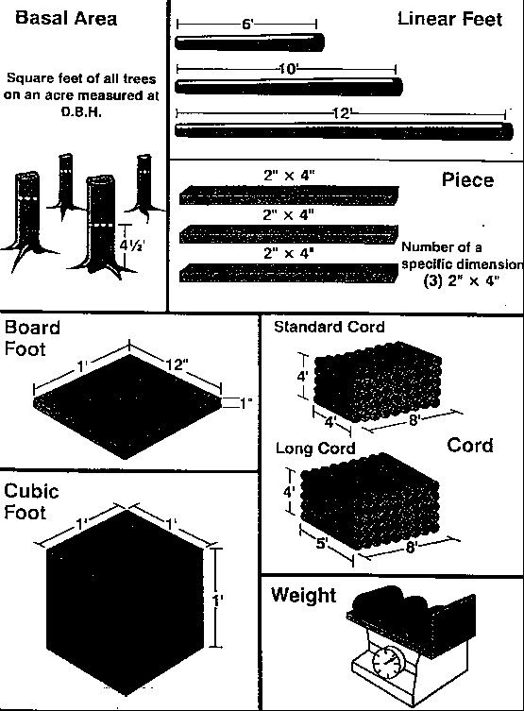
Figure 4.8.1

Notes & Reflections: May include notes to the teacher, pre-requisite knowledge & skills, suggestions, etc.

Culminating Performance Task (Optional)
Culminating Unit Performance Task Title:
Conversion Problems
Culminating Unit Performance Task Description/Directions/Differentiated Instruction:
Develop sample conversion problems for the students to complete.
Attachments for Culminating Performance Task: Please list.

Unit Resources
Web Resources:
www.gaaged.org

Attachment(s): Supplemental files not listed in assessment, learning experiences, and performance task.

Materials & Equipment:
Computer access, internet access, scientific calculators, various measuring equipment
What 21st Century Technology was used in this unit:
Top of Form
 | Slide Show Software |  | Graphing Software |  | Audio File(s)
 | Interactive Whiteboard |  | Calculator |  | Graphic Organizer
 | Student Response System |  | Desktop Publishing |  | Image File(s)
 | Web Design Software |  | Blog |  | Video
 | Animation Software |  | Wiki |  | Electronic Game or Puzzle Maker
 | Email |  | Website
Bottom of Form

