Gramineae
Annual Bluegrass | Poa annua L.
Small tufted to clumped winter annual. Leaf blade, smooth on both surfaces, with two distinct, clear lines, one on each side of the midrib. Leaf tip keeled or boat-shaped. Ligule membranous. Light green to whitish spikelets that lack cottony hairs, are arranged on branches, one to two per node, in dense to open flower clusters. Reproduces by seed. Found throughout the world.
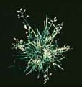

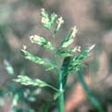

Cyperaceae
Purple Nutsedge | Cyperus rotundus L.
Rapidly-spreading, perennial with three-ranked basal leaves. Leaves flat or slightly corrugated, usually shorter than flowering stem, abruptly tapering at tip. Seedhead purple to reddish brown, formed at end of triangular stem. Tubers, oblong, covered with hairs, and found in chains connected by brown, wiry rhizomes. Tubers bitter to taste. Reproduces primarily by tubers. Found north to Kentucky and West Virginia, west to Central Texas and in southern California. Also occurs in the West Indies, Mexico, Central and South America, Europe, Africa, Asia and Hawaii.
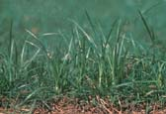
 | 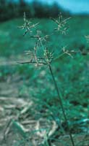
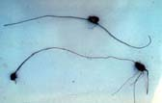

Gramineae
Large Crabgrass  and  Southern Crabgrass | Digitaria sanguinalis (L.) Scop.)  Digitaria ciliaris (Retz.) Koel
Tufted, or prostrate to spreading summer annual with branched stems that root at the nodes. Leaf blade, longer than 2 inches (5 cm), usually hairy on both surfaces, visible toothed membranous ligule at base of leaf. Leaf sheath with dense hairs. Spikelets in two to nine finger-like branches. Southern crabgrass is distinguished from large crabgrass on the basis of the length of the second glume (a bract at the base of a spikelet). These species differ from tropical crabgrass in that the seedhead branches arise from different points of attachment along the stalk. Both species reproduce by seed. Southern crabgrass occurs northward on the coastal plain occasionally to Connecticut, more common southward east of the Appalachian region, throughout Florida, extending west into Texas and north into Kansas and Nebraska. Also occurs in the West Indies, Mexico, Central America and South America. Large crabgrass is found throughout North America, except Florida, and the warm temperate regions of the world. Both species thought to be introduced from the Old World.
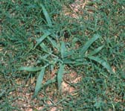
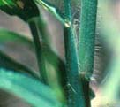 | 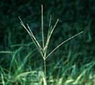

Gramineae
Smooth Crabgrass | Digitaria ischaemum (Schreb. ex Schweig.)
Tufted or prostrate, spreading summer annual. Leaves smooth on both surfaces. Leaf sheath smooth, few long hairs at collar. Visible membranous ligule at base of leaf blade. Seedhead with two to six "finger-like" branches. Reproduces by seed. Found throughout the United States and in Europe.
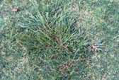

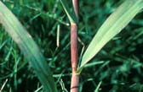

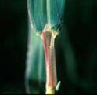

Broadleaf Plantain | Plantago major L.
Perennial with a distinctive rosette of leaves, and slender, fibrous root system. Leaves broad, egg- shaped, with several main veins. Erect, leafless stems terminate in dense, flower spikes. Found in all of North America except the northeastern United States. Also found in the West Indies, Central and South America, Europe, Asia, Australia and Hawaii. Blackseed plantain (Plantago rugellii Dcne.) is similar except stems and petioles longer and leaves somewhat larger. Both species reproduce by seed.

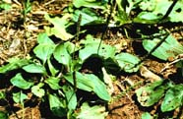

Plantaginaceae
Buckhorn Plantain | Plantago lanceolata L.
Perennial with a distinctive rosette of leaves and a slender, fibrous root system. Leaves narrowly elliptic to lance-shaped, often twisted or curled, with ribbed veins on lower leaf surface. Erect, leafless, hairy stalk terminated by dense, tapered, white to tannish flower spike. Reproduces by seed. Found throughout the continental United States. Also found in Canada, the West Indies, Central and South America, Europe and Asia.
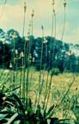
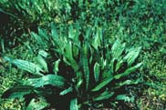
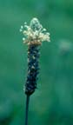

Caryophyllaceae
Common Chickweed | Stellaria media (L.) Cyrillo
Mat-forming winter annual with numerous branched stems. Leaves opposite, smooth, oval to broadly elliptic in shape. Upper leaves without petiole; lower leaves with sparsely hairy long petiole. Stems with vertical lines of hairs. Flowers in small clusters at ends of stems, white, with five deeply notched petals. Reproduces by seed. Located throughout North America except for the Rocky Mountains. Also found in Mexico, Central and South America, Hawaii, Asia, Africa and Europe.
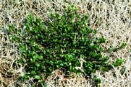
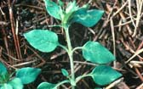 | 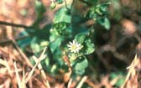

Compositae
Dandelion | Taraxacum officinale Weber
Deeply taprooted, stemless perennial. Leaves, basal, slightly to deeply cut, with lobes that point back towards base. Single yellow flowers at end of each long, smooth hollow stalk. Leaves and flower stalks exude a "milky" juice when broken. Seeds brown, long stalked with a parachute of hairs forming a "globe". Reproduces by seed and can form new plants from fragments of broken taproots. Found throughout the United States, Alaska and Hawaii. Also found in the West Indies, Mexico, Central and South America, Africa, Europe, and Asia.
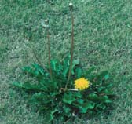
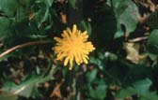 | 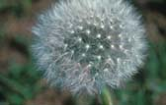

Labiatae
Henbit | Lamium amplexicaule L.
Sparsely-hairy winter annual with greenish to purplish, tender, four-sided stems. Similar in appearance to purple deadnettle but upper leaves lack petioles. Leaves opposite, broadly egg-shaped with bluntly toothed margins, and prominent veins on underside. Flowers, reddish-purple with darker coloring in spots on lower petal, arranged in whorls. Reproduces by seed. Found throughout most of North America. Also occurs in the West Indies, South America, Europe, Africa, Asia and Australia.
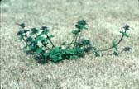
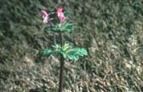

Leguminosae
White Clover | Trifolium repens L.
Low-growing perennial with creeping stems that root at the nodes. Stems smooth to sparsely covered with hairs. Leaves with three elliptic to oval shaped leaflets. Leaflets with small marginal teeth. Flowers white, often with pink tinge, arranged in round heads. Reproduces by seed. Found throughout the continental United States and Hawaii. Also found in Canada, Mexico, the West Indies, Central and South America, Europe, Asia and Australia.
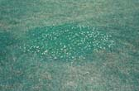
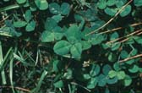 | 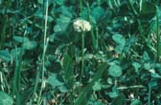

Scrophulariaceae
Purslane Speedwell  (Neckweed) | Veronica peregrina L.
Low-growing, freely-branched winter annual with smooth to somewhat fleshy leaves and stems. Leaves, opposite, longer than broad, coarsely toothed on the margins. Flowers, white, in the upper axils. Fruit a smooth heart-shaped capsule. Reproduces by seed. Found throughout North America. Also found in the West Indies, Mexico, Central and South America, Europe, Asia and Australia.
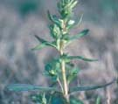
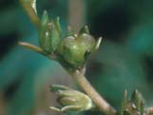
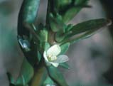

Portulacaceae
Broadleaf Pink Purslane | Portulaca amilis Speg.
Prostrate, mat-forming summer annual with fleshy, flat, thick leaves. Leaves broadly oblong and pointed at the tip. Brownish to white hairs in leaf axils. Pink to pink-purple showy flowers in terminal heads. Reproduces by seed. Found from North Carolina south into and throughout Florida. Native to South America.
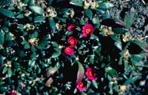 | 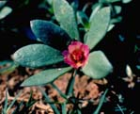

Oxalidaceae
Yellow Woodsorrel  (Oxalis) | Oxalis stricta L.; [Oxalis dillenii Jacq.]
Upright, herbaceous perennial with hairy stems. Leaves, alternate, divided into three partly-folded, deeply cut, heart-shaped lobes. Foliage with sour, acrid taste, Flowers, bright yellow, with five petals, on stalks bent below the fruit and attached to a common point. Fruit a narrow "okra-like" capsule. Found in most of the eastern and central United States. Also occurs in Canada, Europe, Africa, Asia, Japan and New Zealand. Creeping woodsorrel, (Oxalis corniculata L.), has a more prostrate growth habit than yellow woodsorrel. Stolons readily root at the nodes. Leaves similar to yellow woodsorrel but may be green to reddish purplish. Florida yellow woodsorrel (Oxalis floridaSalisb.) is similar in appearance to yellow woodsorrel, but has slender stems and a smooth to sparingly hairy smaller capsule. All species reproduce by seed.
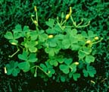
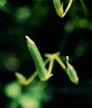 | 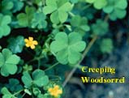

Liliaceae
Wild Garlic | Allium vineale L.
Cool-season perennial with slender, hollow cylindrical leaves. Leaves occur on the flowering stem up to half the height of the plant. Underground bulb bears offset bulblets that are flattened on one side and enclosed by a membrane. Flowers, greenish-white, small, on short stems above aerial bulbils. Plant with distinctive garlic odor when crushed. Reproduces by seed, aerial bulbils and underground bulblets. Found throughout most of the eastern and southern United States, west to Missouri and Arkansas. Also found in Canada, North Africa and Europe. Wild onion (Allium canadense L.) is often found on same sites as wild garlic. Wild onion can be distinguished from wild garlic by presence of a fibrous coat on the central bulb, no offset bulblets and leaves that arise near the base of a solid flowering stem.
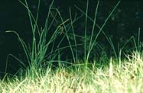
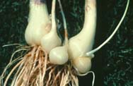 | 