Beneficial Insects That Feed On Pests
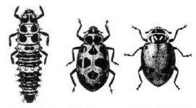
Lady beetle larva (left) and two types of adults
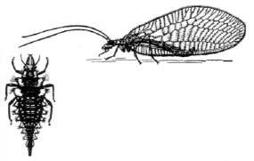
Lacewing larva (left) and adult (right)
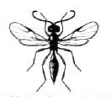
Parasitic wasp that attacks aphids

