Cricket | Name:_________________________________

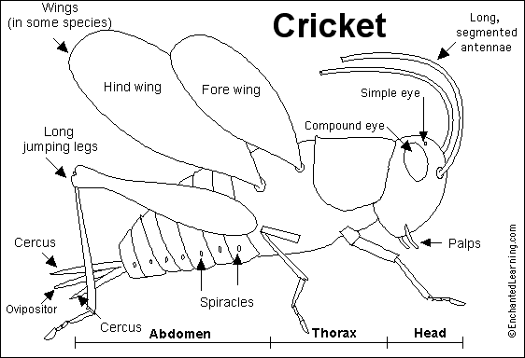
Crickets are jumping insects. Males of most cricket species make a loud chirping sound by rubbing their forewings together; they do this to attract females. Crickets chirp faster when the temperature is warmer. Crickets live under rocks and logs in fields, grasslands, and meadows. Many crickets are nocturnal (most active at night). The most common cricket in the US is the field cricket; the most common one in Europe is the house cricket (which is stockier).
Anatomy: Like all insects, crickets have a three-part body (head, thorax and abdomen), six jointed legs, and two antennae. Their body is covered with a hard exoskeleton. Crickets breathe through a series of holes called spiracles; they are located along the sides of the body. Crickets are brown or black. Crickets are very similar to grasshoppers, but the cricket's antennae are very long, the wings are held flat over the body, and the ovipositor is very long. Not all crickets have wings. Crickets sense sounds using tympani (hearing organs) located in their front legs.
Metamorphosis: Crickets undergo incomplete metamorphosis. They hatch from eggs that the female deposits in soil (or plant material) using her ovipositor. Immature crickets (called nymphs) look like small adults, but the wings and ovipositor (of the female) are not fully developed. They molt many times as they develop into adults.
Diet and Predators: Crickets are omnivores (they eat both plants and animals). They scavenge dead insects and eat decaying material, fungi and young plants. Their predators include birds, rodents, reptiles, other insects (including beetles and wasps), and spiders.
Classification: Kingdom Animalia (animals), Phylum Arthropoda (arthropods), Class Insecta (insects), Order Orthoptera (crickets, grasshoppers, etc.), Suborder Ensifera, Family Gryllidae (crickets), Genera Acheta, Gryllus, Oceanthus, Myrmecophila, many species.

Label the Cricket Anatomy Diagram
Read the definitions below, then label the cricket anatomy diagram.
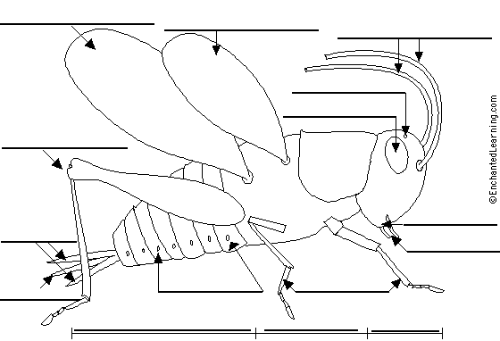

abdomen - the segmented tail area of a cricket, which contains the heart, reproductive organs, and most of the digestive system  antennae - like all insects, crickets have 2 segmented antennae that sense touch and odors  cerci - a pair of sensory organs located at the rear of the abdomen (the singular of circi is cercus) - larger in males  compound eye - crickets have 2 faceted eyes made up of many hexagonal lenses  fore wing - the pair of wings closest to the head  head - the head is at the front end of the cricket's body and is the location of the brain, the two compound eyes, the mouth parts, and the points of attachment of its two antennae.  hind wing - the pair of wings farthest from the head | jumping legs -the long, hindmost pair of the cricket's six legs  mouth - located on the head near the palps  ovipositor - a reproductive organ located at rear of the female's abdomen (between cerci)  palps - long, segmented mouth parts (under the jaws) that grasp the food  simple eye - small, primitive organs that distinguish dark from light  spiracles - a series of holes located along both sides of the abdomen; they are used for breathing  thorax - the middle area of the cricket's body - where the legs and wings are attached  walking legs - the four, short front legs that are used for walking

