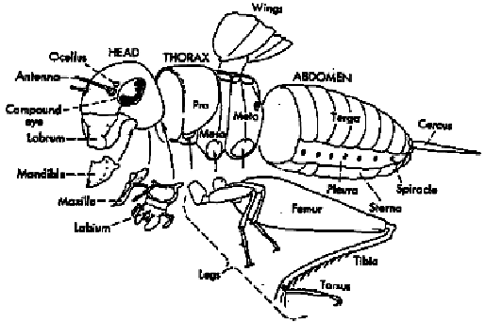

External structure of an insect. This diagram, based on the generalized structure of the common cricket, shows the body regions and their associated structures.

