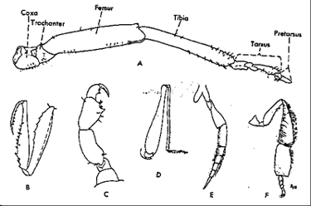

Insect legs. A, commonly observed features of an insect leg; B, the grasping and heavily spined foreleg of a mantid, which preys on other insects; C, the clinching leg of a hog louse, adapted for seizing the hairs of its host; D, the long and well-muscled hind leg of a grasshopper, adapted for jumping; E, the swimming hind leg of a diving beetle; F, the hind leg of a honeybee, adapted for carrying pollen (outlined mass is the position of the pollen ball).

