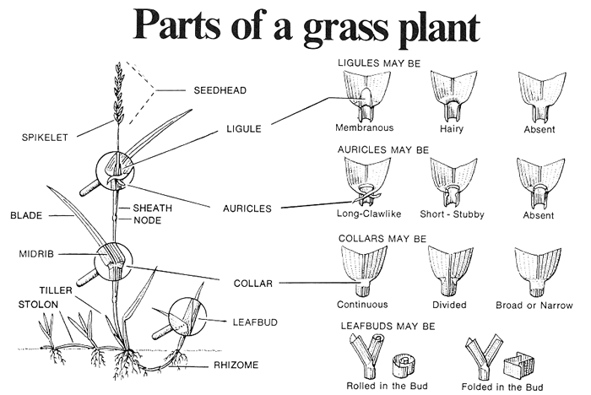

Vernation
The arrangement of a leaf or leaves in the budshoot. In general they may be classified as rolled or folded. (Example: New shoots of Kentucky bluegrass are folded. New shoots of Quackgrass are rolled.)
Ligule
The structure which clasps the stem at the junction of blade and sheath. The type (membranous or hairy) and shape (tall, short, jagged, etc.) remaining fairly uniform and constant within each given species.
Collar
The area on the outer side of the leaf where the blade and the sheath join. It is generally much lighter in color and varies in size and shape from species to species.
Auricles
Appendages that project from either side of the collar. They may be slender, claw-like, long or short. In Quackgrass slender auricles clasp the stem.
Sheath
The tubular portion of the leaf which wraps around or encloses the stem. Edges of the sheath may join, overlap or be closed. They are also rough or smooth, cylindrical, flattened or compressed.

Blade
The upper portion of the leaf, which is divided from the sheath by the collar and the ligule. The length, width, type of tip, roughness or smoothness are a few characteristics of various species.
Rhizomes
An underground stem that produces a new plant. Rhizomes are present or absent, strong or weak.
Stolons
A horizontal, above ground stem that takes root at various intervals and gives rise to new plants.
Seedhead
The collection of flowering or seeding parts which are arranged in various ways, (spike, panicle, etc.). A very important identifying feature.
Spikelet
The unit of the seed head which composes the seeding parts. Properly dissected and analyzed, it provides the most accurate method for the identification of various species.
Other characteristics, such as growth habit and color, all help to classify the various grasses. To make identification even more practical, it is advisable to use a small magnifying glass. Magnification of lOx to 16x is ideal for making tiny features more easily observed.
