Nursery Landscape Problem Solving
Mark answers in the Assessment and Solution Section on score card.

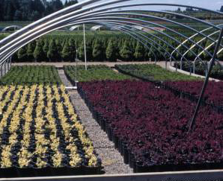
Container production for nursery crops is one of the most common methods of production. Producing plants in containers reduces production time and improves water and nutrient efficacy of the same field grown crop, therefore a quicker turnover in the nursery. Media choice is of primary importance. For successful container production the media should drain well, provide adequate oxygen to the roots while having enough weight to support the plant and keep the containerized plant from falling turning over.

Container Size | # Containers per Cubic Yard of Media
1 gallon | 275
2 gallon | 140
3 gallon | 80
5 gallon | 50

Question
Given the information provided, what media would be the best selection to prepare 200, 5 gallon container?

Select from the below answers:
A. 2.5 cubic yards of 2 part sand, 1 part perlite, 3 parts vermiculite
B. 2.5 cubic yards of 2 part bark, 1 part sand, 6 parts peat
C. 4 cubic yards of 2 part peat, 1 part sand, 6 parts vermiculite
D. 4 cubic yards of 1 part perlite, 1 part peat, 4 parts bark

Answer: D. 4 cubic yards of 1 part perlite, 1 part peat, 4 parts bark
Solution:

200, 5 gallon containers

Fill 50 containers with 1 cubic yard media

200 / 50 = 4 cubic yards of media mix

Now think about what media will drain well and supplies oxygen yet still provides support for the plants.

