Nursery Landscape Problem Solving
Mark answers in the Assessment and Solution Section on the scorecard.

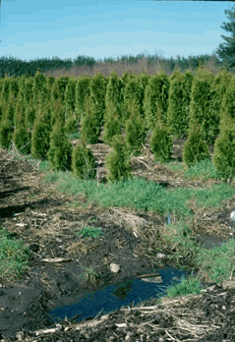
Pre-emergent herbicides are used to prevent weed growth in nursery production areas. The following is a list of herbicides suggested for use in commercial nurseries.

Herbicides for Container Nurseries
Materials | Herbicide/1000 sq. ft.
Dacthal 5-G | 5.9 oz
Surflan | 1 oz
Ronstar 4G | 1.5 lbs.
Treflan | 2 lbs.

Question

Using the above information, how many pounds of Ronstar 4G would be used to treat a nursery production area of 4.5 acres?

Note: 43,560 sq. ft./ acre

Select one of the following answers:

- 196 lbs.
- 294 lbs.
- 588 lbs.
D. 394 lbs.

Solution

Answer: B. 294 lbs.

- Calculate the square feet in the nursery production area.

4.5 x 43,560 = 196,020

- (area in square feet ÷1000) x herbicide rate = pounds necessary for treatment
(196,020÷1000) x 1.5 lbs. = 294 lbs.

