Nursery Landscape Problem Solving
Mark answers in the Assessment and Solution Section on score card.

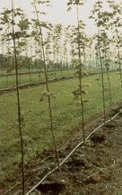
Drip irrigation is a very efficient system of watering nursery field-grown stock. It applies small amounts of water to the root zone area.
It also promotes compact root development that is important for subsequent tree survival in the landscape.
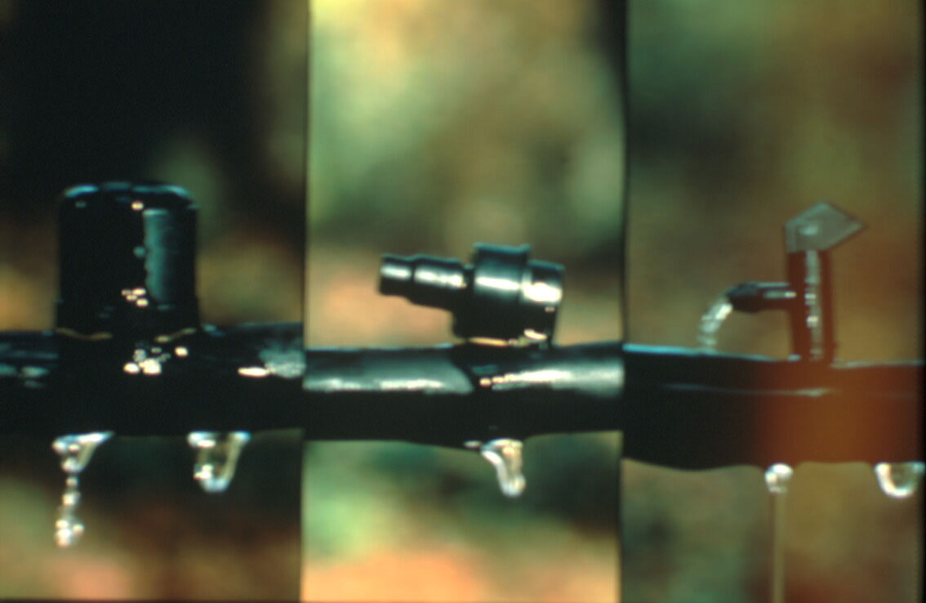

Question
If your drip irrigation system has the capacity to deliver 10 gallons per hour per zone and each tree needs 1/2 gallon per hour. How many trees can you water on a 10-zone irrigation system?

Select from the below answers:

A. 50 trees B. 100 trees

C. 200 trees D. 300 trees

Answer: C. 200 trees
Solution:

1. Calculate 10 gallons per zone and each tree needs 1/2 gallon = 20 trees per zone

2. 10 zones x 20 trees/zone = 200 trees

