Nursery Landscape Problem Solving
Mark answers in the Assessment and Solution Section on score card.

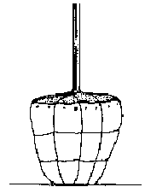
Figure 1. American Standard for Dogwood Rootball
Up to 6 feet Height | Over 6 feet Caliper | Minimum Diameter Ball(inches)
2 |  | 10
3 |  | 12
4 |  | 14
5 |  | 16
 | 3/4" | 16
 | 1" | 18
 | 11/2" | 20
 | 13/4" | 22
 | 2" | 24
 | 21/2" | 28
 | 3" | 32
 | 31/2" | 38
 | 4 | 42
 | 41/2" | 48
 | 5" | 54
Ball Depth Ratio

Diameter less than 20"

Depth not less than 75%
of diameter or 3/4 of width

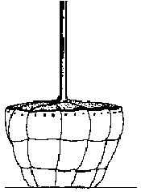
Diameter 20"-30"
Depth not less
than 66 2/3%
or 2/3 of width

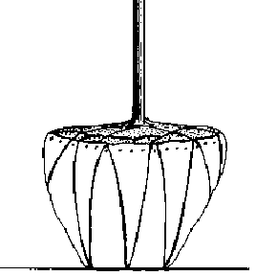

Diameter 31"-48"
Depth not less than 60%
or 3/5 width. Balls with
a diameter of 30" or more
should be drum-laced

Question
Given the above information, what minimum depth should the root ball for a 3” caliper field grown dogwood tree be dug?

Select from the below answers:

A. 12 inches B. 19 inches

C. 28 inches D. 32 inches

Answer: B. 19 inches

Solution:

1. 3” caliper field grown dogwood tree minimum diameter of root ball = 32”

2. Ball Depth Ratio Diameter 31-48" = Depth not less than 60% of diameter or 3/5 of width
32 x .60 = 19” deep as minimum depth dug

