Nursery Landscape Problem Solving
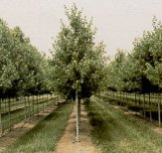
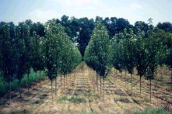
Mark answers in the Assessment and Solution Section on score card.

In choosing planting dimensions for field grown trees, it is important to account for space required by fertilizing, cultivating, mowing, and spraying equipment.

Note: 43,560 sq ft / acre

Question
Given the above information, how many trees per acre could you plant with rows spaced 16’ apart and trees planted 10’ apart down each row?

Select from the below answers:

A. 272 trees/acre B. 328 trees/acre

C. 426 trees/acre D. 572 trees/acre

Answer: A. 272 trees/acre
Solution:

1. Calculate square foot per tree
16 x 10 = 160 square foot per tree

2. 43560 sqft in acre divided by 160 square feet = 272 trees in acre

