Classification Using Plant Characteristics
A. Leaf Morphology - Angiosperm
a. Parts
1) blade - the flattened part of a leaf.
2) midrib - the mid-vein or primary vein of a leaf or leaflet.
3) petiole - a leaf stalk that connects the leaf to the stem.
4) axillary bud or lateral bud - a bud located in an axial at the base of a leaf.
5) margin - edge of a leaf.
6) veins - a strand of xylem and phloem in a leaf blade.
b. Types
simple
compound
pinnate compound
palmate compound

2.1.2
Leaf Parts, Types, Arrangements, and Vein Arrangements

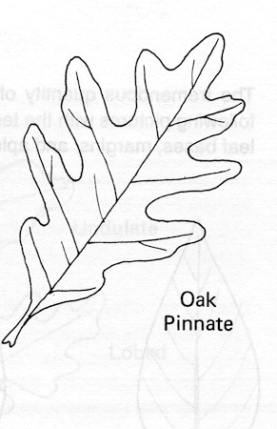
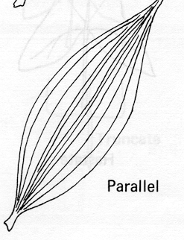
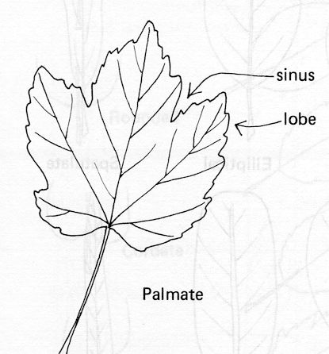
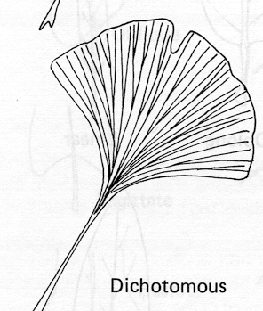
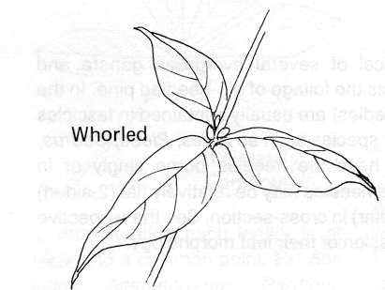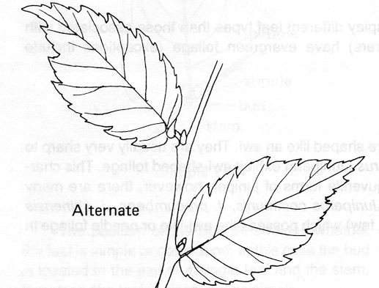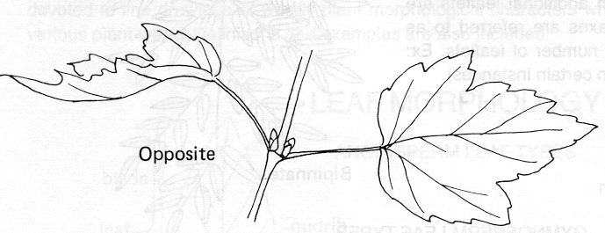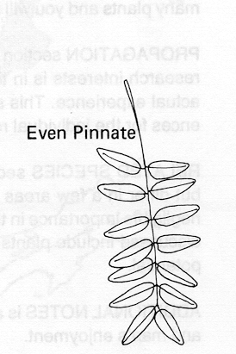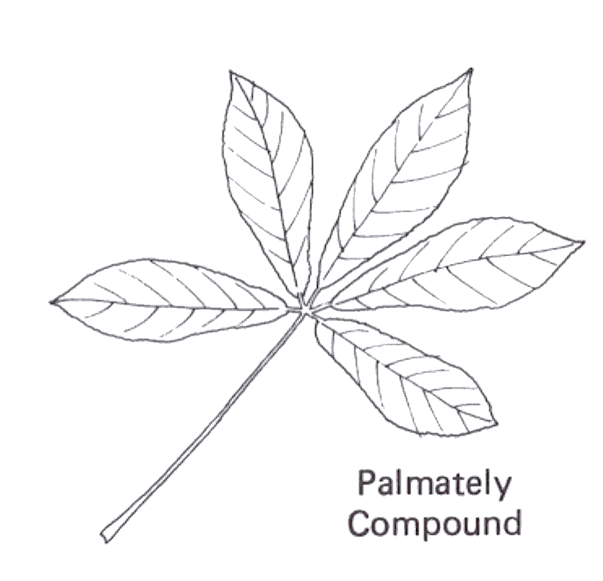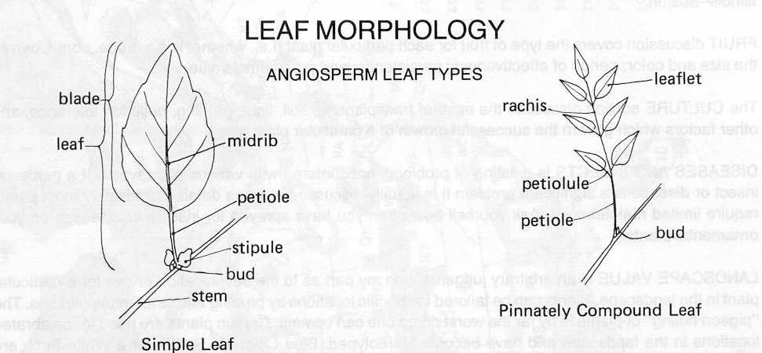
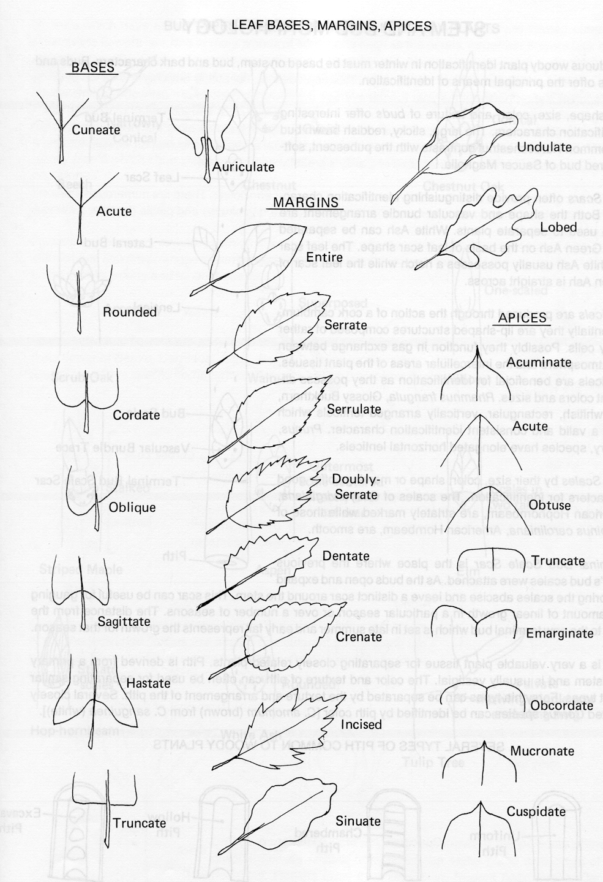
2.1.2

2.1.2
B. Stem Morphology - Angiosperm
a. Parts
1. Apical or terminal bud - a stem’s growing tip.
2. Nodes - The segment of a stem to which leaves and axillary buds are attached.
3. Internode - The segment of a stem between two nodes.
4. Axillary bud or Lateral bud - A bud located in an axil at the base of a leaf.
5. Lenticels - Scattered bumps located on young bark are breathing pores that exchange gases from the atmosphere and the inner bark cells.
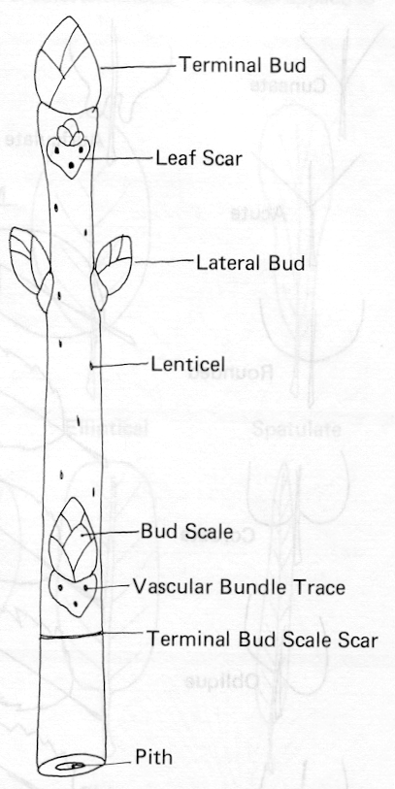
6. Leaf scars - A scar left on a stem after a leaf has fallen.
2.1.2
Leaf and Stem Classification Worksheet

Find a live plant specimen for each classification and attach to paper. Record the plant's name and classification.

Simple Leaf

Palmate Compound Leaf

Pinnate Compound Leaf

Whorled Leaf Arrangement

Alternate Leaf Arrangement

Opposite Leaf Arrangement

Pinnate Veins

Parallel Veins

Palmate Veins

Dichotomous Veins

Stem with Lenticels

Stem without Lenticels

Entire Margin

Serrate Margin

2.1.2
C. Flower Morphology - Angiosperm
a. Parts
1. Receptacle - stem tip that holds the flower parts.
2. Sepals - green floral leaves that act as temporary, protective scales around the unopened bud.
3. Petals - colored or white leaves that attract the attention of insects, birds, and people.
4. Stamen - male part of the flower.
a) Filament - supports the anther.
b) Anther - produces and holds the pollen.
c) Pollen - male gametophyte that fertilizes the eggs.
5. Pistil - female part of the flower
a) Stigma - Receives the pollen.
b) Style - supports the stigma.
c) Ovary - The basal part of a pistil that becomes a fruit.
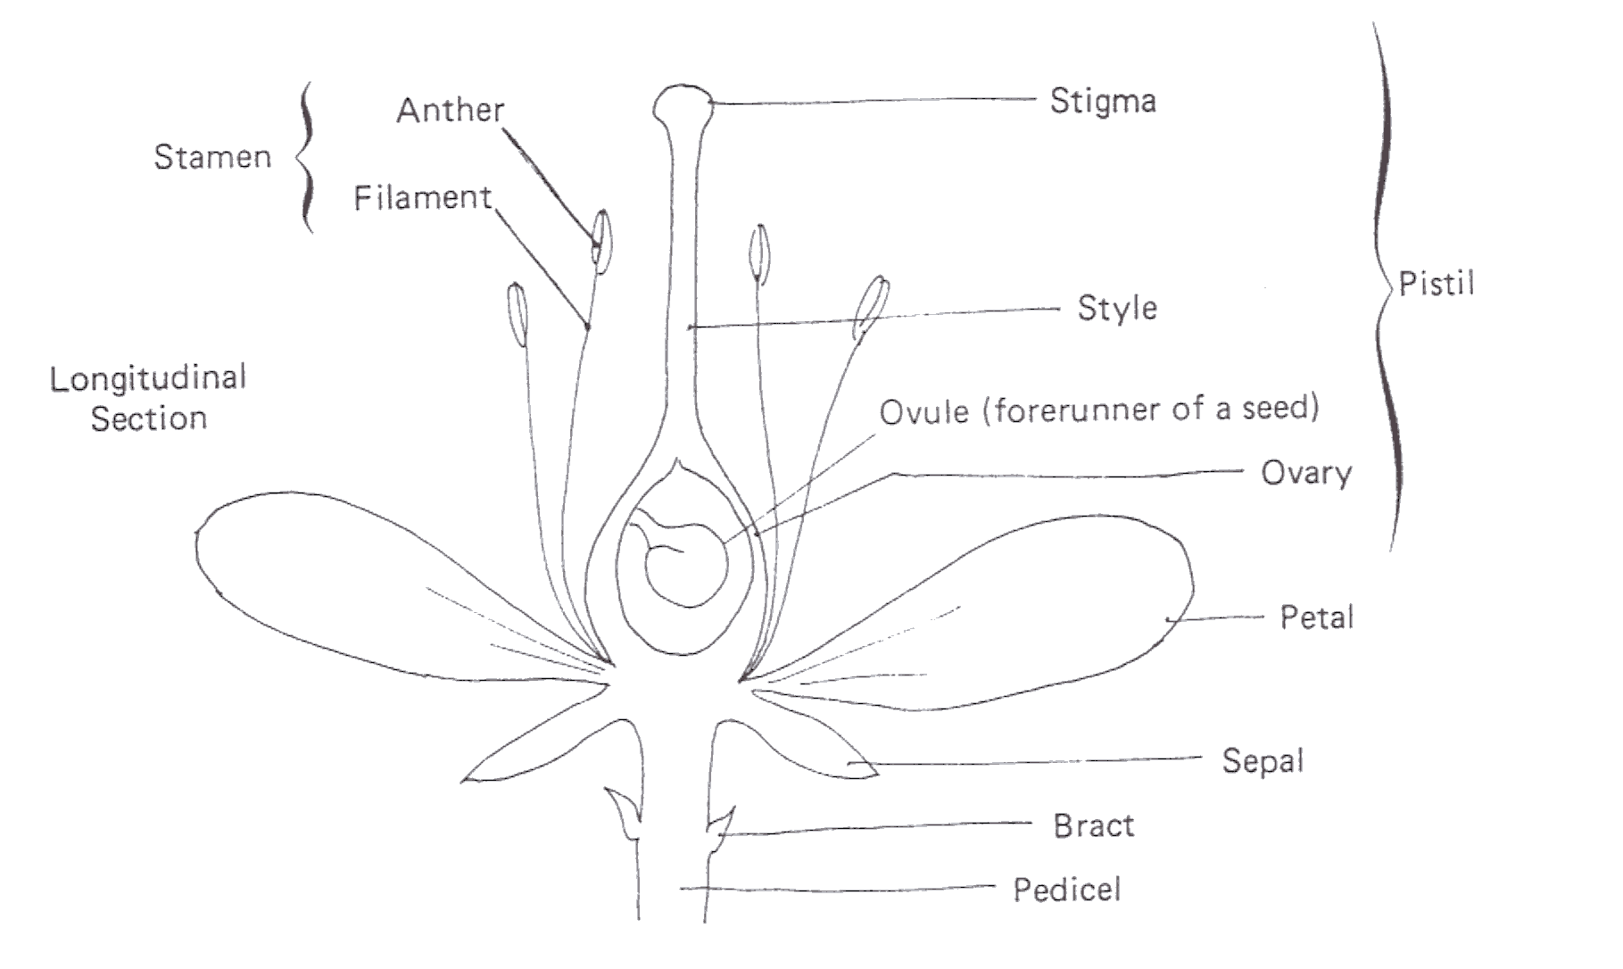
1) Ovules - An immature seed.

