Cooperative Extension Service
The University of Georgia
College of Agricultural and Environmental Sciences

Soil Testing

For Home Lawns & Gardens

C. Owen Plank, Extension Agronomist
Soil Testing & Plant Analysis
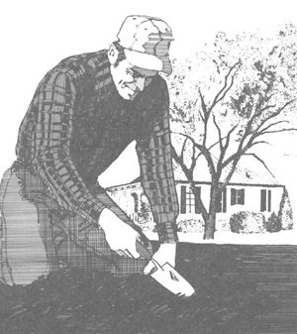 | Soil tests such as those conducted by the University of Georgia Soil Testing and Plant Analysis Laboratory will help you develop and maintain a more productive soil by providing information about the fertility status of your soil. Information from a soil test will help you select the proper liming and fertilization program to obtain optimal growth of lawn, garden and ornamental plants.  One of the most important steps in soil testing is collecting the sample. Soil test results can be no better than the sample submitted to the laboratory for analysis. A soil sample weighing about 1 pound is used to represent thousands of pounds of soil in the landscape or garden. Therefore, it is extremely important that soil samples be properly and carefully taken.

A Good Soil Sample Should Be Representative of the Area
- Take soil from a minimum of 10 random locations (x) in the sampled area and mix together in a clean bucket.
- For trees and shrubs, take soil from six to eight spots around the dropline of the plants and mix.
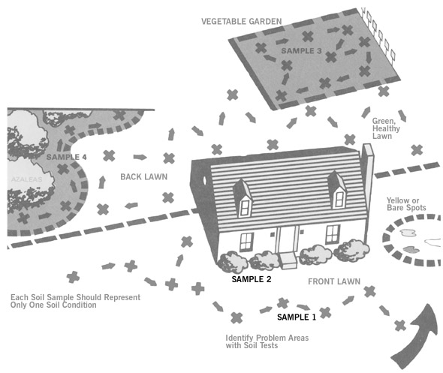
- Areas that have been treated differently should be sampled separately. In the above example, four samples should be taken -- one each from the garden, the lawn, the ornamental shrubs in the landscape, and the azaleas. If the front and back lawns have been treated differently or if they are seeded to different grasses, take a separate sample from each. | - Areas where plants grow differently and/or the soil appears different should be sampled separately.

3.2.1

Do Not Contaminate the Sample
- Use clean sampling tools and containers.  - Never use tools or containers that have been used for mixing or applying fertilizer or limestone. A small amount of residue on containers can cause serious contamination of the sample. | 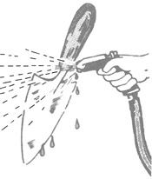

Sample to the Proper Depth
- Remove any surface litter such as turf thatch or mulch.  - For lawns, sample to a depth of 4 inches. For gardens, ornamentals and fruit trees, sample to a depth of 6 inches.  - Use a trowel or sampling tube to collect soil samples. To use a trowel or spade, push the tool to the desired depth into the soil. Then push the handle forward, with the trowel or spade still in the soil, to make a wide opening. Cut a thin slice from the side of the opening that is of uniform thickness -- about ¼ inch thick and 2 inches wide, extending from the top of the ground to the depth of the cut. Scrape away any grass thatch or mulch, and place the slice of soil into a clean bucket or other container. After the soil is taken, remove the shovel or spade and let the soil fall back in place. | 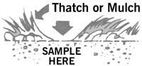
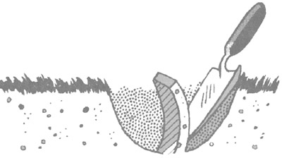

Soil Samples Should Be Carefully Mixed and Packaged
- Do not use sample bags other than those provided by the University of Georgia Soil Testing and Plant Analysis Laboratory. All cores taken for a given sample should be collected in a clean bucket and thoroughly mixed.  - Fill the soil sample bag to the indicated line with the mixed soil.  - Supply all the information asked for on the soil sample bag. List your Name and Address, Plant to Be Grown, Sample Number (please use a simple code and do not exceed 3 digits, e.g. 1, 2, 3, ... 20, 21, 22, ... 321, 322 ... 32A, 32B ...) and your County. This information is essential for the return of your sample results and fertilizer recommendations to the proper county extension office. On the bag, indicate tests desired by checking the proper box. For lawns, gardens and shrubs, a routine test will suffice. If a special analysis, e.g. nitrate-nitrogen (NO₃-N), organic matter (O.M.) or boron (B) is needed, first consult your local county extension office. Samples should be dropped off at your county extension office for mailing to the laboratory. Soil sample bags and other pertinent information are available at your county extension office. | 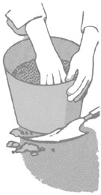  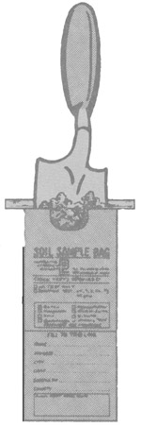

When and How Often Should Soils Be Tested?
Soils can be tested any time during the year; however, be sure to sample well in advance of planting or spring green-up. This is particularly important on areas where lime is likely to be needed. Lime reacts fairly slowly and should be mixed with the soil several weeks before planting. Generally, fall is the most desirable time to sample soils, because landscapes and gardens are usually dry and easily accessible. Soils should be dry enough to till when sampling. If wet samples are collected, they should be air dried before being placed in the soil sample bag.
Once medium or high fertility levels are established, lawn and ornamental areas only need to be sampled every two to three years. Vegetable gardens should be sampled every one to two years.

PDF version
Leaflet 387/Reprinted March, 2000

